# GEMS Royal Dubai School-Dubai branch

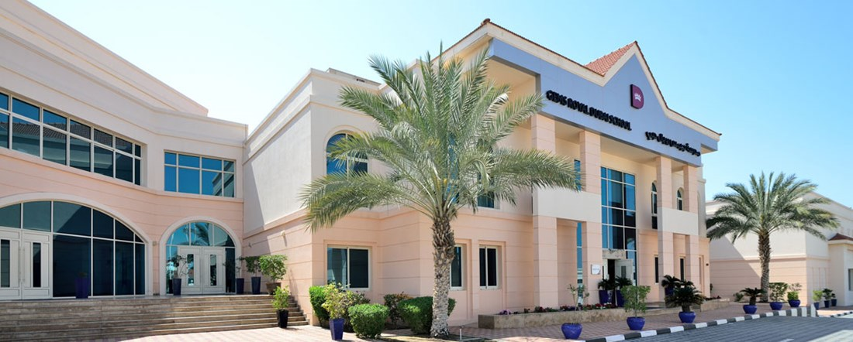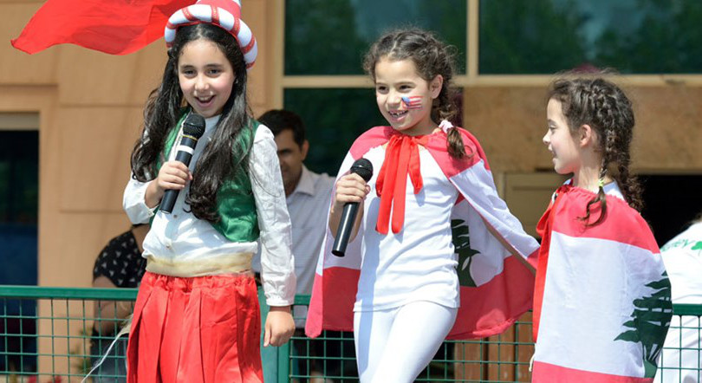

GEMS Dubai Royal School (RDS) is a BSO excellent, high-performance, inclusive, and family oriented community located in the center of Mirdif. In RDS, our students have the right to learn and develop, and receive support to become successful and confident contributors in a constantly changing world.

**School History**

GEMS Dubai Royal School has been continuously growing since its opening in 2005 and is now recognized as one of Dubai's leading UK primary schools. It has been recognized as an outstanding school in all categories by the BSO (British Overseas Schools).

GEMS Royal Dubai School offers a rich version of the UK's new national curriculum, emphasizing core subjects and carefully monitoring progress to ensure academic success. Basic disciplines (including creative arts, sports, humanities, and social studies) have excellent facilities and regulations.

Our school continues to keep up with the times, adopting new learning methods and technologies to prepare students for the inevitable challenges of change that the 21st century will bring. This makes GEMS Royal Dubai School the only excellent school in the region to offer the new national curriculum in the UK, and has excellent teachers who have received training in the UK. The school has been accredited by the Council of International Schools (COBIS) in the UK and combines the best educational standards and methods with an understanding of local culture and regional background.

GEMS Dubai Royal School strives for excellence in everything we do. Your child's academic needs are our top priority, and we encourage students to develop their strengths both inside and outside the classroom through a wide range of extracurricular activities (ECA). Paying attention to the personal development of students can promote a positive learning attitude. We also attach great importance to communication with parents and strive to develop effective home school partnerships. This includes regular communication, meeting and listening to each other's voices, as well as exciting performances, exhibitions, competitions, and sports events. The most important thing in our school is a warm family atmosphere that makes children feel safe, secure, and happy.

**School Introduction**

GEMS Dubai Royal School opened in September 2005, providing excellent educational quality from the basic stage to sixth grade. We offer a national curriculum in the UK, taught by experienced teachers who have been trained in the UK and are selected to be capable of cultivating proactive children. A - centered environment. This has resulted in the school being rated as an "outstanding" school by the BSO (British Overseas Schools) across all categories.

The whole school is filled with a warm and friendly "family" atmosphere. Confidence and self-esteem thrive in an environment full of encouragement, academic challenges, and rewards. We teach the English national curriculum in a high-performance learning culture.

Individuals are important to us, and our goal is to provide positive encouragement to all children in school life, helping them grow into successful, happy, confident, polite, and respectful young people.

We attach great importance to connecting with parents of GEMS Dubai Royal School and strive to develop effective home school partnerships. This includes regular communication, meeting and listening to each other's voices, as well as exciting performances, exhibitions, competitions, and sports events.

2019 International Metal Processing Exhibition

Mathematics and science meet international high standards

The International Trends in Mathematical and Scientific Research (TIMSS) is an international assessment of the mathematical and scientific performance of fourth and eighth grade students. Dubai is one of the 64 countries participating in the TIMSS 2019 cycle and has set ambitious goals to become one of the top 15 countries according to the UAE's vision for 2021.

At GEMS Dubai Royal School, our 5th grade students were evaluated in 2019. We are very proud to report that our students have achieved high international benchmark scores in both mathematics and science. This is also significantly higher than the average level of private schools in Dubai.

2022 GL Progress Test

Significantly higher than the UK benchmark

GEMS Dubai Royal School consistently outperforms UK benchmarks in English, mathematics, and science tests.

2022 Basic Stage

Students in the early foundational stage reach a level higher than the UK average. Last year's GLD (Good Development Level) results showed excellent performance compared to British children.

**teaching method**

As adults, we look back on our student days and see them as the cornerstone of many aspects of our lives; Drive our successful social interaction, skills, knowledge, and aspirations. At GEMS Dubai Royal School, we believe in setting ambitious goals for all students and equipping them with life skills that can be transferred as they prepare for secondary and future learning. We see the uniqueness of each student and cultivate and celebrate it in school. When you visit GEMS Dubai Royal School, you will experience the feeling of "family", which makes us a special learning place.

**Course Introduction**

Course Overview

A school located in Dubai that has been recognized as an outstanding British curriculum by the BSO, based on the National Curriculum of the United Kingdom (NCfE).

GEMS Royal Dubai School provides a rich version of the UK national curriculum, emphasizing core subjects and carefully monitoring progress to ensure academic success records, complemented by regulations for basic subjects, including creative arts, sports, and French. Our courses also include the Ministry of Education's Arabic language subjects for both native and non-native speakers, Islamic studies, moral, social, and cultural studies, as well as a wide range of extracurricular courses.

GEMS Royal Dubai School is widely regarded as one of the best UK curriculum schools in Dubai, with forward-looking thinking; Embrace new learning and technological methods to prepare students for their future. By working together to achieve our vision of excellence, HPL Cognitive Domain (ACP), and Values, Attitudes, and Attributes (VAA), RDS students become active participants in their learning journey.

Early basic stage

GEMS Royal Dubai School is an excellent school with an experienced team of early childhood teachers. We are a passionate and dedicated team that takes pride in providing an enhanced Early Foundation Stage (EYFS) course framework that combines it with our HPL values, attitudes, and attributes, as well as advanced cognitive performance characteristics. We plan and adjust our teaching through inquiry based thinking, using children's voices as the starting point for all of our key activities and regulations that have cross curriculum connections and real-life learning opportunities.

Our child centered approach enables us to focus on the individual needs of children, particularly in the field of development, and provide continuous follow-up steps to support optimal progress. Our preschool teachers work closely with the ACe department to support us in meeting the needs of all children. We also adopted some school wide methods, including Talk 4writing and Read Write In physics, which are embedded in the early childhood stage and support the transition to primary school. Although Arabic is not a mandatory course in FS, we do provide an Arabic experience in the early curriculum, which includes songs, stories, and initial vocabulary to prepare children for the first critical stage.

primary school

Our primary school provides an inspiring and engaging learning environment where every child is recognized and valued. We are a school full of family atmosphere, with all work centered around children, ensuring a close balance between academic learning and sports, creative arts, and language. As a world-class school for high-performance learning, we believe that every child can become a high performer, and our responsibility is to cultivate lifelong learning skills through challenges, innovation, and real-life experiences. We understand the importance of working together with our entire family, and establishing positive and supportive relationships has always been the driving force behind our school's vision of achieving excellence together.

GEMS Dubai Royal School provides world-class education based on the National Curriculum of England (NCfE). NCfE emphasizes the depth and breadth of learning through mastering methods, while developing the personal, social, emotional, and physical needs of the entire child.

By providing personalized learning for each child, we can identify and cultivate talents and support individual needs, ensuring that every child graduating from GEMS Dubai Royal School is a high-performance learner for the future.

**tuition**

Grade tuition fee/AED First semester Second semester Third semester

FS1 38,331 15,331 11,500 11,500

FS2 48,331 19,331 14,500 14,500

Year 1 48,331 19,331 14,500 14,500

Year 2 48,331 19,331 14,500 14,500

Year 3 48,331 19,331 14,500 14,500

Year 4 48,331 19,331 14,500 14,500

Year 5 48,331 19,331 14,500 14,500

Year 6 48,331 19,331 14,500 14,500

# The Indian High School

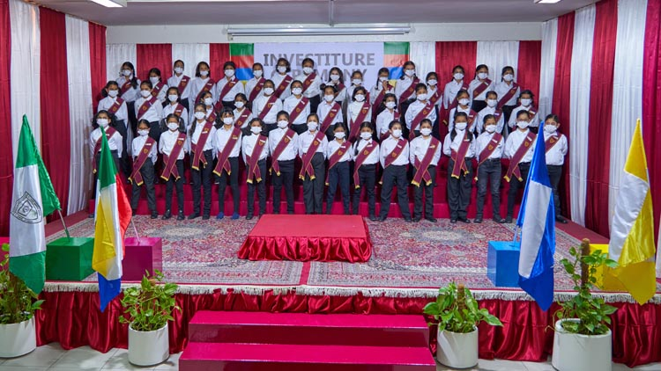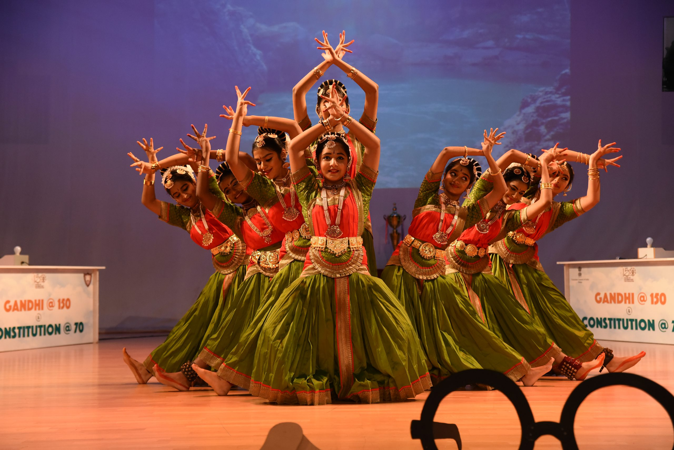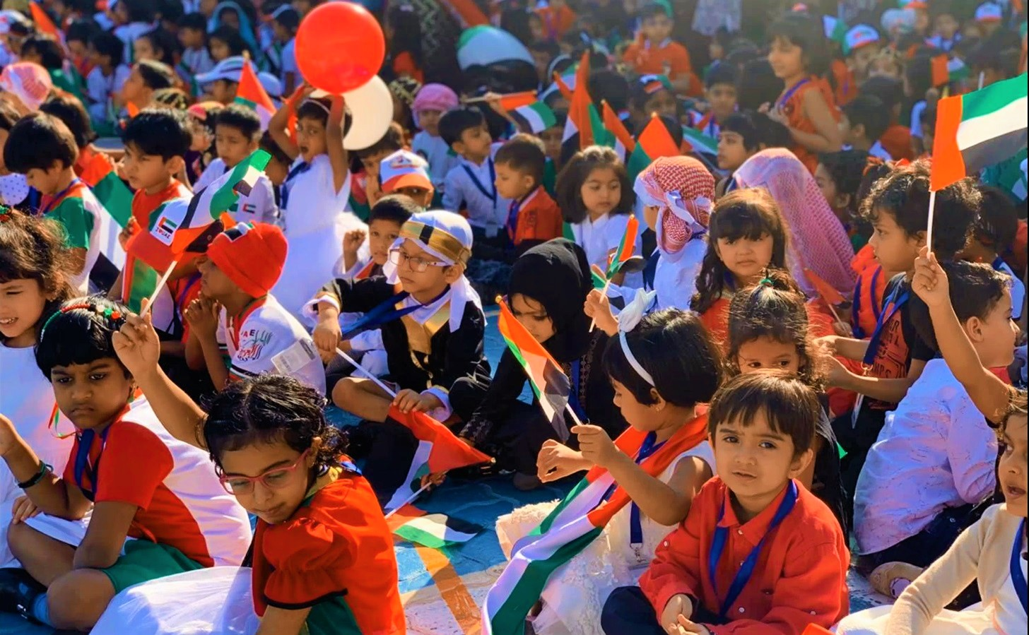

**School Introduction**

We proudly present The Indian High Group of Schools, Dubai - the pioneering Indian Curriculum School (CBSE) in the UAE that has successfully completed six decades of outstanding educational provision to thousands of expatriate Indians.

Established in 1961, in a small villa with five students, the school became the reason why the business community could keep their children in Dubai under the loving care of complete family units.

In subsequent years the school continued to grow and its oldest campus, in Oud Metha, was built on land generously donated by the late H.H Sheikh Rashid bin Saeed al Maktoum. Today, we are proud to have three campuses and a total student strength of 11. 500 students and are undoubtedly the first choice for expatriate Indians looking for the highest quality education that is international in its outlook while enriching the Indian cultural roots. Managed by a philanthropic Board of Trustees on a certified not- for- profit basis, the governing board leaves no stone unturned in providing the best and updated digital and conventional educational resources, competent and committed educators catering to both academic and pastoral needs and a nurturing environment with contemporary. This vision was not only well sustained but rather strengthened in the times of COVID, with the Oud Metha Campus receiving the highest rating of “Developed” in the Distance Learning Evaluation conducted by the KHDA in June 2020.

The Indian High School, Oud Metha campus – our oldest institution has many firsts to its credit- the highest rating of “Outstanding” by the Dubai Schools Inspection Bureau for six consecutive years – the only CBSE school to achieve this distinction - and the Sheikh Hamdan Award for Distinguished School and School Administration twice, to name some.

**Course Introduction**

A robust, rigorous, contemporary and comprehensive curriculum is the cornerstone of the educational experience at The Indian High School, Oud Metha. For six decades we have successfully and consistently kept the promise to parents spelt out in our Vision and Mission. Continually reviewed and updated, the curriculum prepares learners for the challenges of the world they will inherit. With provision of relevant and updated Knowledge, conscious and consistent development of Skill and a positive Attitude to achievement, what else can a learner ASK for?

Our curriculum, which is based on the CBSE and MOE guidelines, is all-inclusive. Led through the curriculum in a nurturing environment that caters to their unique needs, all learners are facilitated to realize their academic and social- emotional potential. With student wellbeing as our prime focus, there is a perfect balance between the curricular and co-curricular activities of the school. Careful and thoughtful planning ensures a smooth transition across all grades. A detailed and robust analysis of the external and internal assessments guides the modification of the curriculum as per the specific needs of our learners and provides them with the best learning experience.

21st Century Learning Skills particularly - Critical and Creative Thinking - and Problem Solving, prudent and relevant use of educational technology and Innovation are well embedded in the curriculum. We take care to stay well-informed about and integrate the latest developments in the field of education e.g. The National Education Policy and international best practices in teaching and learning.

Middle School:

The Middle School at IHS sees the students being readied to deal with the CBSE syllabus of Secondary and Senior Secondary, through our unique, customised curriculum for grades 1 to 8. Tremendous support and constant monitoring by our very competent teachers helps learners to work on their strengths and areas for improvement. Great emphasis is given to developing both academic and life skills in these formative years.

Secondary School:

The school strictly follows the CBSE curriculum from grade 9 to 12. As relevant, the ministry subjects like Arabic, Islamic Education, UAE Social Studies Studies and MEP are integrated. Optional, elective subjects like French, Computer Applications and Artificial Intelligence are offered from grade 8 upwards until grades 10/12 for the CBSE board examination.

Senior Secondary:

The Senior Secondary stage acquires a great significance as students diversify into elective subject choices based on their career and higher education plans future. A variety of subject combinations from 21 progressive subjects are offered at this level with due focus on career guidance and counselling sessions to keep them future ready.

# Jebel Ali School

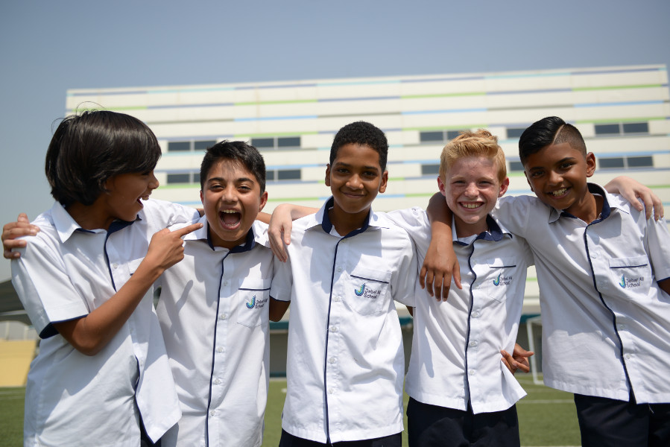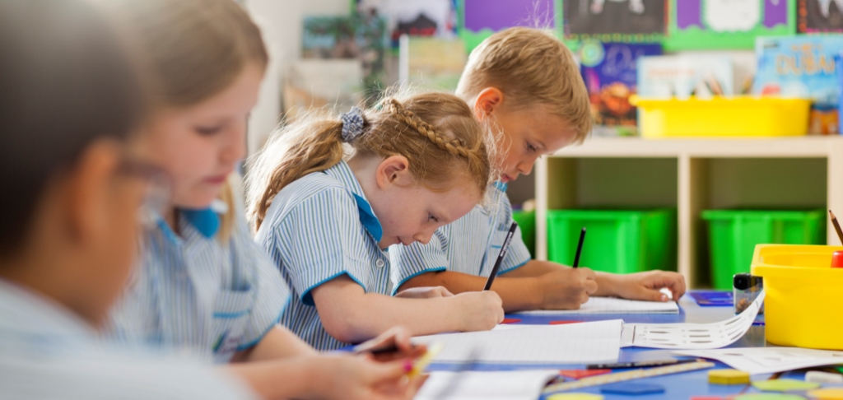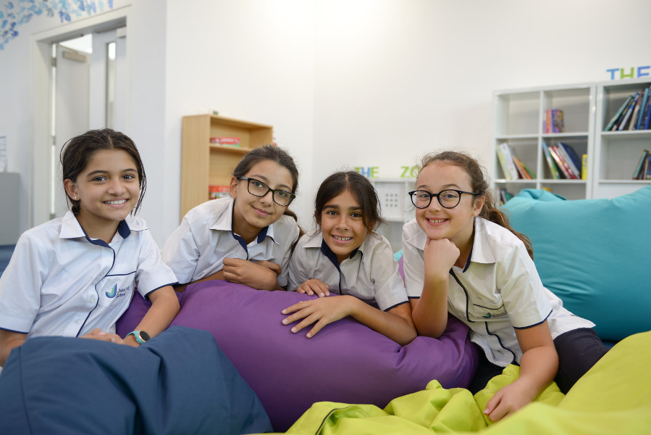

Jebel Ali School, which has been established for 42 years, ranks among the top five in the United Arab Emirates under the British A-level education system. The school covers all ages from kindergarten to high school, with students from 54 different nationalities. The annual tuition fee for 6 years of primary school is only 90000 RMB, leading many international schools in China in terms of educational environment, education level, and internationalization. However, the tuition fee is at least 30% lower than that in China, and it is also easier to apply for admission to world-class universities after graduation.

**School Introduction**

Jebel Ali School was founded in 1977 and has been committed to meeting the educational needs of children in Dubai for many years. Our school is a non-profit institution, so we do not aim to operate for profit, which makes us deeply proud. All of our income will be reinvested in education to enhance student welfare. Our school has excellent academic performance and students have consistently outperformed their peers in the UK.

**Principal's message**

"Our enabled reporting in Dubai is built on developing responsibility and caring for young people who have gained the confidence, skills, and knowledge to empower the joy - as well as manage the complexity - of the modern world."

Peter Hill

**Basic information**

Year of establishment: 1977

Teaching language: English

Religion: None

Nature: Non profit

Number of students: 1107

International student ratio: over 50%

Largest student group: UK

Dress code: School uniform

Geographical location: suburban areas of large cities

**Academic courses**

Course type: International A levels, International GCSE

Social science subjects:

PSHE (Personal Development, Social, Health, and Economics), History, Business Studies, Geography, Social Studies, Economics

Literature and Language Subjects: French, English, English (Literature), Spanish, Arabic

Mathematics subjects: Mathematics, Computer Science

Scientific subjects: Chemistry, Physics, Biology

**Sports projects**

Swimming, rugby, blue tennis, cross-country, football

**tuition**

Application fee: 500 dirhams

PK tuition fee: 44960 dirhams

K tuition fee: 44960 dirhams

1st grade tuition fee: 44960 dirhams

Tuition fee for 2nd grade: 44960 dirhams

3rd grade tuition fee: 44960 dirhams

4th grade tuition fee: 44960 dirhams

5th grade tuition fee: 44960 dirhams

6th grade tuition fee: 44960 dirhams

7th grade tuition fee: 79900 dirhams

8th grade tuition fee: 79900 dirhams

9th grade tuition fee: 79900 dirhams

10th grade tuition fee: 79900 dirhams

Tuition fee for 11th grade: 79900 dirhams

Tuition fee for 12th grade: 79900 dirhams

Tuition fee for 13th grade: 79900 dirhams

Refundable deposit: 60000 dirhams (priority admission) or 25000 dirhams (regular admission)

Scholarship: Provided

**Application Information**

Visa support: not provided

School start date: September

Other enrollment dates: enrollment at any time

Application deadline: Apply at any time

Grades accepting new students: PK~10, 12

Is admission based on academic performance: No

Admission waiting list: Usually there are

Application materials and requirements:

- Transcripts from the past two years

- Online assessment

- Passport scanned copy

# GEMS Our Own English High School

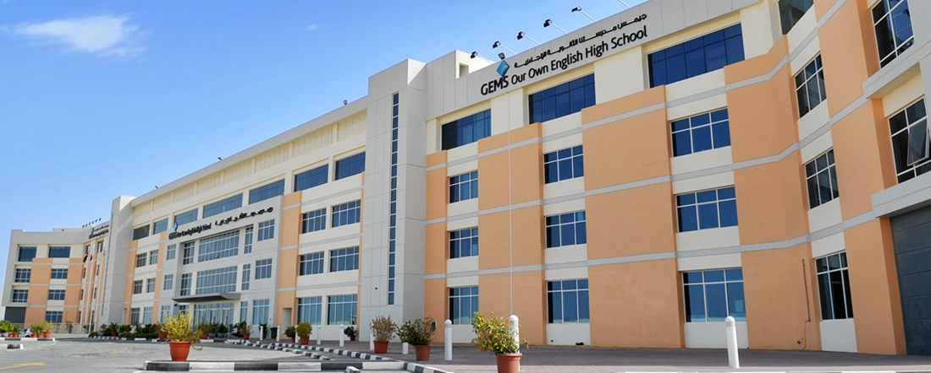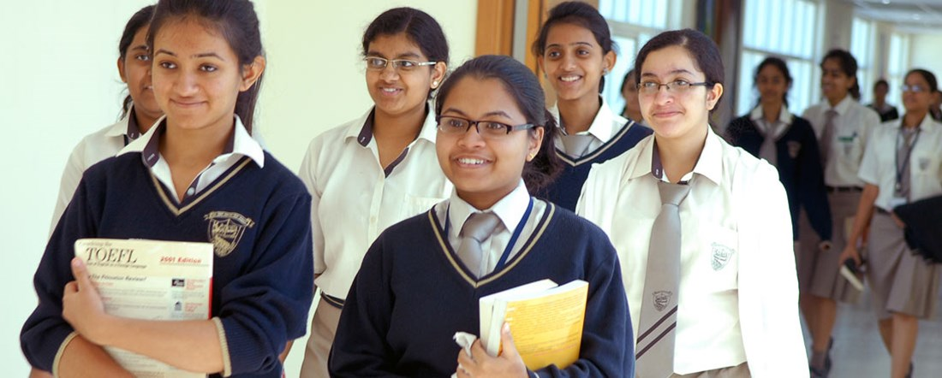

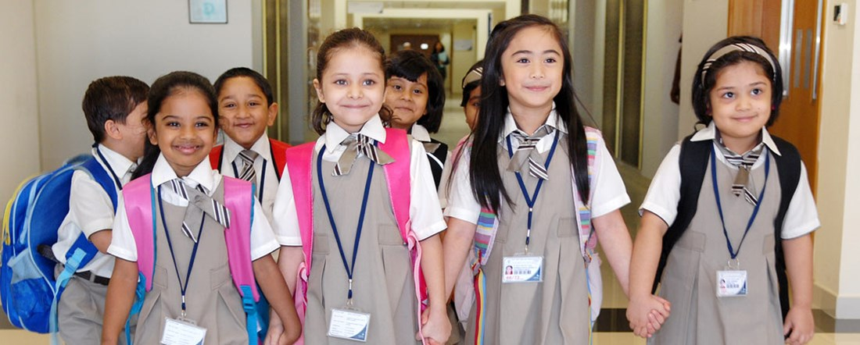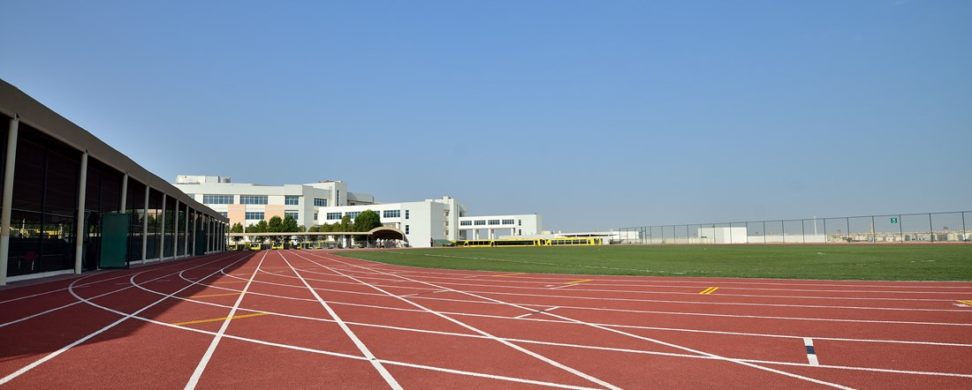

**School Introduction**

GEMS Our Own English School (OOD) is one of the oldest schools in the United Arab Emirates and a leader among many schools under GEMS. For nearly forty years, we have been providing high-quality education to students from all over the world. Although our school teaches Indian courses, it is an international school with students from over 20 different countries. We are proud to provide students with a comprehensive learning experience and cultivate them into outstanding individuals in various fields.

**Principal's message**

Head of School

"GEMS' Our Own 'is one of the oldest schools in the UAE and one of the largest girls' schools in the world."

Thomas Mathew

**Basic information**

Year of establishment: 1968

Teaching language: English

Nature: Profit making

Number of students: 10246

International student ratio: over 50%

Number of student countries of origin: 22

The largest student group: India

Dress code: School uniform

Geographical location: suburban areas of large cities

**Teaching quality**

Teacher student ratio: 1:22 UAE government rating: Very Good

**School culture**

Our students have lively thinking and strong curiosity, and our goal is to cultivate their enthusiasm for lifelong learning. We believe that everyone should receive the best education. We strive to create opportunities for students to shine in their chosen fields, respect each other's cultures and diversity, and lead others in creating a better world and future.

GEMS Education is a campus network consisting of over 100 schools in the Middle East, Europe, India, Africa, Southeast Asia, and the Americas. GEMS schools recruit over 9000 professional instructors, experts, and staff from around the world, providing high-quality comprehensive education to over 100000 students from 125 countries. From the first day children step into any GEMS school, you can see the surprises and surprises in their eyes. They were all amazed by the enthusiasm and vitality of the teachers, the unparalleled learning environment on campus, and so on. GEMS schools are excellent international schools that set a benchmark for today's high-quality education and shape future educational models.

**tuition**

Application fee: 500 dirhams

PK tuition fee: 7237 dirhams

K tuition fee: 7237 dirhams

1st grade tuition fee: 8862 dirhams

Tuition fee for 2nd grade: 8862 dirhams

3rd grade tuition fee: 8862 dirhams

4th grade tuition fee: 8914 dirhams

5th grade tuition fee: 8914 dirhams

6th grade tuition fee: 10068 dirhams

7th grade tuition fee: 10068 dirhams

8th grade tuition fee: 10068 dirhams

9th grade tuition fee: 12584 dirhams

10th grade tuition fee: 12584 dirhams

Tuition fee for 11th grade: 14684 dirhams

Tuition fee for 12th grade: 15313 dirhams

Scholarship: Provided

**Application Information**

Visa support: not provided

Grade for accepting new students: PK-12

Attention: Only PK-4 grade male students are admitted

Is admission based on academic performance: No

Application materials and requirements:

- Current year's transcript

- Passport scanned copy

Email: communication\_ood@gemsedu.com

Phone:+97142361335

Application webpage (in English): <http://www.gemsoo-dubai.com/admissions/>

# The Millenium School

Video Introduction

<http://www.themillenniumschools.com/sites/default/files/video/tms_about.mp4>

**School Introduction**

The Millennium Schools are a national chain of CBSE affiliated co-educational schools, powered by the Millennium Learning SystemTM . Our thought and philosophy is based on deep rooted Indian values and rich culture integrated with a global mindset. Our policies represent a vibrancy and sensitivity to the needs of all stake holders.

We aspire to equip our students with skills that will help them excel in life and prepare for their greater role of shaping the Indian Millennium tomorrow.

The Millennium Learning SystemTM is our distinctive pedagogy supported and directed by Research and Development wing of Education Quality Foundation of India,along with a team of distinguished teaching professionals.

From this mindscape, we endeavour to develop conscientious citizens. Citizens who are open-minded, innovative, creative, critical thinkers, self- disciplined yet energetic in thought and action.

**Teaching methods**

Well structured curriculum: The Millennium Schools follow the Millennium Learning SystemTM (MLS), a child –centric unique curriculum which adopts an innovative pedagogy to develop each child’s inherent potential. It’s aptly called the “Science of Education”. MLS is a science which enables an enriched learning environment to cater to the uniqueness in each child. The entire learning process is well phased out across four distinctive learning stages designed to help every child to realize his/her talent to the fullest. SmartclassTM Technology: SmartclassTM is a digital initiative by Educomp Solutions. This initiative endeavors to make available a vast resource of knowledge content to each class through an interactive multimedia Smart Board. Thereby, fostering a better understanding and igniting a curiosity and a joyous learning environment for the students. The entire content is mapped to the curriculum class-wise.

Brings abstract and difficult curriculum concepts to life.

Improves the teacher's effectiveness and productivity.

Makes learning an enjoyable experience for students.

Maximizes the academic performance of students.

Enables a constant monitoring of your child's progress in class.

Innovative textbooks: Over 22,000 pages of content have been developed into workbooks which are fun and facilitate learning through activities and games. These books are application-based and enable children to understand the world around them, with minimal assistance from the teacher. To ensure that the learning process is made a truly meaningful and holistic one, the children are introduced to each subject through a series of practical work and project work. Text books are linked to project files, making every concept relevant, practical and application based. This helps to make the process an experiential, enjoyable and memorable experience, ensuring that it is retained for life.

Scientific teaching methods: The objective is to teach children at their own natural pace. The facilitator approaches learning in a sequential manner from easy to difficult. This ensures that concept clarity leads to a strong base, before the child moves to the next higher level of learning.

The teaching methods adopted ensure that every child absorbs maximum new knowledge in a natural and effortless way. This enables slow learners to reach the requisite standards, whilst allowing the gifted children opportunities to constantly engage in challenging tasks of a higher order. Thus, an ambience of all-round joyous learning is created by using stimulating educational content.

Unique dictionary: Young learners are encouraged to improve and continuously add to their vocabulary at every step of the learning ladder. To aid memory, the Millennium Learning SystemTM uses a unique visual dictionary. This dictionary allows the recording and explanation of every word, a child is likely to come across in the educational environment.

Intuitive assessments: Daily creative assessments are integrated into every subject in order to better identify the strengths and limitations of each child. A specially designed program is used to interpret the data collected and the results are a part of the ongoing scientific assessment of the child. The analysis is further used to guide the children about their strengths and enable them in making future vocational choices.

**Curriculum**

While the Indian education system concentrates on loading as much information as possible in the minds of the students, it rarely enables the teachers to draw out their inherent potential. The change was needed to stop teachers from directing and feeding in answers in the minds of the learners; to bring about a paradigm shift by getting the teachers to become facilitators of knowledge; and to help the learners to extract solutions, question preset theories and be responsive and adaptable. Thus, a unique pedagogy had to be built to fulfill this vision and philosophy.

Another factor to be kept in mind is that children need to become equipped with 21st century skills, social and emotional skills while developing themselves in areas they have talent in. They need to be proficient in creative and critical thinking, analysis, reasoning, problem solving, synthesis, data handling, applying their learning, and presentation skills. They need the best pedagogic practices, the latest technological tools and liberation from the tyranny of rote learning.

At the end of the years of schooling, the confident and responsible person that needs to emerge out of the school system requires careful nurturing. Thus, the system needs to be given opportunities to build values unconsciously in the minds of the child so s/he becomes an asset to society and becomes a harbinger of progress.

To enable progressive and aware parents to provide such learning opportunities to their children, the Millennium Learning SystemTM was developed. Over the years, it has evolved and now is replete with a complete solution to each aspect of education, including content in various forms for children, facilitators and even for parents.

# Delhi Private School

Video Introduction

<https://dpsajman.com/school-tour/>

**Curriculam Overview**

At Delhi Private School, Ajman, educational excellence and commitment are of prime importance to a meaningful teaching and learning environment, where quality education is provided to each and every child. DPS believes that love for education should be developed in children during initial years within an environment radiating with positivity. The teacher is an inspirer, a team leader initiating work, nurturing students, guiding them to achieve milestones without the phobia of examinations and homework. Development of oral and written expression is emphasized upon for the intellectual growth of the students. Home assignments are not a carry-over of classwork but oriented towards honing individual talents. Delhi Private School, Ajman is affiliated with the Central Board of Secondary Education (CBSE), which is the largest educational board in India and is duly recognized by the Ministry of Education, Ajman. Currently the School has enrolled students from KG-1 to Grade 11. We follow the CBSE curriculum that advocates an inclusive education, which aims at bringing about a healthy shift from examination centered learning to holistic education. This approach is most advocated by the modern neuro-educationists engaged in educational research and development. It relates to hands on experience rather than the theoretical approach to teaching learning and lays a lot of emphasis on the importance of innovation in education in order to achieve academic excellence in conformity with psychological, pedagogical and social principles.

Kindergarten

The kindergarten curriculum is based on specific learning goals and the present needs of the children. We adapt approaches to foster learning across the curriculum, placing an emphasis on developing key skills, promoting inquiry based learning, and critical thinking.  
It is planned for different areas of learning, facilitating the children to develop at their own pace through differentiated and collaborative plans.  
It is child oriented, emphasizing learning through fun and enthusiasm. We firmly believe that the children need to be happy, if they are to learn.  
Therefore, our endeavour is to make learning interesting, enjoyable and fun.

Primary School

The primary school curriculum is to provide students with opportunities for personal and intellectual growth through speaking, listening, reading, viewing, writing, and representing to make meaning of their surrounding environment.  
The child completing primary school should be able to question, to investigate and make critical observations; he/she should be able to demonstrate responsibility towards the environment He/she should be culturally, aesthetically and spiritually aware and committed to social and moral principles.  
A well-defined curriculum is an effective tool to mould a child into an individual with desired qualities.  
In the primary section we ensure connectivity within the syllabus for the next consecutive class in order to do away with any stress due to the transformation from one class to the next. Approved scientific methods of teaching are incorporated in such a way that the skills to read and write become second nature without any undue pressure on the child. Art and craft, music, public speech, storytelling and flip teaching are integrated into the curriculum. They study English as their first language and Arabic as their third language. We offer five optional languages;French, Urdu, Tamil, Hindi and Malayalam from which our students can select any one as their second language for their secondary school years.  
We adopt a holistic approach to meet individual needs, developing skills for life. To procure the objective, we concentrate upon delivering skill based subjects like ICT and Life skills, Value based subjects like Islamic Studies, and Moral Science so that the children are able to communicate effectively and appropriately in real-life situations. They also inculcate human values like sympathy, empathy, honesty, kindness, respect etc.

Middle School

Our middle school curriculum includes a variety of learning approaches, along with multi-sensory and hands-on activities that appeal to the different learning styles. These activities ensure that students are presented with concepts in multiple ways to reinforce them, thereby leading its mastery.

Our curriculum focuses on four core subject areas: Languages, Math, Science and Social studies.  
We continue to lay emphasis on providing moral development to the students by offering subjects like Islamic Studies/ Moral Science beginning from their primary classes.  
As our curriculum reflects not only on the scholastic learning, we pay equal importance to co-scholastic learning and proficiency in co-curricular activities too.  
Hence grading of a student is based not only on their academic achievements but graded on their all-round development and thus prepare them to be strong and independent individuals, ready to face the challenging world.

Senior School

Our senior school curriculum is based on NCERT curriculum developing the minds of the teenagers with 21st century skills.

Focus is laid on character building, social and emotional learning, innovative practices and honing the inborn skills in curricular and co curricular arenas. Regular career orientations are held for students to develop the career competencies in children.

Inclusion of the vocational subject of Information Technology as the sixth subject provides students the requisite basic computer skills to adapt to the demands in the futuristic workforce.

# The Winchester School-DUBAI BRANCH

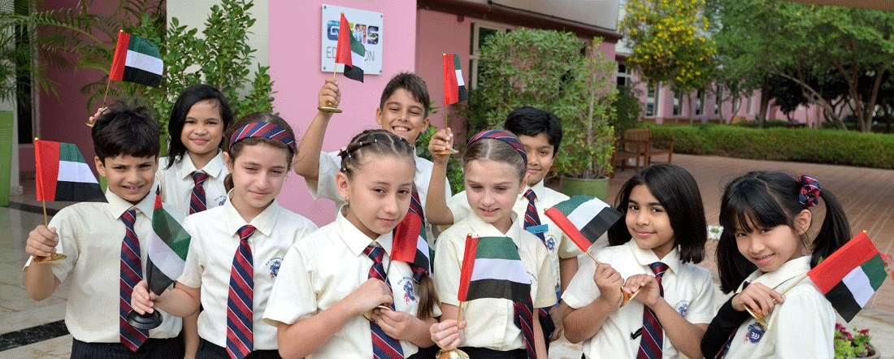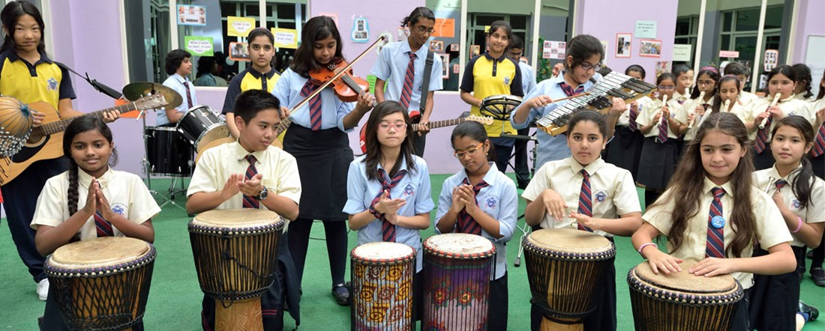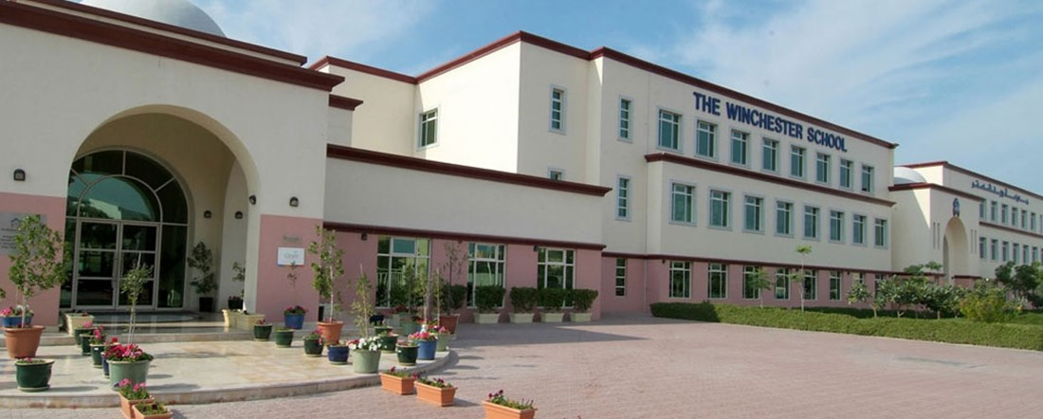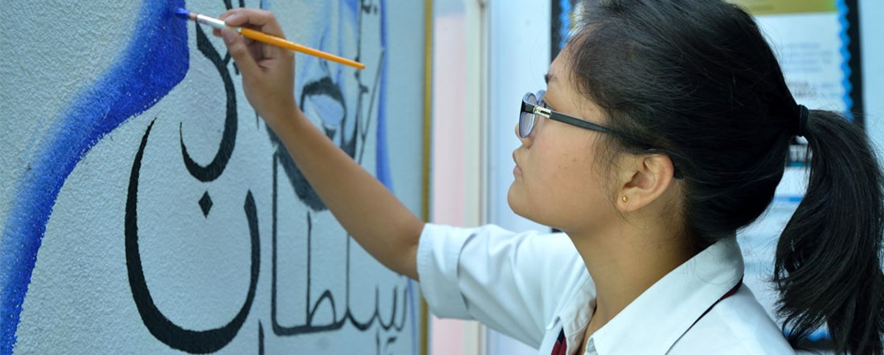

**School Introduction**

Dubai Winchester School is one of the most popular schools in Dubai and has been dedicated to teaching the UK national curriculum to students from around the world since 2003. Due to our advantageous geographical location, advanced teaching facilities, and reputation for high educational quality but affordable prices, our school is the preferred choice for many families. The children at Winchester School have unique personalities and are versatile, which is our source of inspiration and motivation.

**Principal's message**

Head of School

"The children of The Winchester School are a versatile talent and unique group of individuals, who are both a source of inspiration and motivation for us all."

Meenakshi Dahiya

**Basic information**

Year of establishment: 2003

Teaching language: English

Nature: Profit making

Number of students: 3826

International student ratio: over 50%

The largest student group: India

Dress code: School uniform

Geographical location: urban area of a large city

**Teaching quality**

Teacher student ratio: 1:17 International A level "National best": 4

International GCSE "Global Best": 1 International GCSE "National Best": 2

UAE government rating: Very Good

**Academic courses**

Course type: International A levels, International GCSE

Social science subjects:

Global perspectives, history, business studies, geography, psychology, tourism sociology, economics, communication and information technology

Literature and Language Subjects:

French, English (literature), Arabic

Mathematics subjects:

Accounting, Mathematics, Computer Science

Science subjects:

Chemistry, Physics, Biology

**Sports projects**

Gymnastics, volleyball, cricket, athletics, karate, basketball, tennis, badminton, football

Student organizations and clubs

STEM Public Speech, Entrepreneurship, Foreign Language, Religious Film and Television Production, Drama, Mathematics, Science, Poetry Appreciation and Debate Society

**School culture**

Dubai Winchester School has created a warm, inclusive, and conducive learning environment for students, aiming to cultivate them into lifelong learners and confident, independent, progressive, and skilled world citizens. Our mission is to create opportunities for students to exercise their innovative, independent, and analytical thinking; Guide students to become future citizens with strong adaptability, confidence, and potential to become world leaders; Cultivate students' love for learning through various experiences in a loving and inspiring environment.

GEMS Education is a campus network consisting of over 100 schools in the Middle East, Europe, India, Africa, Southeast Asia, and the Americas. GEMS schools recruit over 9000 professional instructors, experts, and staff from around the world, providing high-quality comprehensive education to over 100000 students from 125 countries. From the first day children step into any GEMS school, you can see the surprises and surprises in their eyes. They were all amazed by the enthusiasm and vitality of the teachers, the unparalleled learning environment on campus, and so on. GEMS schools are excellent international schools that set a benchmark for today's high-quality education and shape future educational models.

# GEMS Wellington Academy -Fze

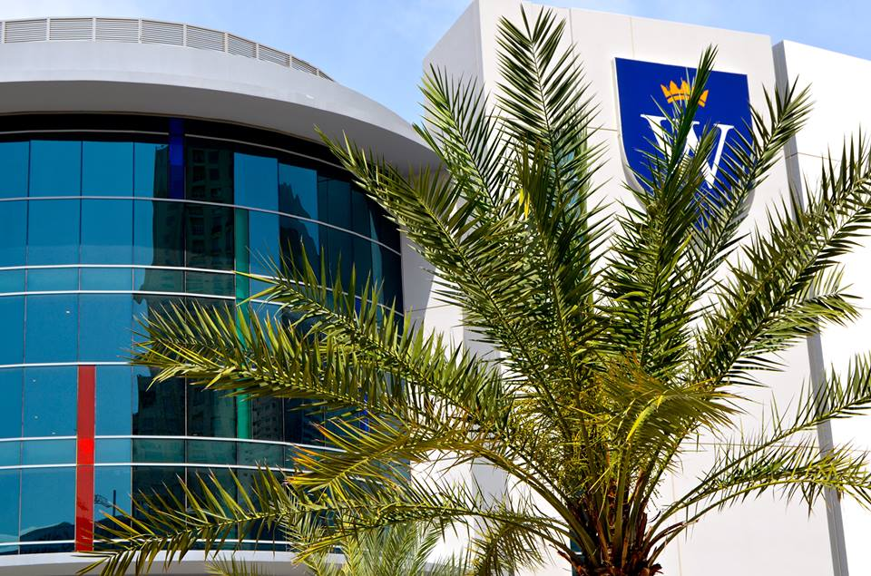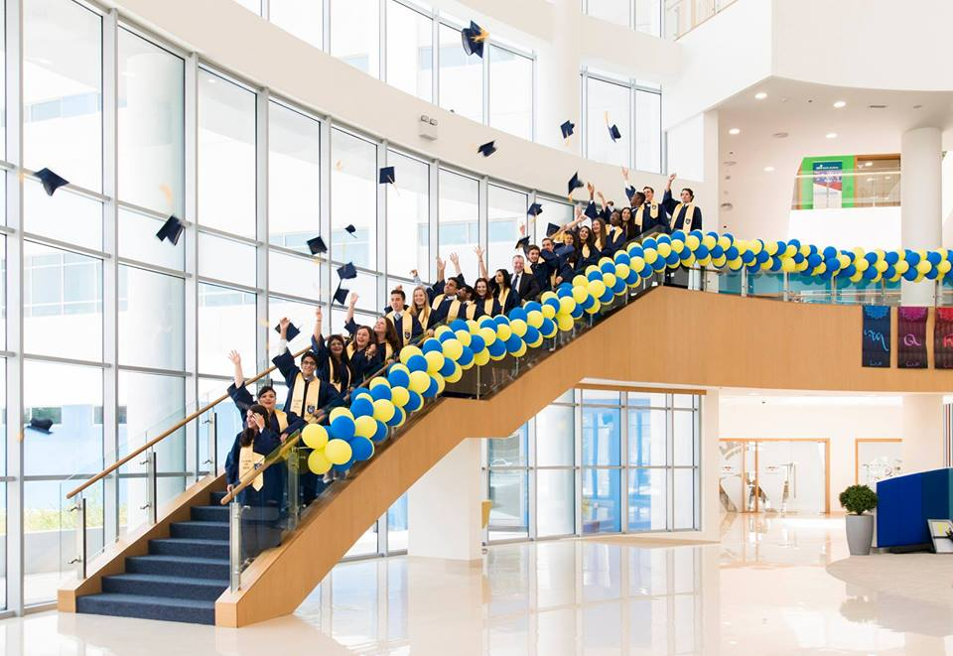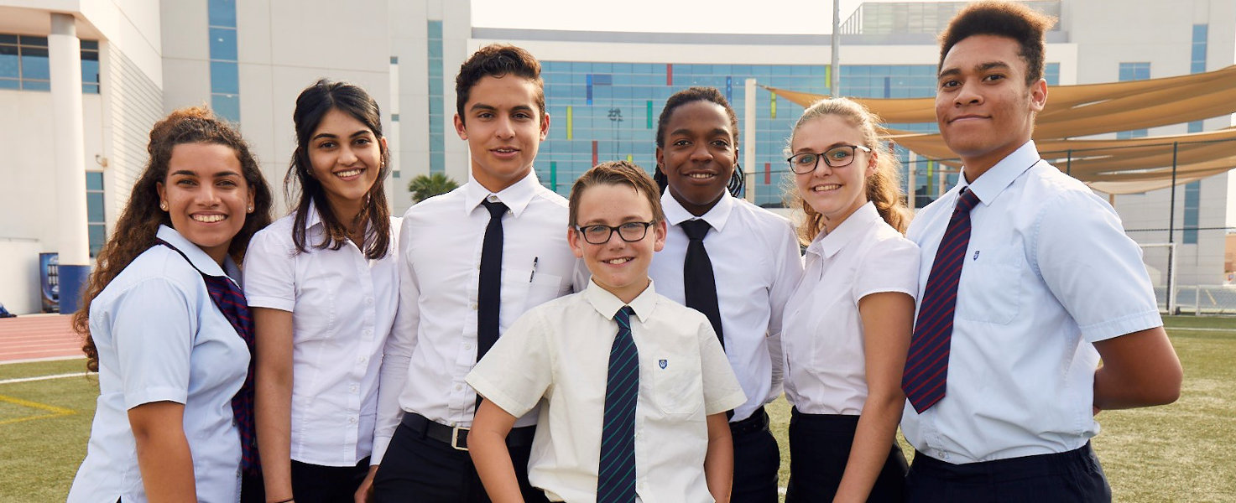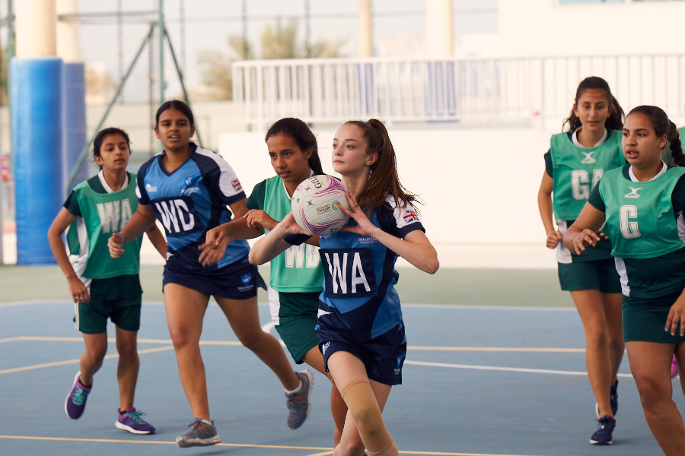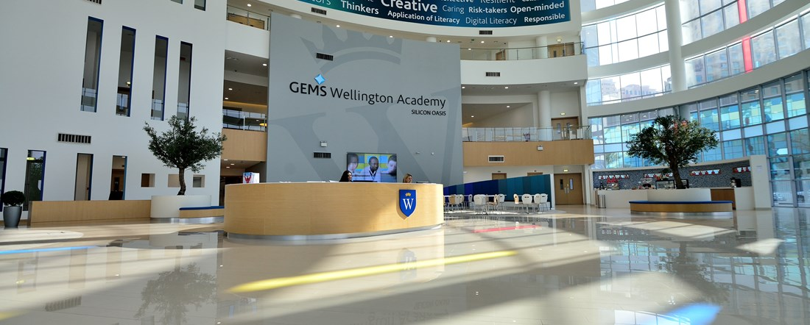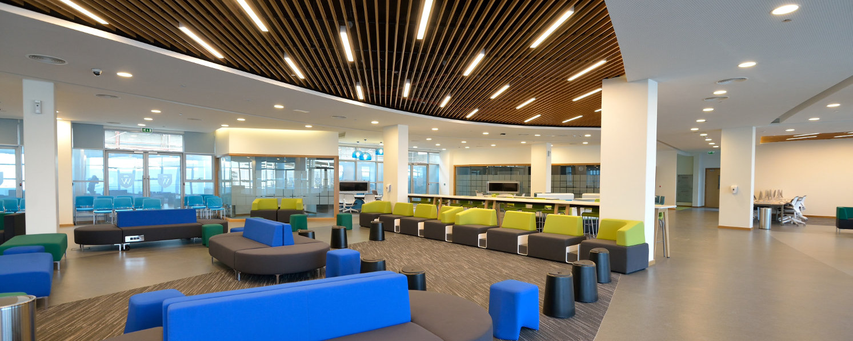

GEMS Wellington Academy (Silicon Valley Oasis Campus) is a world-class British curriculum school and a unique place where every child is told a unique and unique story.

The school attaches great importance to the uniqueness of children, explores their imagination, encourages them to unleash various talents, and cultivates healthy, confident, and independent personalities.

The school offers a rich range of British national courses, which are constantly evolving based on educational background and local conditions, providing comprehensive coverage of personalized qualification education from the early basic stage to after the age of sixteen, including IGCSE, GCSE, IB, A 'Level, and BTEC. It also closely integrates early basic courses with higher-level courses, emphasizing inter stage connections and the integrity of the overall curriculum, aiming to cultivate a spirit of cooperation, tolerance, and mutual respect among students, while encouraging them to feel their unique values.

The school also provides world-class facilities, emphasizing blended learning and integrating technology into the curriculum to align with the college's educational philosophy and vision.

**Curriculum system**

WSO's curriculum is a unique one that adheres to educational values of inclusiveness, excellence, growth through learning, and learning through innovation.

Starting from the early foundational stage, through a rich English national curriculum, enter personalized education that includes IGCSE and GCSE, and continuing education after the age of sixteen, including IB diploma courses, IB vocational courses, A 'Level, and BTEC, laying the foundation for children's future career paths.

In addition to a wide range of subjects taught by high-quality professional teachers, WSO courses also offer innovative curriculum design, focusing on providing a rich learning environment and resources, and developing students' learning skills and abilities

Curriculum System - Nursery Stage

The school combines the Early Foundation Stage Curriculum (EYFS) in the UK with the Reggio Emilia method to provide children with a comprehensive learning experience. We follow a child centered approach, viewing children from a holistic perspective, and making their needs, interests, and learning styles the core of our teaching.

A favorable learning environment

The learning experience will be integrated into indoor, outdoor, and sensory exploration areas. Provide children with a space for exploration, creation, and participation, while also providing rich sensory experiences.

Self expression

Respect children's personal interests, actively respond to their choices, and encourage them to transform their ideas into multiple perspectives.

Relax the mind

Children will develop skills in mindfulness, regulate their thoughts and feelings, enhance their adaptability, and provide strategies to control their feelings and behaviors.

A healthy body

Dance, yoga, motor skills, and water exploration can cultivate children's fine and unified motor skills, as well as independence and self-expression abilities. Children will understand the importance of caring about fitness and health.

Growth in the game

Practicing real-life scenarios and activities, cultivating independence, self-awareness, and confidence, children participate in everything from cooking to daily challenges, as well as other elements of the adult world.

Entering nature

Understand the natural environment and its sustainability, learn and appreciate life and its cycles.

Language learning period

In early childhood, the language center system of the brain grows rapidly, cultivating children's language and cultural knowledge in English, Arabic, and French through participation and active language courses.

Curriculum System - Basic Stage

The basic stage follows the early basic stage curriculum in the UK, laying a solid foundation for each child's WSO learning journey. The EYFS course is divided into seven areas of learning and development.

These fields are crucial for stimulating children's curiosity about the world around them, cultivating their learning abilities, establishing positive interpersonal relationships, and thriving in their early years. Specifically, it involves literacy, mathematics, understanding the world, and expressing art and design, cultivating the basic skills and knowledge that students need to learn from primary school to higher grades.

The teaching method in this stage is based on three characteristics of effective learning: play and exploration, active learning, creativity, and critical thinking. Teachers create an inspiring, creative, and fun classroom environment where children learn through games and child led experiences. Children truly love learning and have a passion for it. Teachers carefully plan and prepare activities that can inspire and inspire children to participate. Through personalized learning, each child can make rapid progress in seven learning areas. Children also have abundant opportunities to develop a range of skills in professional courses, including Arabic, French, performing arts, sports, and outdoor learning. In addition, the school will organize various activities to guide children to perceive, learn, and appreciate the diverse cultures within the school and the local culture of the United Arab Emirates.

In addition, the school's "Little Falcon Program" provides free after-school care services.

Curriculum System - Primary School Stage

The school carefully designs learning activities to provide students with a unique learning experience, requiring them to actively participate through problem-solving, collaboration, and higher-order thinking; Cultivate independent and resilient learners who can learn independently, maintain curiosity, and be responsible. Cultivate children's enthusiasm and curiosity for learning and personal growth, and cultivate their enthusiasm for learning. We no longer focus on the question of "What do our students need to know to succeed in the future?", but on "What kind of people do our students need to become?".

The national curriculum for primary schools in the UK is divided into two key stages: Key Stage 1 (first and second years) and Key Stage 2 (third, fourth, fifth, and sixth years).

The WSO curriculum integrates the UK national curriculum and the UAE Ministry of Education curriculum, allowing students to establish connections between different concepts, subject areas, and previous learning experiences. The core courses in primary school include English, mathematics, science, Arabic (expert), Arabic B (expert), Islam (expert), social research, and moral education. The core subjects form the foundation of all other subjects and are subject to more formal evaluations every year. Additional subjects place greater emphasis on the practicality of learning, emphasizing students' independent exploration. Through projects, knowledge and practice are combined and applied to daily life. Additional subjects include Geography, History, Design and Technology, Art and Design, Computing, Sports (Specialized), Performing Arts (Specialized), Outdoor Learning (Expert), and MFL (Expert). In addition to basic courses, the school also provides comprehensive and diverse extracurricular activities to promote the comprehensive development of students.

Curriculum System - Middle School Stage

Every child's story is worth investing energy and resources into. The school provides students with a wide and balanced curriculum, enabling them to adapt to life outside the campus in the 21st century.

The school is committed to increasing children's knowledge, skills, experience, and imagination, thereby increasing their understanding and identification with moral values, improving their ability to discover joy in life, gaining as much independence as possible, and becoming active participants and responsible contributors to society. And the education provided by the school can ensure admission to higher education or employment after the age of 16.

The school firmly believes that learning is related, interconnected, collaborative, independent, constantly innovative, continuously evaluated, and combined with moral education and sports. The curriculum is not only about imparting knowledge, but also encourages our students to develop their learning abilities and solve problems on their own. The school encourages and cultivates independent, curious, and resilient young thinking, and cultivates students to become eloquent, knowledgeable, and responsible global citizens.

The middle school stage includes key stages 3 for grades 7 and 8, and key stages 4 for grades 9-11.

The core courses of Key Stage 3 include Science, Arabic, Islamic Studies (limited to Muslim students only), Modern Foreign Languages, UAE Social Studies, Moral Education, and some other foundational courses, as shown in the table below:

C=Core subject

English (Chinese)

Mathematics (C)

Science (C)

Arabic A/B (C)

Islamic Studies A/B (C) - Muslim Studies Only

Modern Foreign Language (C)

living

computer science

Art

design technique

music

drama

polyethylene

UAE Social Studies (C)

Moral Education (C)

9th grade students have embarked on the next stage of their educational journey. The Key Stage 4 course consists of compulsory and elective courses.

The required subjects include:

GCSE English Language and English Literature

GCSE Mathematics

GCSE Science

sports

social research

moral education

Arabic (mandatory for all 9th grade students, Arabic)

Islamic Studies (Muslim Students)

Boyu A students are required to complete up to 11th grade

The elective subjects are (students choose four):

Art

computer science

Information and communication technology

music

Business research

economics

drama

dance

history

polyethylene

geography

psychology

Advanced Mathematics (students are selected by the head of the mathematics department)

Media research

Canadian Tourism and Tourism

musical skill

Arabic/MFL: All Arabic A students will learn Arabic AGCSE; All of its

His students select from French, German, and Spanish

In addition, throughout the entire middle school period, students also engage in a series of other activities to encourage independent thinking and develop skills. Performance groups including sports and arts, participating in the Duke of Edinburgh Award, participating in the Global Innovation Challenge, skiing at Dubai Ski Resort, sustainable cooking in gardens, excavating prehistoric creatures at archaeological clubs, volunteering at local dog shelters and camel rescue centers, as well as specific subject clubs, cash clubs (learning stocks and stocks), 3D modeling and printing, volunteering, photography, and Muay Thai, among others.

Curriculum System - After the Age of 16

The school continues to provide more Post-16 pathways. Students can not only choose from the following four "traditional" approaches: IBDP, IBCP, BTEC, or A-Level, but also have the opportunity to independently choose combinations, choose their own future, and meet their needs and desires in rigor, balance, and academic aspects. For example, a creative media student is learning BTEC media, IB visual arts, and A-level photography.

Students also have the opportunity to achieve comprehensive development and practice happiness and self-awareness through the school's carefully designed GroWell program. The GroWell project provides students with the opportunity to develop their personal and interpersonal skills, and is also the initial pathway for students to start college applications.

The school also has specialized vocational and higher education consultants to assist and support students in completing the university application process.

**tuition**

Application fee: 500 dirhams

PK tuition fee: 37296 dirhams

K tuition fee: 46319 dirhams

First grade tuition fee: 46319 dirhams

Tuition fee for 2nd grade: 46319 dirhams

3rd grade tuition fee: 46319 dirhams

4th grade tuition fee: 46319 dirhams

5th grade tuition fee: 46319 dirhams

6th grade tuition fee: 46319 dirhams

7th grade tuition fee: 73080 dirhams

8th grade tuition fee: 73080 dirhams

9th grade tuition fee: 73080 dirhams

10th grade tuition fee: 75438 dirhams

Tuition fee for 11th grade: 75438 dirhams

Tuition fee for 12th grade: 82511 dirhams

Tuition fee for 13th grade: 82511 dirhams

Scholarship: Provided

# Uptown International School

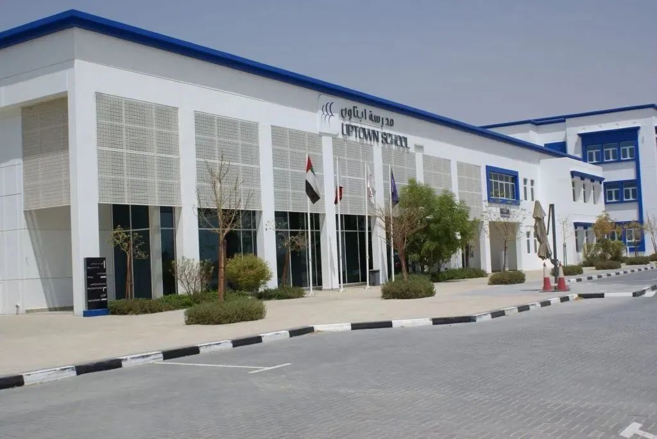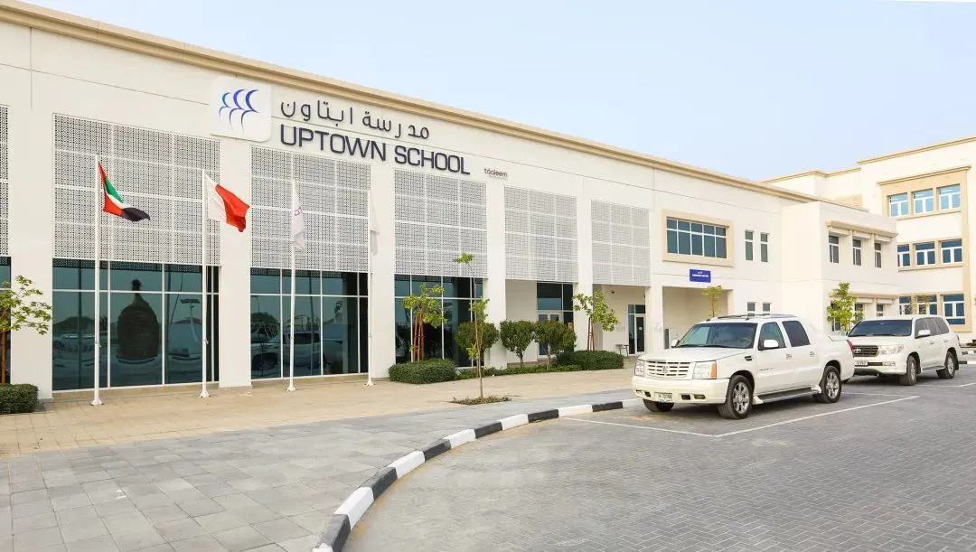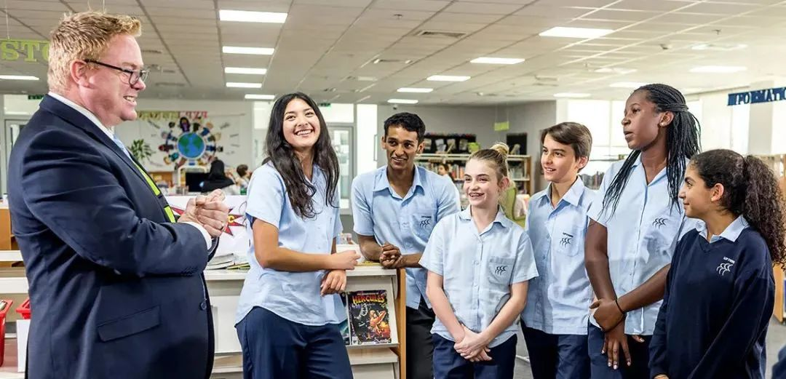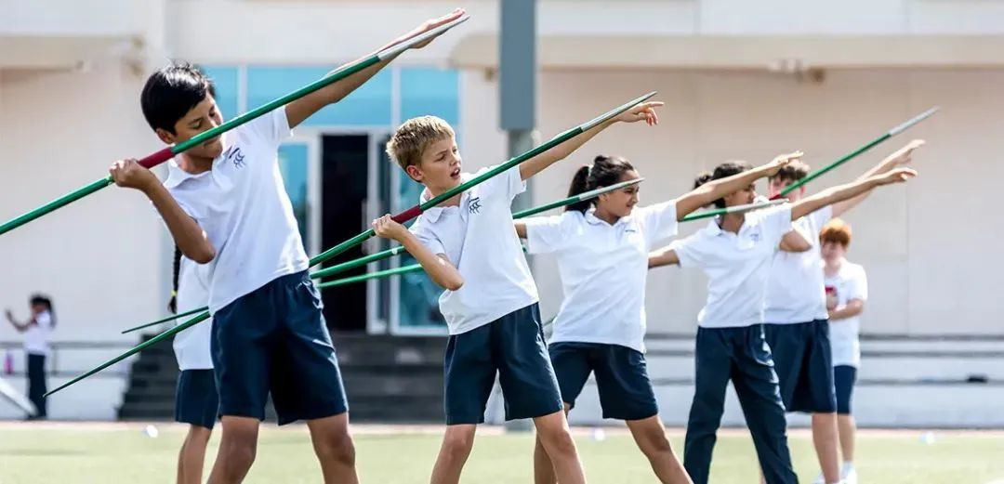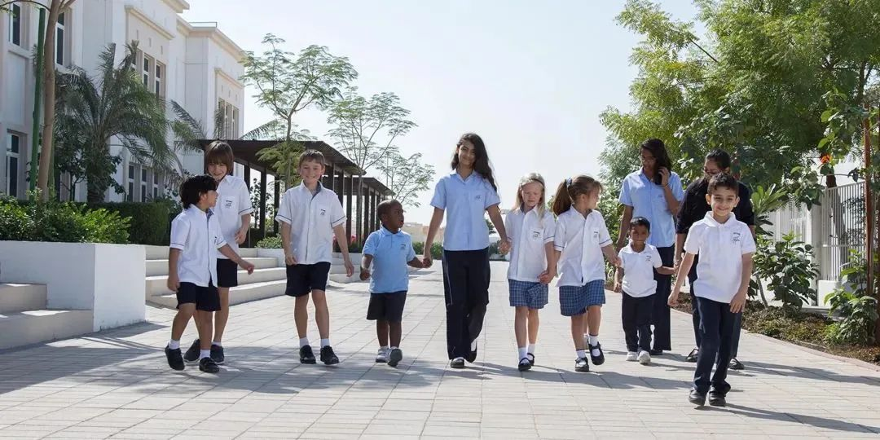

Enrollment grade: Nursery to 12th grade

KDHA ranking: Very Good

IB exam pass rate: 100%

Tuition fee: AED 29660- AED 74675

Address: Mirdif Area, Tripoli Street, Algeria St, Dubai

**Principal's words**

Uptown International School (UIS) is a school under the Taaleem Education Group and one of the best IB schools in the UAE. UIS is located in Mirdif, Dubai, and is a place where students learn how to think critically, challenge assumptions, stand out, shape character, build lifelong friendships, and become global multilingual citizens. We have a magnificent campus and first-class facilities. We have world-class courses and a true ambition to change our lives and the world we live in. What sets Uptown International School apart is our students. They are adventurous people who know they can learn from their mistakes and that through perseverance and resilience, they can achieve their dreams. We offer three international diploma courses: primary school curriculum (PYP), secondary school curriculum (MYP), and diploma curriculum (DP), providing a seamless educational experience for students aged 3 to 18. The core concept of these projects is to cultivate students with an international perspective, enabling them to learn how to become better people and learners.

**School Introduction**

Uptown International School is affiliated with the Talim Group and is one of the best schools in the United Arab Emirates. Located in the core area of Mirdif, the campus has a variety of activity facilities, including science laboratories, libraries, ITC, swimming pools, and self-service restaurants. UIS teaches students how to think dialectically, enrich their imagination, develop good personalities, establish lifelong friendships, and face various challenges of the 21st century. The school adopts an IB curriculum system, admitting children aged three to eighteen, and provides a seamless IB curriculum: primary school curriculum (PYP), secondary school curriculum (MYP), and diploma curriculum (DP). These courses focus on aligning children with international standards, making them better learners and embarking on the path to world-class universities. The main driving force for achieving a successful school is the teaching staff. UIS teachers help children depict the shape of their dreams, enabling them to live and learn confidently, and guiding them to learn self-directed learning.

As the second largest early childhood and primary and secondary education group in the United Arab Emirates, Talim has been committed to:

·Enable children to fully possess the ability to compete globally in all aspects of skills, knowledge, and personality

·Provide comprehensive international leading courses

·Design, manage, and optimize teaching equipment

·Create and implement benchmark teaching plans

·Cultivate and support educational talents through the appeal, knowledge, and development of the best educators

·Continuously evaluating and improving the teaching capabilities of its schools

·Make each school the cornerstone of local education

**Curriculum system**

UIS adopts the IB (International Baccalaureate) curriculum system, providing three stages of IB curriculum: primary school curriculum (PYP), secondary school curriculum (MYP), and diploma curriculum (DP).

How does IB define "international education"?

① Cultivate "world citizens" in terms of culture, language, and learning to coexist peacefully with others

② Establishing and strengthening awareness of student identity and culture

③ Cultivate students' understanding of common human values

④ Stimulate students' curiosity and desire for exploration to promote their spirit of exploration and enjoyment of learning

⑤ Enable students to have the ability to learn and acquire knowledge, whether through self-directed learning or collaborative collaboration, so that they can apply these skills in various learning areas

⑥ Provide international bibliographies for learning in various regions

⑦ Encourage diverse and flexible teaching techniques

⑧ Provide international benchmarks and evaluation forms

All courses are based on a unified IB study document, which includes various aspects such as personal abilities and sense of responsibility, in addition to academic aspects. The IB study document is committed to helping students learn to respect themselves, others, and the world.

**tuition**

Application fee: 525 dirhams

PK tuition fee: 52190 dirhams

K tuition fee: 52190 dirhams

First grade tuition fee: 57500 dirhams

Tuition fee for 2nd grade: 57500 dirhams

3rd grade tuition fee: 57500 dirhams

4th grade tuition fee: 57500 dirhams

5th grade tuition fee: 57500 dirhams

6th grade tuition fee: 67500 dirhams

7th grade tuition fee: 67500 dirhams

8th grade tuition fee: 67500 dirhams

9th grade tuition fee: 67500 dirhams

10th grade tuition fee: 67500 dirhams

Tuition fee for 11th grade: 72500 dirhams

Tuition fee for 12th grade: 72500 dirhams

# GEMS World Academy

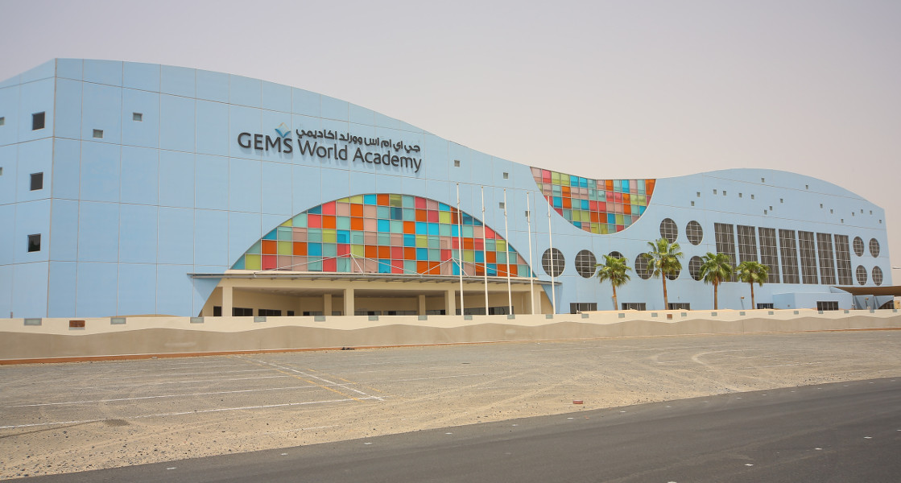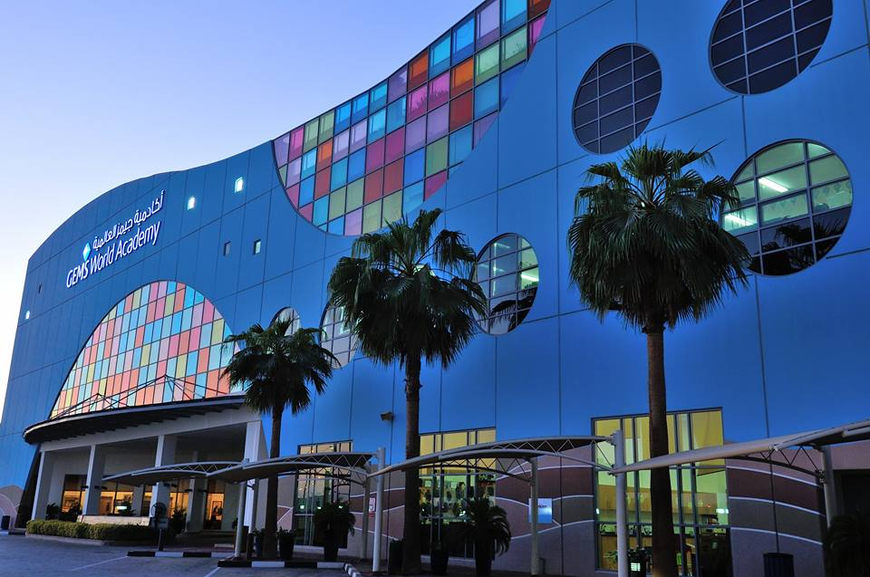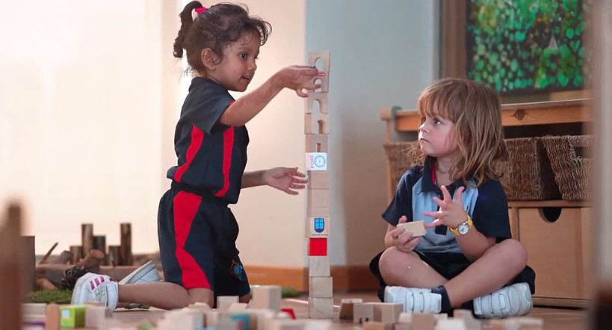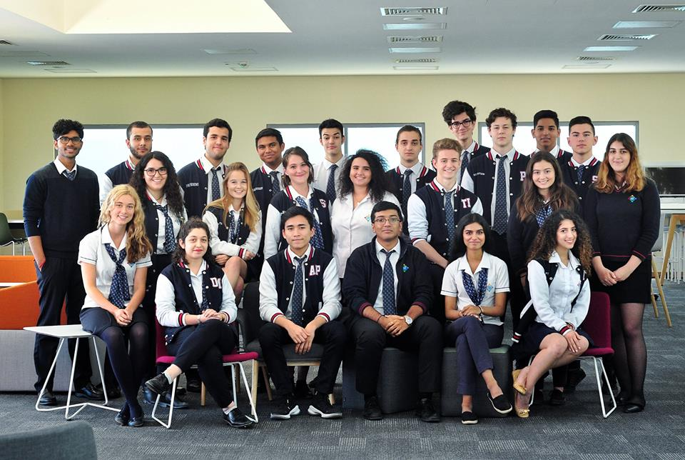

School system: IB system

Current rating: Very Good

Enrollment grade: PreKG-G12

Address: AI Barsha South, Dubai, UAE

GEMS World Academy Dubai (GWA) is a truly international school. Since the start of enrollment in 2008, the school has grown into an international college belonging to young world citizens, where students can benefit immensely from education that surpasses any other country's curriculum. Our school has about 2000 students from 85 countries. The multicultural community provides us with the opportunity to understand the differences between people, and as the world becomes increasingly interconnected, we will also respect each other's commonalities more.

GWA students love to explore, think hard, and have love. By studying rigorous IB courses, they acquire knowledge, learn skills, develop excellent character, and have the ability to take action to create a better and more peaceful world. Our school has a high-quality teaching team and world-class teaching facilities, encouraging a diverse international community to promote cross-cultural understanding and respect.

At GEMS World Academy Dubai, we offer award-winning education. We have great aspirations and aspirations for every student, and our commitment to their success is combined with excellent pastoral support to ensure that students always feel safe, secure, and successful.

Our students have developed a passion for learning and the ability to think independently. We have a good academic success record, which is reflected in our excellent IB grades. Adhering to the goals of our founder, Mr. Sunny Varkey, we encourage a thirst for knowledge and entrepreneurial spirit, and cultivate a true sense of collaborative effort.

We are an inclusive, positive, motivating, demanding, and open-minded community. We enable students to discover true interests outside of the classroom and express themselves through encouraging a broad understanding of the world, social conscience, and thoughtful treatment of others. We strive to ensure that students at GEMS World Academy Dubai understand their position in the local and global society, and always seek to have a positive impact on them.

We try, we demand, we persist. GEMS World Academy - Dubai is a place with high expectations, ambition, and extensive knowledge, where manners and manners are crucial. GEMS World Academy - Dubai is a place where hard work and a sincere commitment to achieving goals will create a path to success.

**School advantages**

As an IB World Academy, students are surrounded by international learning opportunities every day. The experienced and caring educators at this school ensure that every child is happy and prepared for tomorrow's world.

01

IB course

The school's tailor-made IB integrated curriculum creates a unique experience for each child, extending the academic rigor of the IB curriculum beyond the classroom and preparing students for life after graduation at GEMS World Academy Dubai.

GEMS World Academy - Dubai believes that the International Baccalaureate program is the best educational experience today. It is the gold standard for international education and has been proven to provide the best preparation for the most competitive universities and other institutions. However, the most unique aspect of IB is that it is not just a qualification; This is a broad and coherent educational vision supported by a clearly defined set of values, making our students and faculty global leaders. The IB of the college provides our students with a unique educational experience. It allows students to learn a wide range of subjects and gain various experiences, while giving them the freedom and opportunity to choose the subjects they wish to delve deeper into. Students have the opportunity to develop their professional knowledge and skills in the topics they are most interested in. IB also provides teachers with opportunities to discuss topics and issues of interest to students. IB students have also developed the ability to embrace interdisciplinary new ideas throughout their lives. We are authorized to offer PYP, MYP, DP, and CP courses and have been recognized by the International School Council and the New England Association of Schools and Colleges.

All courses in the school are guided by the philosophy and framework of IB. Through the IB core curriculum, we offer volunteer service, critical thinking, and reflection programs to help students develop skills and experiences beyond their academic qualifications. A decisive feature of the GEMS World Academy spirit - Dubai is a fully inclusive community with excellent academic performance, with annual IB diploma course grades significantly higher than the world and UAE averages. We are the most powerful mathematics school in the United Arab Emirates. Our graduates are admitted to top universities in the world, and our students often take the podium in innovation and entrepreneurship challenges.

02

Entrepreneurship, Innovation, and Social Impact

As the core of Dubai GEMS World Academy, our mission is to cultivate diligent, reflective, and compassionate leaders who will graduate from our college with the knowledge, skills, and character to take action and create a better and more peaceful world.

In today's constantly changing world, our role is to prepare our students for the world that awaits them. In tomorrow's world, students are more likely to create their own job opportunities because 65% of the jobs they will engage in do not exist today. We cannot prepare them for work that does not yet exist, so we are here to prepare them to remain agile and adaptable in the face of profound changes.

03

languages institute

GEMS World Academy - Dubai Language Institute offers the largest mother tongue course among all schools in the United Arab Emirates.

Cross cultural understanding involves recognizing and reflecting on one's own views as well as those of others. In our highly diverse international community, learning another language and preserving and understanding one's mother tongue are crucial.

The language school of the college enables us to impart cross-cultural understanding and respect to students from over 90 countries. Multilingual opportunities can enhance critical thinking skills, allowing students to interact and understand the world as global citizens.

04

University Purpose

We have dedicated universities and career counseling centers on campus to create personal pathways for students and connect them with top universities and businesses.

Our students continue to study at some of the world's leading universities, with over 60% of IBDP students being admitted to the top 50 universities in QS World Rankings. This includes the University of Cambridge, Yale University, Oxford University, Princeton University, London School of Economics, Australian National University, University of Edinburgh, New York University, Durham University, and McGill University. All GEMS World Academy Dubai students are admitted to one or more of the top three universities they have chosen.

05

Enrichment and opportunities

Enriching experiences for all age groups

GEMS World Academy- Dubai has a comprehensive and proactive enrichment program that offers a range of activities to ensure that every child is inspired and enriched, whether they are athletic, musical, dramatic, thoughtful, competitive, curious, caring, or creative. We encourage students of all ages to sign up for a variety of exciting and challenging activities. This project is diverse and offers opportunities across multiple disciplines, including music, performing arts, sports, science, language, and public speaking.

Beyond the classroom

Our diverse opportunities can be divided into the following categories: clubs and committees, performing and expressive arts, sports, language, entrepreneurship, innovation and social influence, travel and activities, and genius methods: leadership and volunteering. We offer opportunities in all three semesters of each academic year, with some clubs offering them annually and others offering them on a per semester basis. The vast majority of expansion opportunities are free, but some may require additional fees to cover professional materials or external tuition fees (such as skiing and golf).

It is not uncommon for students to develop sustained interest and enthusiasm for their activities, and many continue to reach higher levels of progress both inside and outside the classroom. Therefore, our rich curriculum has made an important contribution to the comprehensive education provided by the college.

Rich opportunities

The activities will be held on campus during pre school, primary and secondary school lunchtime, and after school from 3:15 pm to 4:15 pm. This rich program has been tailored to ensure compliance with the health and safety guidelines established by KHDA and Dubai authorities.

**Course settings**

01

Nursery

GEMS World Academy - Dubai Kindergarten provides Reggio inspired courses for children aged 2 and 3, starting from the age of 3 and entering the IB program.

02

Early Childhood Plan

The early childhood plan is an inquiry based development plan that can meet the individual needs of different groups of learners aged two and a half to six and a half.

We believe that every child is endowed with their unique talents, talents, learning methods, and preferences, and we are committed to investing in realizing their potential to make them passionate problem solvers and lifelong learners. In early childhood education programs, our students are encouraged to ask questions, establish connections, and build their own understanding of the key concepts, skills, knowledge, and personalities outlined in the International Baccalaureate Primary School Program curriculum under the guidance of the entire curriculum. The acquisition of mathematics and language skills is not only taught separately, but also combined with exploration units, providing a meaningful background for building understanding. Social research, science, and art are also taught through exploration units created for each grade. In addition, our preschool students learn courses in the fields of art, sports, swimming, music, information technology (ICT), and library with single subject teachers outside of the regular classroom. KG1 offers a course on Arab studies as an introduction and appreciation of local culture and traditions.

The core of our course is the image of IB learners, encouraging students to become explorers, knowledgeable individuals, thinkers, communicators, principled, open, caring, adventurous, balanced, and reflective individuals. Our child centered classroom creates a warm and pleasant atmosphere, welcoming children and stimulating their innate curiosity for learning. The curriculum is planned in collaboration with grade and subject teachers, with the aim of establishing a balance between guided learning and free exploration.

In our early childhood program, we place greater emphasis on:

1. Learning through games and personal discoveries

2. Learning through comprehensive exploration units

3. Developing skills for collaborative work among students

4. Learn by operating specific materials

5. Through various learning activities

6. Differentiation achieved through selection and preparation

7. Initiate inquiries and raise questions

8. Building a highly sensory environment suitable for multiple intelligences

In addition to studying in the classroom, students also share an indoor exploration corridor, providing space for various activities and supporting their learning through games. We also have an outdoor learning space aimed at challenging and developing gross motor skills through playing sand and water, cycling, climbing, ball and basketball, and other activities.

We know that children have different developmental rates, but after entering our early childhood program, children should be prepared to fully participate in all aspects of daytime classes. To support children's learning, we encourage their independence, including the ability to separate from caregivers and parents every morning. Children should also independently take care of their personal needs, such as going to the bathroom, eating, swimming, changing clothes, and monitoring personal belongings. We look forward to providing support for your child's learning journey.

03

Primary School (Preschool -5th Grade)

GEMS World Academy - Dubai is an IB World College that offers the IB Primary School Program (PYP). The primary school project provides an overall curriculum design approach and places children at the center of the learning process. The PYP framework displays a series of concentric circles, representing the fundamental elements of the PYP curriculum. These elements are interrelated to meet the personal, social, emotional, and physical needs of the entire child.

04

Middle school (grades 6-10)

The college follows the International Baccalaureate Organization's High School Program (MYP), which is a natural development of PYP and a well prepared program for 11th and 12th grade DP. MYP spans grades 6 to 10, during which teenagers are experiencing rapid and profound development. To achieve physical, emotional, and intellectual development. The courses taught and the teaching and learning provided are designed to meet the needs of this specific stage of development. Students will rigorously acquire knowledge and undefined information in an environment that promotes their exploration, conceptual thinking, and creative and critical thinking development.

Subjects studied: Language and Literature, Language Acquisition, Mathematics, Science, Personal and Social, Art, Design, Sports and Health Education

05

High School (grades 11-12)

1. Career related plans

The Career Related Program (CP) is an international education framework that integrates IB values into a unique program to meet the needs of students engaged in career related education. Among all IB schools in the UAE, Dubai GEMS World Academy is one of the only two schools in the region to receive certification for all four IB courses.

CP is specifically developed for students who wish to engage in career related learning while acquiring transferable and lifelong skills such as applied knowledge, critical thinking, communication, and cross-cultural engagement.

CP students should take at least two IB Diploma courses (DP), one of which is a core course consisting of four parts, and one is related to their career.

2. IB Diploma Program

Diploma Course Preparation

Students will work with their teachers and learning directors to arrange courses and evaluations in five to six subject areas of interest to them as part of the desired diploma program. This will provide students and teachers with an opportunity to understand the knowledge required to start a diploma program. In addition, teachers will be able to develop personalized plans to help guide students to ensure successful transitions by understanding the content, skills, and concepts of DP courses.

The IB Diploma Program (DP) is an academically challenging and balanced educational program with final exams aimed at helping students aged 16 to 19 achieve success in college and beyond. It aims to address students' intellectual, social, emotional, and physical health issues. This project has gained recognition and respect from world leading universities. This program is designed for proactive students seeking a rigorous educational experience.

3. IB Connection Course

What is the IB bridging course like?

Students will work with their teachers and learning directors to arrange courses and evaluations in five to six subject areas of interest to them as part of the desired diploma program. This will provide students and teachers with an opportunity to understand the knowledge required to start a diploma program. In addition, teachers will be able to develop personalized plans to help guide students to ensure successful transitions by understanding the content, skills, and concepts of DP courses.

Students will receive introductory seminar support to successfully master the core elements of IBDP CAS, TOK, and EE, as well as course selection support from our university consulting team and university and career guidance.

GWA freshmen and returning students will have the opportunity to build important relationships with new classmates through a series of team building exercises and participating in our guest speech series, which aims to motivate, guide, and build students' confidence in their learning journey before entering the next stage.

**Extracurricular activities**

one

ESM

Dubai GEMS World Academy also collaborates with sports management provider ESM. ESM offers an additional activity plan that includes sports, science, language, media, and arts.

About ESM

ESM was founded in 2004 with the goal of providing high-quality sports guidance to Middle Eastern children through our school's network of high-quality sports facilities.

ESM manages a range of professional sports and enrichment programs for children, coordinates adult facility leasing, and provides comprehensive activity management services in a safe environment, based on integrated online systems.

Nowadays, ESM is a leading sports service provider in the United Arab Emirates, providing services to children, adults, communities, and corporate users.

ESM active

ESM Active is a new identifier for ESM paid extracurricular sports and expansion programs, providing a range of dynamic extracurricular sports and expansion activities, provided by professional and qualified third-party providers selected based on the specific needs of each school.

Whether your child enjoys active physical activities such as football, basketball, and tennis, or active thinking activities such as robotics, language, music, or programming, there is a range of exciting activities to choose from.

ESM active families

We are pleased to announce the launch of the ESM Active Family Project, which is an exciting initiative that will bring our GWA families and wider communities back to our campus to enjoy sports and learning together. We will collaborate with our sports and event provider ESM to organize a season of free community sports and learning activities that you and your family can participate in.

Our provider will host a series of events, including adult sports leagues, language and music courses, parent and baby courses, and more, all for free.

Registration is conducted on a first come, first served basis, so you need to take quick action to register up to two ESM Active plans for yourself and your family.

ESM Vacation Camp

ESM Holiday Camp works closely with GEMS Education, Dubai Sports Council, Taleem, and KHDA to meet your child's entertainment needs, personal growth, and welfare during school holidays. We are proud and honored that our day camp has been the best choice for parents for the past 15 years. Every year, ESM welcomes thousands of enthusiastic young campers to participate in our holiday camp program. ESM provides your child with the opportunity to experience a series of exciting activities in a safe and friendly environment.

ESM holiday camp cultivates community spirit among campers, families, coaches, campers, venues, and partner colleges. ESM is proud to cultivate young campers who are passionate about a positive lifestyle, thrive as members of the team, and make lifelong friends.

two

Duke of Edinburgh

The Duke of Edinburgh International Award is a non competitive, internationally recognized program aimed at encouraging young people to develop positive skills and lifestyle habits. Now is the third year we are offering this course at GEMS World Academy Dubai. In the 2019-2020 academic year, a large group of ambitious students have taken on the challenge of competing for the bronze award, with a few choosing to continue winning the previous silver award.

three

Clubs and Committees

At GEMS World Academy Dubai, we offer a variety of high-quality clubs and committees to meet individual needs and interests. These projects support the academic, social, emotional, and physical health of our students, and cultivate a friendly, collaborative, and creative community from preschool to 12th grade.

Clubs and committees provide students with opportunities to learn new skills and enhance existing talents. We encourage them to discover new interests, collaborate with others in a range of environments, develop their leadership style, and expand their relationships beyond their direct peers.

Students can choose from a wide list at the beginning of the semester

Art Club

Drama Society

LEGO Club

Programming and Code Club

Model United Nations

Ecological Club

Mathematics Club

Mindfulness Club

Book Club

Science: Chemistry, Biology, and Physics Club

Enterprise Management Club

Orchestra and Choir

School F1

Entrepreneurship Club

Clubs, Committees, and Travel

At the college, we support students to participate in a large number of external competitions, including math, physics, chemistry, engineering challenges, debate competitions, essay contests organized by Model United Nations and renowned universities, Dubai Fitness Challenge, and the upcoming Olympic competition at the Dubai World Expo in the United Arab Emirates.

four

Music and Art

1. Drama

The drama courses in high school and pre university programs are a series of exciting and dynamic tasks that allow students to experience the theme both theoretically and practically. Students in grades 6-8 can choose drama and dance as elective courses for one semester of study. In the experience of drama courses, they will cover four criteria for high school projects: understanding and comprehension, developing skills, creative thinking, and responsiveness. The topics covered include puppet theater traditions, storytelling, and theatrical genres.

9th grade students will delve into an art subject as part of a two-year curriculum. In ninth grade, drama students study drama schedules, studying Greek drama, Elizabethan drama, comedy, and musicals. Tenth grade students explore 20th century drama, with a focus on influential theater practitioners and styles. Then, this led to influential monologue writing, ultimately becoming the director's notebook and a taster of DP drama courses.

Tenth grade students have the opportunity to choose drama as a one-year subject, covering themes such as drama creation, Shakespeare, and realism.

DP students will learn many different practitioners and theatrical styles within two years, as well as the works required by IB regulations. The evaluation tasks include collaborative projects, solo performances, research reports, and the director's notebook.

2. GEMS Music Center

What is GEMS Music Center?

The GEMS Music Center provides students with opportunities to learn how to play various musical instruments. The college provides students with an opportunity to cultivate lifelong music appreciation and learning enthusiasm in a nurturing environment with the support of teachers.

Why is music important to your child?

The research results indicate that music can improve children's learning abilities, especially their reading and math abilities.

A report links music research, including the rhythms, tones, and practical skills provided by music, to outstanding cognitive performance in reading.

When neuroscientists discovered that music uses more brain parts than most other activities, they also emphasized the benefits of music education. These regions are the same as those involved in analysis and mathematical thinking in the brain.

Another study suggests that music education can have a positive impact on our physical and mental health, including alleviating anxiety, promoting relaxation, lowering heart rate and blood pressure, and contributing to social development.

Although music can enhance our learning ability, the benefits of music education go beyond the classroom and academic environment. Music teaches your child to establish connections with themselves and others. It teaches them how to make decisions and solve problems. It enhances self-esteem and opens the door to dreams and desires.

Who should register?

We accept students from first/second grade and above. Whether your child is preparing for the Trinity/ABRSM music exam, reviewing music skills, or learning to play an instrument for the first time, our teachers are committed to helping your child achieve their music goals.

What musical instruments can my child learn?

piano

voice

Strings - Violin, Viola, Cello

Woodwind instruments - clarinet, saxophone, flute, oboe, vertical flute

Guitar - acoustic guitar, classical guitar, electric guitar, bass

accordion

Drum stand

Copper tube trumpet, trombone

3. Visual Art

Visual art enables students to become both artists and art learners. GEMS World Academy - Dubai encourages all students to become artists and cultivate artistic curiosity about themselves, others, and the world. Learning through curiosity can help students become more effective learners, explorers, and creative problem solvers. Students create and showcase art through participation and communication of feelings, experiences, and ideas. Through this practice, students acquire new skills and master the skills developed in previous learning.

The visual arts at Dubai GEMS World College are studied together with other art subjects, from preschool to 9th grade, providing students with the opportunity to delve deeper into visual arts. This major allows students to develop skills and knowledge in the field of visual arts, preparing them for diploma courses.

The visual arts course aims to cultivate the technical and aesthetic value of 2D and 3D media. A two-dimensional project includes drawing, drawing, graphic design, and printmaking. Three dimensional research includes projects on ceramics, gypsum, wood, metals, and other recycled materials. Encourage students to choose media and formats based on their personal understanding of the assignment. The assignment is based on an overview of art movements, art styles, and different cultural arts. Encourage students to celebrate artworks from their own culture. Appreciating art and cultivating critical voices are an indispensable part of the curriculum. Students keep a workbook for related research assignments, preparation, idea development, and experimentation.

Visual arts enable our students to better understand the world around them, enhance learning in all subjects, and support their individuality as growing members of local and global communities. Students cultivate their ability to think creatively and express themselves through various art forms, media, and technologies.

The art exhibition throughout the academic year allows students to showcase their skills and build confidence, while sharing their creative talents in our academic community.

The purpose of art is to encourage and enable students to:

Create and present art

Developing skills in specific disciplines

The process of participating in creative exploration and (self) discovery

Establishing purposeful connections between research and practice

Understanding the relationship between art and its background

Response and Reflection on Art

Deepen their understanding of the world

five

Sports

1. Swimming

We provide our unique skill based swimming courses for elementary school students. Our high school curriculum follows the swimming unit as part of the IB curriculum.

Primary and secondary school students represent their college in college competitions throughout the academic year, including swimming and water sports.

The college continues to strengthen its competitive swimming team and currently has over 100 swimmers. These teams are one of Dubai's strongest academic teams, achieving success in various leagues and competitions in the region and surrounding areas. The elementary school team participated in the first level competition of the Dubai Swimming League and won the GEMS Global Swimming Cup championship. The high school team participated in the EAC and NESAC leagues and won the runner up in the GEMS Global Swimming Cup in 2017.

The swimming team trained under the guidance of the coach in our 50m six lane swimming pool. There is also a 15m training pool for young students as part of the swimming course.

We have recently added synchronized swimming and water polo events, and will establish teams representing GWA in primary and secondary DASSA competitions.

2. GWA School provides a variety of rich text activities, inspiring students to actively participate and integrate into a variety of extracurricular activities from an early age. In addition to the above extracurricular activities, there are also tennis, football, rugby, climbing, and so on. The school also offers Chinese language courses. Please confirm with the school for detailed course content.

**tuition**

Application fee: 500 dirhams

PK tuition fee: 65747 dirhams

K tuition fee: 82247 dirhams

1st grade tuition fee: 82247 dirhams

Tuition fee for 2nd grade: 82247 dirhams

3rd grade tuition fee: 82247 dirhams

4th grade tuition fee: 82247 dirhams

5th grade tuition fee: 94652 dirhams

6th grade tuition fee: 94652 dirhams

7th grade tuition fee: 94652 dirhams

8th grade tuition fee: 94652 dirhams

9th grade tuition fee: 104204 dirhams

10th grade tuition fee: 104204 dirhams

Tuition fee for 11th grade: 114128 dirhams

Tuition fee for 12th grade: 114128 dirhams

# Universal American School-Branch

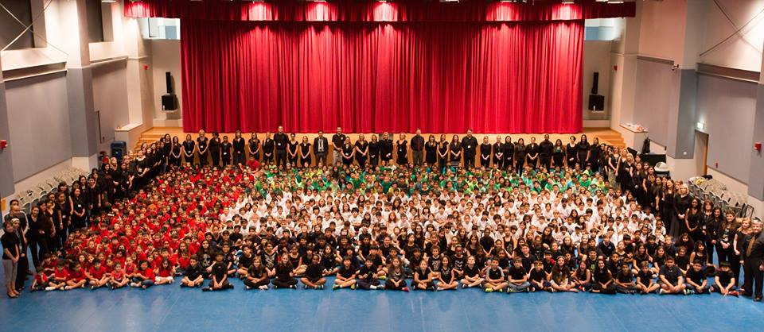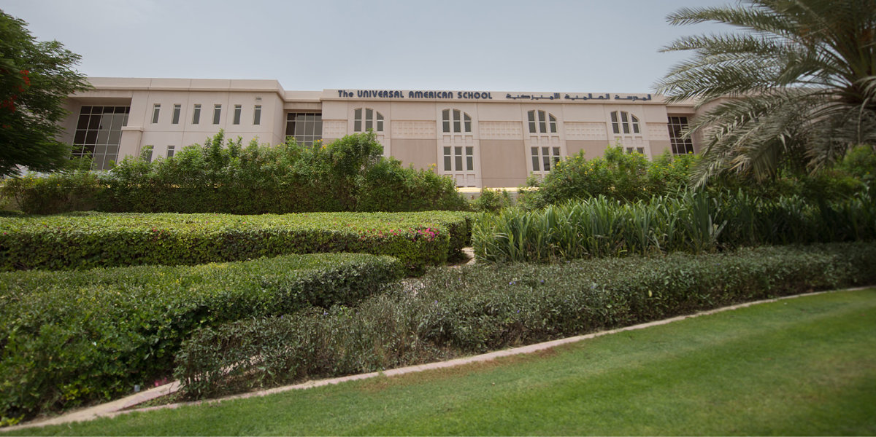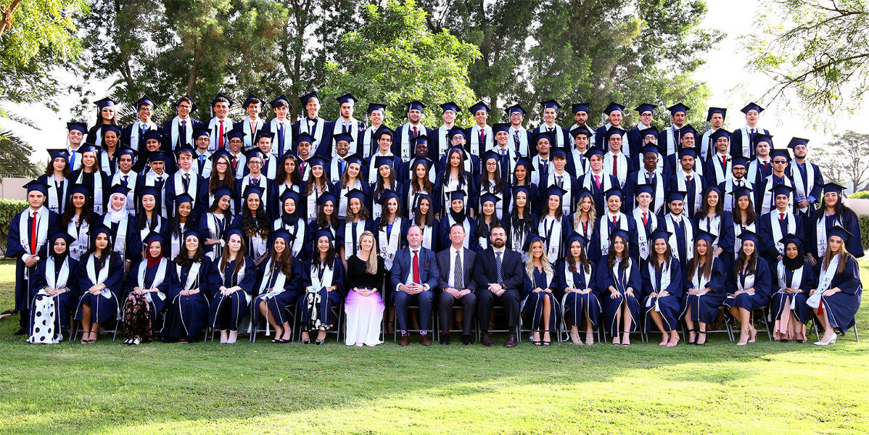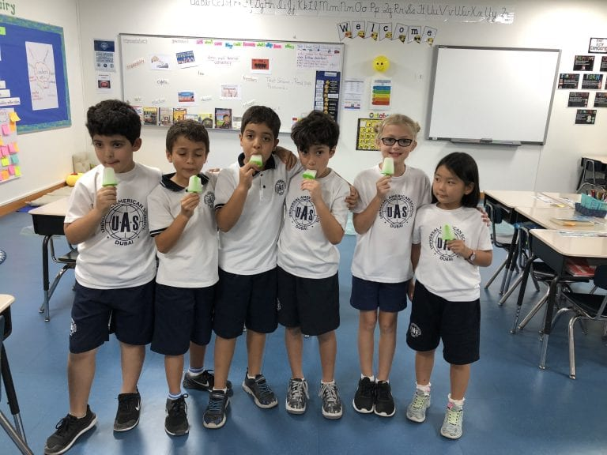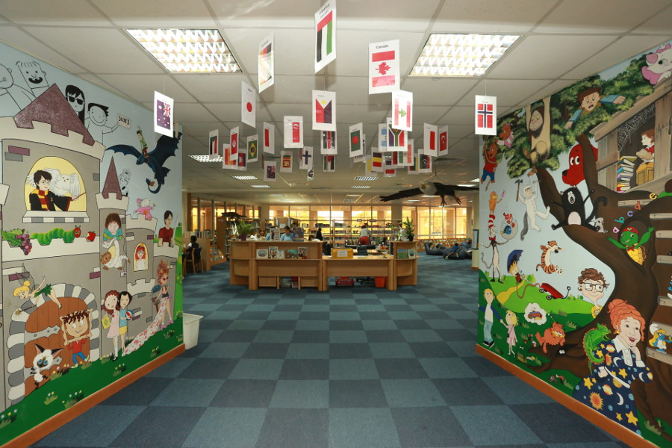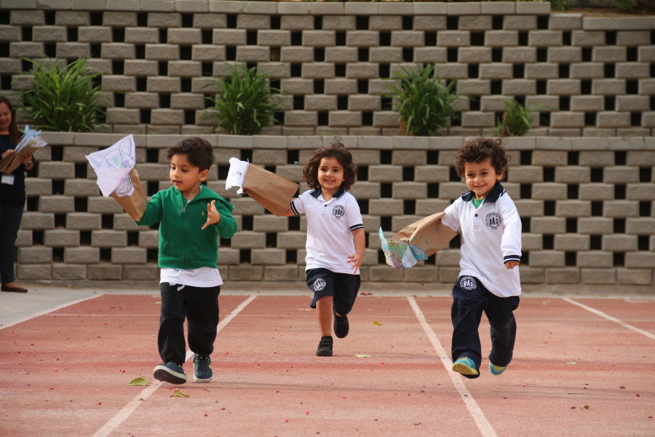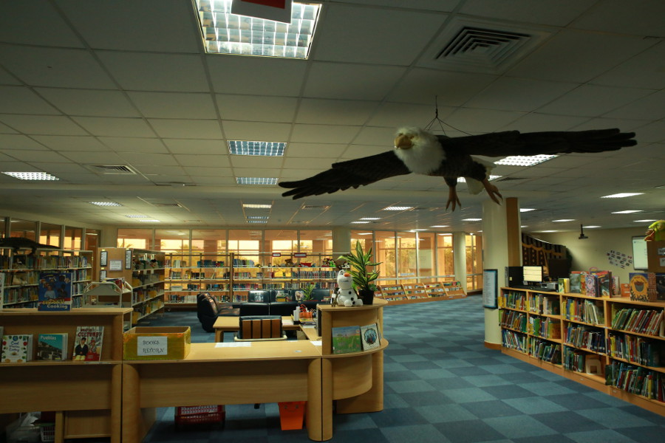

School system: American system

Current rating: Very Good

Enrollment grade: PK-12 grade

Tuition fee: 37330-76670AED

**School Introduction**

Universal American School was founded in 2005 and is a small non-profit school located in the city center. Schools provide challenging American and international education, enabling students to become global citizens who care about themselves, think critically, and take responsibility. In 2019-2020, schools will offer the first batch of AP and common core courses, which will offer IB diploma courses for 11th and 12th grade students. This parallel course will enable students to make more personalized choices in their education. In addition, it also provides students with opportunities to seek alternative routes to higher education. UAS has recently become a non-profit school managed by the Al Futtaim Education Foundation, providing students with a real-world learning experience that other schools cannot offer. From the perspective of learning and growth, United States schools are undoubtedly a good place.

**Course settings**

United States schools provide students with various personalized learning pathways. Starting from elementary school and reaching a climax upon graduation, students will receive rigorous academic guidance aimed at meeting their personal needs and interests. Primary schools offer personalized courses that meet the American AERO standards and the International Baccalaureate (IB) Primary School Program (PYP). In grades 6-10, students will learn various courses that meet the American AERO standards, aimed at helping them make wise choices as learners in the final choice path. During 10th grade, students, teachers, counselors, and parents work closely together to select appropriate and personalized graduation paths for students.

Preschool stage - Strengthening learning through research-based creative courses

At this stage, creative courses are the main resource of school curriculum. The creative curriculum is a comprehensive, research-based curriculum that aligns with the main curriculum objectives of primary school projects. Its characteristic is to explore and discover as a learning method that enables children to develop confidence, creativity, and lifelong critical thinking skills. The course content mainly delves into the themes of children's daily lives, including music production, buildings, insects, and simple machines. In the course, children explore, experiment, and investigate through practical methods through activities conducted in the classroom and outdoors, raise questions about the topic, and find answers. The target areas of the course mainly include social emotions, mathematics, literacy, physics, language, social research, as well as science and technology.

Primary school (grades 1-5) - aimed at instilling and maintaining a love for learning

The curriculum goal of United States schools is to ensure that every student has a passion for the curriculum and possesses the skills required for lifelong learners. Since 2010, United States School has been an authorized International Baccalaureate Primary School Program (PYP) school. Through primary school programs, students can cultivate academic, social, and emotional health, as well as enhance their international perspective and the attributes of IB learner profiles. In addition, the focus of the learning experience is problem-solving, critical and creative thinking, collaboration, and effective communication with others. As part of the International Baccalaureate Primary School Program (PYP) and American schools, UAS incorporates knowledge, skills, and concepts of American (AERO) and UAE Department of Education standards and learning outcomes into the PYP framework to construct rigorous and challenging curricula, providing UAS students with unique international and American education.

PYP course: Based on the knowledge and interests of learners, with a focus on how to learn: asking questions, finding answers, and understanding new information. Students have the opportunity to explore areas of interest and share their learning experiences with peers and the broader UAS community. The PYP survey unit includes local and global issues across multiple thematic areas, and the comprehensive nature of these units allows students to establish connections between themes, leading to an understanding of important ideas or concepts, resulting in more effective and transferable learning. Given the different developmental rates of children, each student is a person whose needs may differ from those of others in the classroom. Schools use various assessment techniques to create learning profiles for each student and design personalized classroom experiences to meet their needs.

Junior High School (Grades 6-8) - Focusing on the holistic development of students

Middle school is a special period for children's development, and the transition between childhood and adolescence is a period full of physical and emotional changes. In order to help students complete these transitions, the curriculum in junior high school focuses on the development of the entire child. Our academic courses meet the American AERO standards and meet the needs of 21st century learners. UAS focuses on developing advanced thinking skills necessary for success in the 21st century. The AERO standard curriculum teaches students critical thinking and emphasizes inquiry driven teaching strategies. Teachers work hard through practical and collaborative teaching methods to cultivate curiosity and creativity. UAS High School also offers a series of elective courses for students to explore language and art, cultivate well-rounded individuals, and courses include visual arts, drama, bands, and choirs, as well as world language courses. Students will learn Spanish, French, and Arabic. The school also has the UAS Week Without Walls program to provide students with a life changing learning experience, extending their course knowledge beyond the classroom. These experiences focus on service and aim to enable students to learn life skills, gain cultural understanding, and experience personal growth.

High School (9th to 12th Grades) - Aspiring to a Lifelong Life for Students

High school offers strict pre university courses that align with the AERO Common Core Plus standards for grades 9 to 12. In addition, UAS provides two clear and academically rigorous ways to directly enter universities: one is through international diploma programs, and the other is through university prerequisite courses and common core courses. The high school curriculum is student-centered, providing students with opportunities to develop independent critical thinkers, innovate problem-solving, and lifelong learning.

IB Diploma Link up Courses: Choose IB Diploma as their student choice for six courses with a duration of two years.

University Connection Courses: University Connection Courses have a series of courses, each lasting one year.

**Extracurricular activities**

The school encourages students to participate in extracurricular activities (ASA) and families to participate or voluntarily assist in school activities, such as those organized by the Parent Teacher Student Organization (PTSO). In addition, the school also invites parents to join our school's back to school night, parent teacher meetings, coffee breakfasts, and seminars.

The UAS Elementary School ASA course is an opportunity for students to explore their interests outside of the classroom, from creative writing to physical education, academic enrichment to imaginative games. The ASA program encourages adventure and balanced living, allowing students to enjoy opportunities to interact with others with similar interests in non academic settings.

\*Internal ASA is provided free of charge by UAS teachers (in some cases, purchasing related equipment may require the lowest cost). External providers provide external ASA within the UAS campus, and UAS establishes partnerships with them. The cost varies depending on each activity.

grade

**Fees and tuition fees**

PK tuition fee: 40450 dirhams

K tuition fee: 45850 dirhams

1st grade tuition fee: 61120 dirhams

Tuition fee for 2nd grade: 61120 dirhams

3rd grade tuition fee: 61120 dirhams

4th grade tuition fee: 61120 dirhams

5th grade tuition fee: 67880 dirhams

6th grade tuition fee: 67880 dirhams

7th grade tuition fee: 67880 dirhams

8th grade tuition fee: 67880 dirhams

9th grade tuition fee: 76670 dirhams

10th grade tuition fee: 76670 dirhams

Tuition fee for 11th grade: 76670 dirhams

Tuition fee for 12th grade: 76670 dirhams

# Raffles World Academy

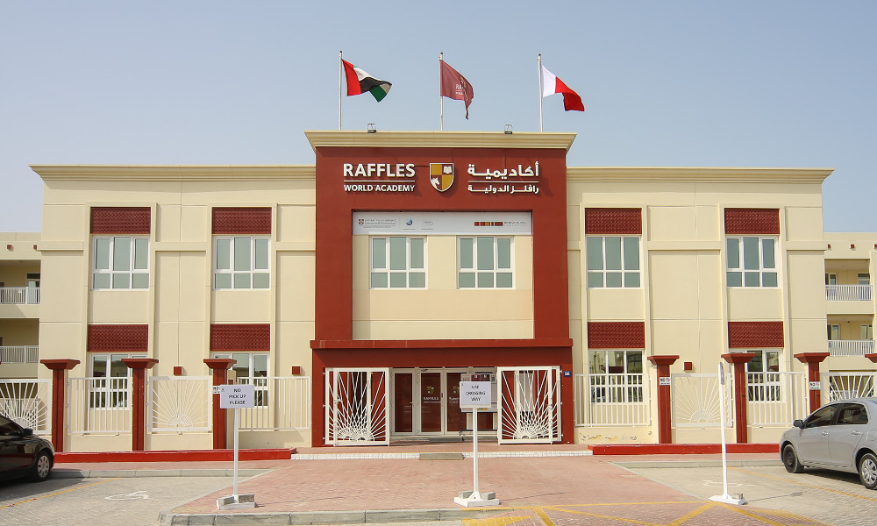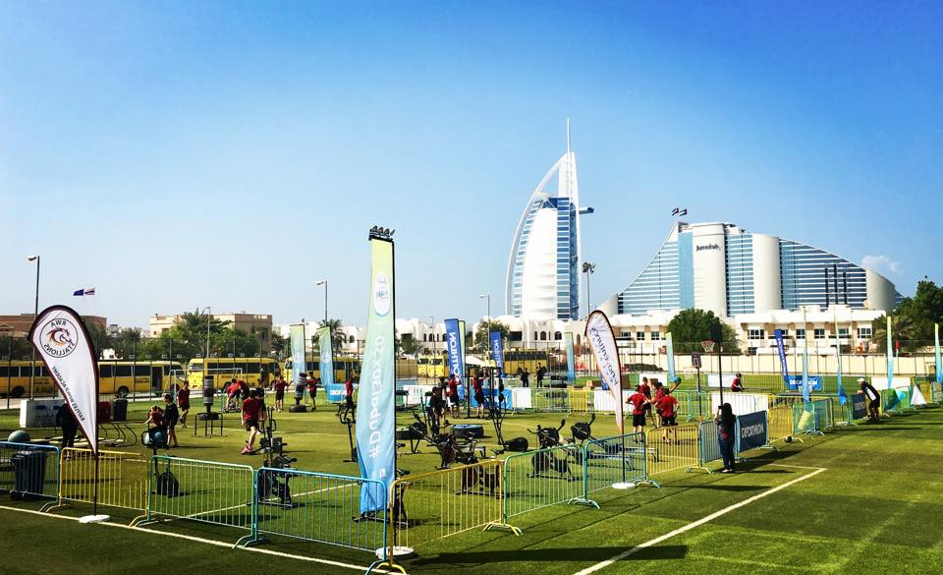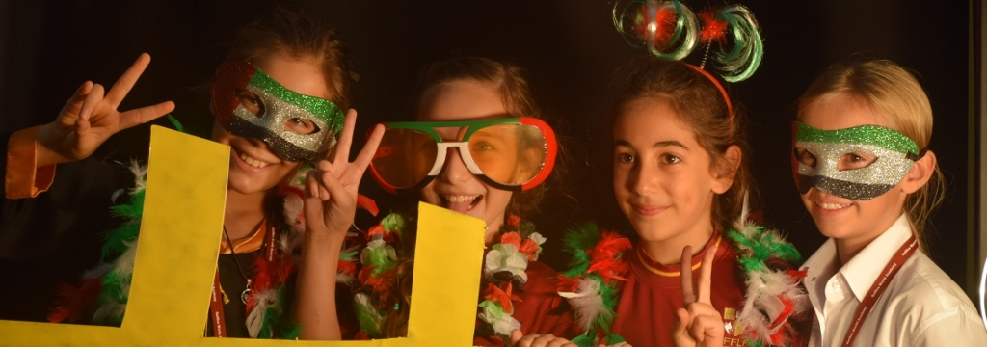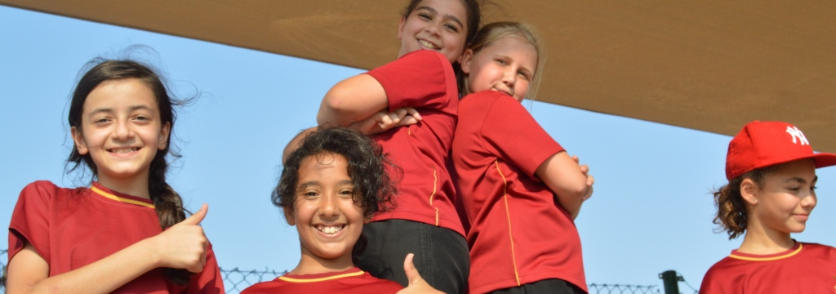

School system: American system

Current rating: Good

Admitted students: KG1-GR12

Address: Al Marcup Street ، Umm Suqeim 3

**School Introduction**

Raffles World Academy was founded in 2008 and is a co educational private international college with over 2000 students currently enrolled. The purpose of running the school is to provide world-class education. The college is located in the UmmSuqueim area of Kumira Beach in Dubai, covering an area of over 3000 square meters and adjacent to Dubai's iconic building, the Sail Hotel.

Raffles World Academy (RWA) values the education and healthy growth of every child. We lay the foundation for the growth of balanced and principled lifelong learners, and our goal is to cultivate them into responsible global citizens, with the aim of contributing to their communities in life and work in the future. We take "Striving for Excellence" as our motto and are inspired by the words of HH Sheikh Mohammed bin Rashid Al Maktoum, Prime Minister, Vice President, and Emirate of Dubai, who stated that "the race for excellence has no finish line.".

**curriculum design**

The college curriculum covers international standard courses for all grades, including Arabic, Islamic studies, English, mathematics, history, science, music, art, computer science, French, and Spanish. The college also offers Chinese language courses, and detailed course design and arrangements need to be confirmed after communication between parents and the college.

**School bus situation**

Raffles World Academy provides bus transportation services for students, provided by ArabFalcon Bus Rental LLC. Arab Eagle Car Rental Company is a reputable transportation company that serves multiple schools in Dubai and provides reliable and professional transportation services for students.

**School facilities**

The college has strong qualifications and provides students with various activity rooms, science laboratories, music classrooms, dance halls, art rooms, computer rooms, networked libraries, and sports venues. At the same time, the school is equipped with 24-hour security facilities to ensure the safety of students on campus.

**Catering facilities**

Due to the fact that Raffles World Academy caters to international students by providing a variety of balanced meals in the school cafeteria catering to meet the tastes of students from different countries, allowing students to freely choose.

**School culture**

As soon as you step into RWA campus, you will feel that our school is a multicultural community with a strong international perspective. As parents, we all hope that our children can be healthy and happy, adapt to the environment, receive good education, and achieve their own dreams. Looking into the future, we seem to see them choosing their careers and even running their own families. RWA is committed to helping students lay a solid foundation and looking forward to their dreams coming true.

**tuition**

PK tuition fee: 30384 dirhams

K tuition fee: 36461 dirhams

1st grade tuition fee: 47156 dirhams

Tuition fee for 2nd grade: 47156 dirhams

3rd grade tuition fee: 47156 dirhams

4th grade tuition fee: 56878 dirhams

5th grade tuition fee: 56878 dirhams

6th grade tuition fee: 56878 dirhams

7th grade tuition fee: 64171 dirhams

8th grade tuition fee: 64171 dirhams

9th grade tuition fee: 64171 dirhams

10th grade tuition fee: 70027 dirhams

Tuition fee for 11th grade: 77562 dirhams

Tuition fee for 12th grade: 77562 dirhams

Other expenses: Textbook fee: 1095-2188 dirhams

# Jumeira Baccalaureate School

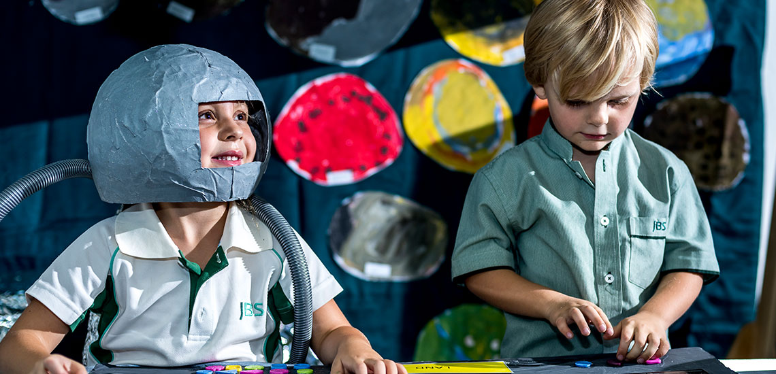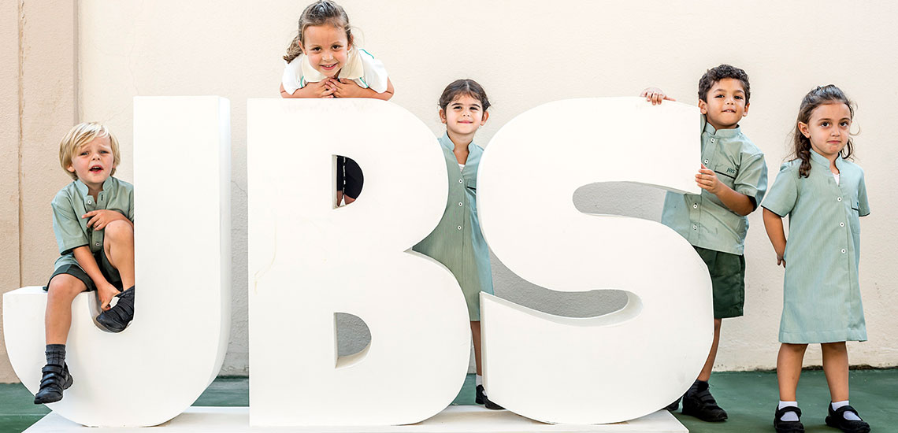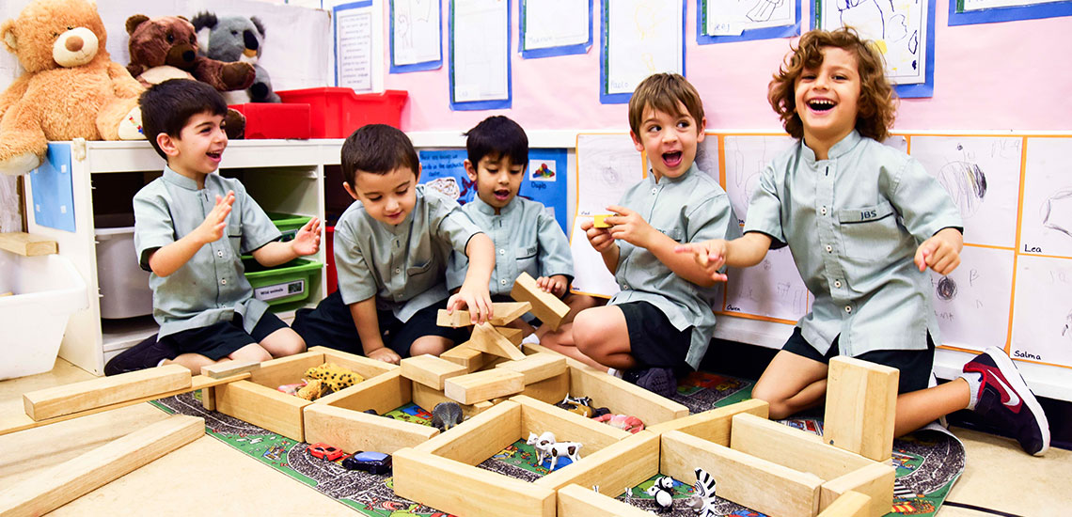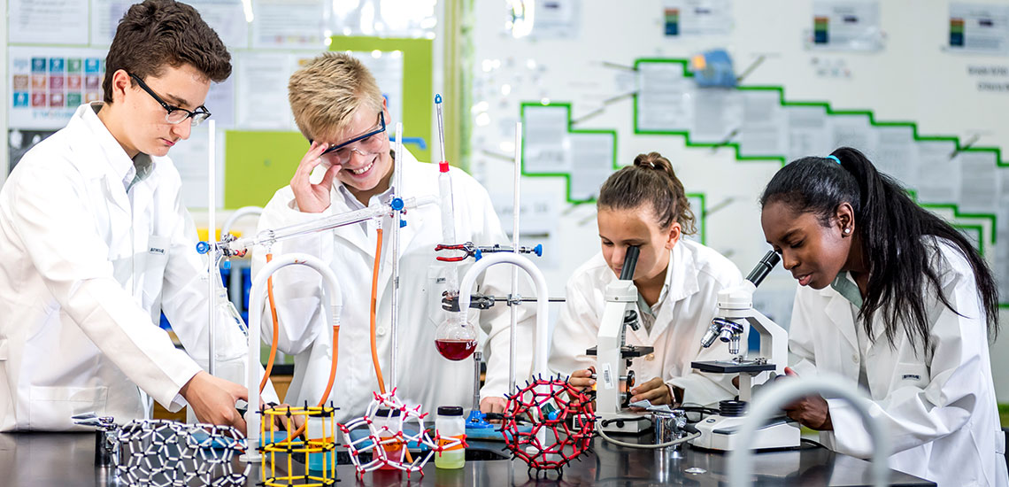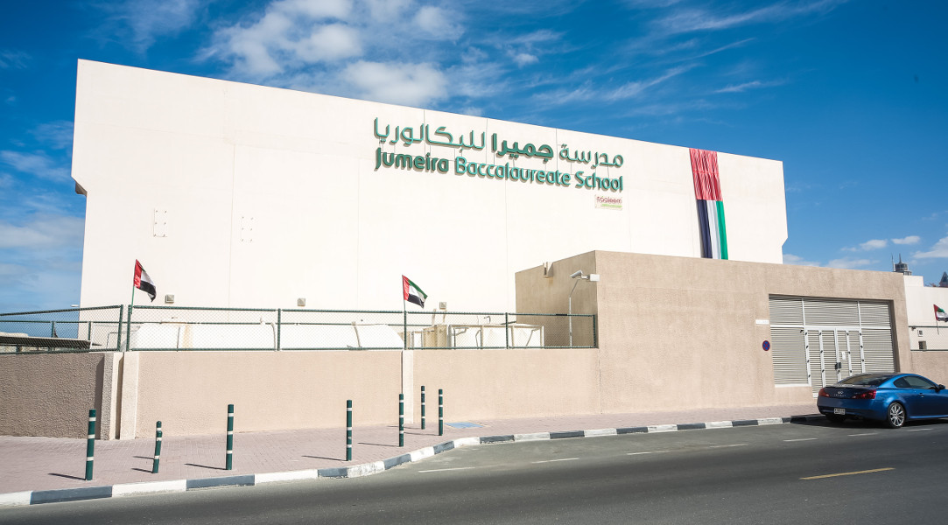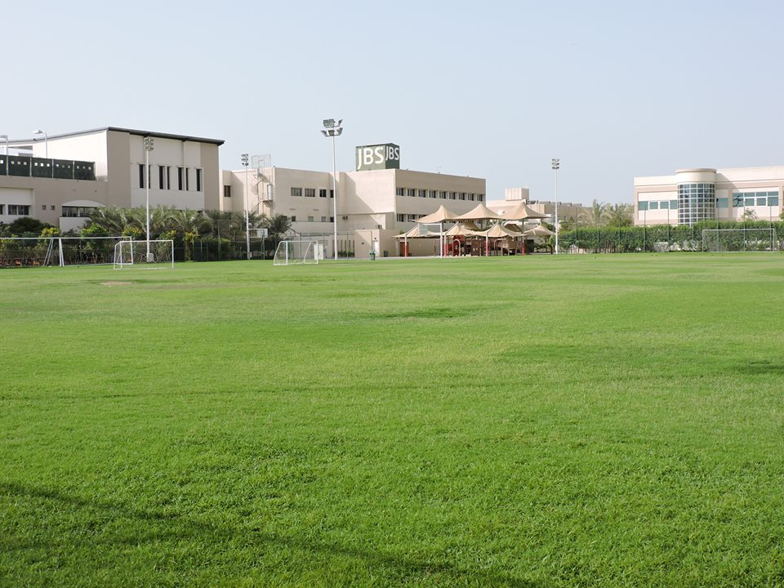

School rating: Very good

Enrollment grade: FS1- Year 13

Tuition fee: AED -40900-86700

Address: 53 B Street, off Al Wasl Road Jumeira 1

**School Introduction**

Why choose JBS?

JBS is an IB World School that offers all four stages of IB courses. As an IB continuous school, JBS provides primary school curriculum (PYP), secondary school curriculum (MYP), vocational related curriculum (CP), and diploma curriculum (DP) for students from kindergarten to 12th grade.

In 2018, JBS introduced character education to further strengthen IB's educational philosophy. In November 2020, JBS, as the first school outside the UK, received the Quality Certification Award from the Character Education Association. Character education teaches to acquire and strengthen positive character traits (or virtues), which are crucial for achieving the highest potential in life. Cultivating good character is the foundation for achieving a comprehensive life and a prosperous society. Therefore, prosperity is the ultimate goal of character education.

As of September 2022, JBS has become a member of KiVa, an anti bullying program developed by the University of Turku in Finland, aimed at further supporting our efforts to establish positive relationships among students and provide a safe and positive campus atmosphere. The course will begin teaching in September 2023.

The methods of JBS to promote physical and mental health have been further elaborated in the following aspects: the school's vision, mission, and core values.

Vision: To become a school with upright conduct, continuous improvement, and outstanding performance.

Mission: To ignite the passion, goals, and curiosity of students. Promote well-being within our community. Provide highly anticipated IB education with innovation, international awareness, and inclusiveness.

**Core Values**: The 4R's

Responsibility, Respect, Wisdom, and Perseverance

Definition of JBS's mission and core values:

● Happiness: promotes self-awareness, self-control, empathy, social skills, and personal responsibility.

Innovation: promoting critical thinking; Communication; Collaboration; And the ability to creatively solve problems.

● High expectations: improving learners' resilience; The ability to reflect feedback and take action; Take pride in work; And the belief of transcendence

● Inclusion: promoting diverse learning communities; Understand and motivate each learner through differentiation.

International awareness: promoting a respectful attitude towards others.

**Principal's message**

I would like to personally welcome you and your family to Jumeira Baccalaureate School under the Taaleem Group. JBS is an IB school that has been accredited by the International School Council, awarded the Quality Mark by the Character Education Association, and offers Pearson BTEC courses.

The ultimate goal of education is to prepare students for a well-rounded life, enabling them to truly thrive and make positive contributions to society. Our method of promoting happiness is to cultivate positive personality traits in students. We achieve this through the IB learning skills approach, IB learner characteristics, and our own 4Rs (respect, responsibility, resilience, and resourcefulness), all of which are taught both inside and outside the course. Our employees should also develop positive personality traits in order to cultivate a good character. In addition, our service learning programs, extracurricular activities, field trips, (overseas) summer camps, and student leadership courses all aim to cultivate and strengthen positive personality traits that are necessary to achieve maximum potential in life.

We believe that our scientific approach is successful because graduates of our IB diploma and career related courses have achieved IB scores far above the global average. In addition, as an inclusive school, we take pride in excellent passing rates every year. Our students have been admitted to universities around the world, and many have even found employment in positions that did not exist a few years ago.

Our school also has some unique aspects (USP'S), including a comprehensive French A course designed for native speakers, allowing them to learn language and literature courses based on their own family curriculum; A firm commitment to Arabic language learners, including IB and Ministry of Education courses, as well as inclusive education programs for students who are unable to enter mainstream schools.

JBS is a unique school, not only because of the content we provide, but also because we are an international community composed of 85 different nationalities, and parents are partners in all of our work. We know that our website can only provide you with a glimpse of the comprehensive education provided. Therefore, we warmly invite you to personally visit the school and learn about the excellent facilities we provide; Experience a positive atmosphere; And understand how we can stimulate young thinking, cultivate them to become confident and empathetic learners, enable them to successfully and effectively contribute to society, and become responsible citizens.

Richard Drew

**Course Introduction**

IB's Mission

The International Diploma Program aims to cultivate curious, knowledgeable, and caring young people who help create a better and more peaceful world through cross-cultural understanding and respect. To this end, the organization collaborates with schools, governments, and international organizations to develop challenging international education and rigorous assessment plans. These courses encourage students from all over the world to become active and empathetic lifelong learners who understand that others, despite their differences, can still be right.

JBS is a fully authorized IB World School that is certified to provide IB Primary Curriculum (PYP), IB Secondary Curriculum (MYP), Diploma Curriculum (DP), and Career related Curriculum (CP) for students from kindergarten to 12th grade.

IB Diploma Program (DP)

The core extension thesis of the diploma program requires students to participate in independent research by delving into issues related to one of the DP subjects they are currently studying. The World Research Extension Paper option allows students to focus on a topic of global significance, and they study the topic from the perspective of at least two DP projects.

Knowledge theory has developed a coherent learning method that unifies disciplines. In this course on critical thinking, students explore the essence of knowledge and deepen their understanding of knowledge as a human construct.

Creativity, Activities, and Services (CAS) involve students in a range of activities and academic research throughout the entire diploma program. Creativity encourages students to participate in art and creative thinking. The activity aims to cultivate a healthy lifestyle through physical exercise. Community services provide tools for new learning with academic value. The three aspects of CAS promote the personal and interpersonal development of students through experiential learning, and enable a journey of self discovery.

Each subject group offers different courses, and students must choose the first five groups of each subject, as well as the arts or second subjects in groups 1 to 5.

Why choose a diploma course?

Students take the written test at the end of the DP and are graded by an external IB examiner. Students are still completing assessment tasks in school, which are initially graded by teachers and then hosted by external hosts or directly sent to external examiners.

The score range for each course is from 1 (minimum) to 7 (maximum). Students can also earn an additional score of up to three points due to their comprehensive grades in knowledge theory and extended papers. Diplomas are awarded to students who score at least 24 points, but must achieve a certain minimum level of performance throughout the course and satisfactorily participate in creative, action, and service requirements. The maximum total score that DP students can achieve is 45 points.

IB Primary School

The International Baccalaureate Program (PYP) aims to build on children's innate curiosity. This course is aimed at children aged 3 to 12 and focuses on cultivating their comprehensive development as explorers, both in the classroom and in the outside world. Students participate in four to six "exploration units" every year.

To ensure that children acquire a broad knowledge base, the exploration unit is developed under six "organizational themes":

Who are we

● Our location and time

How the world operates

How we organize ourselves

How we express ourselves

● Shared Earth

The six disciplines of Chinese language, social research, individual, social and sports, mathematics, science and technology, and art are included in the exploration unit, providing interdisciplinary learning methods. In the final year of PYP, students participated in the PYP exhibition to showcase their development.

The characteristics of IB PYP are:

● Addressing students' academic, social, and emotional health issues

Encourage students to cultivate independence and take responsibility for their own learning

● Support students in their efforts to understand the world and operate comfortably within it

Assist students in establishing personal values as the foundation for the development and flourishing of international consciousness.

PYP focuses on the development of the entire child as an explorer, whether in the classroom or in the outside world.

PYP is the first of four IB education programs. It lays a solid foundation for other IB courses, MYP, DP, and IBCP.

IB Middle School Department

After completing the initial stage, JBS students enter the IB Secondary School Program (MYP) to prepare them for the IB Diploma Program or IB Career related courses. MYP is available from 6th to 10th grade (students aged 11 to 16). MYP aims to help students develop their personal understanding, emerging self-awareness, and sense of responsibility in the community. Our MYP teacher will pay appropriate attention to:

Teaching and learning in context. When students have a background and interconnected learning experience, their learning outcomes are best when it comes to their lives and the world they experience. Utilizing the global context, MYP students explore human identity, global challenges, and the significance of having international awareness.

● Conceptual understanding. Concepts are large conceptual regions that have relevance in specific disciplines and interdisciplinary contexts. MYP students use concepts as tools to explore issues and ideas of personal, local, and global significance, and comprehensively examine knowledge.

● Learning Methods (ATL). A unified mainline that runs through all MYP subject groups, learning methods provide a foundation for independent learning and encourage the application of their knowledge and skills in unfamiliar environments. Developing and applying these skills helps students learn how to learn.

Service is action (community service). Action (learning while doing, learning while experiencing) and service have always been common values in the IB community. When students apply the knowledge they have learned both inside and outside the classroom, they take action. IB learners strive to become caring members of the community, demonstrating a commitment to service and bringing positive impact to the lives and environment of others. Service as Action is a component of this plan, especially in the MYP community project.

Language and identity. Students of IB secondary school curriculum must learn at least two languages (language instructions and other selected languages). Learning to communicate in various ways is the foundation for their development of cross-cultural understanding and the key to their identity recognition.

It provides a learning framework that encourages students to become creative, critical, and reflective thinkers. High school programs emphasize intellectual challenges and encourage students to establish connections between traditional subject learning and the real world. It promotes the development of communication, cross-cultural understanding, and global engagement skills, which are crucial for life in the 21st century.

The secondary school project consists of eight subject groups, integrated through five interactive areas, providing a global background for learning.

Students must learn at least two languages (as part of their multilingualism), humanities, science, mathematics, art, sports, and technology. In the final year, students will also engage in an independent personal project to showcase their skills and understanding development. Then, the teacher breaks down the eight subjects into interactive areas.

Research has shown that students who participate in IB secondary school courses:

● Establish confidence in managing one's own learning

● Learn while doing, connecting the classroom with the larger world

● Superior to non IB students in key academic skills

Continuously achieving greater success in the IB Diploma course exams

● Grow strong in a positive school culture, allowing them to participate and have the motivation to excel

● Cultivate an understanding of global challenges and strive to become responsible citizens

**extracurricular activities**

Developing children's universal skills and educating philosophy beyond limitations

JBS supports the concept of education transcending classroom limitations. Therefore, we have a variety of exciting sports, creative, cultural, and aesthetic activities.

In the current climate, the health and safety of the JBS community is our top priority, and the school is taking all preventive measures to ensure the health and safety of every person entering the campus.

Developing skills beyond core courses

We collaborate with over 20 top colleges in Dubai to encourage students to participate in extracurricular activities such as academic, artistic, performance, language, design, and sports. All of these activities revolve around customized learning journeys and outcomes, and students may develop their skills for the activity, as well as a range of increasingly relevant general skills such as leadership, collaboration, resilience, perseverance, responsibility, and commitment

These skills play a crucial role in creating a positive and nurturing environment, which is crucial for students to succeed academically and in their lives beyond JBS. Participating in extracurricular colleges has successfully helped students enter some of the world's top universities. It is obvious that more and more universities not only value students' academic performance, but also show great interest in the extracurricular activities that applicants participate in. People have noticed that measuring an applicant's ability to complete some of the more challenging degree courses in university focuses on resilience and perseverance.

Example of courses offered by JBS at the Economic Commission for Africa:

Our new EAS course is divided into three different semesters, allowing students to participate in a more diverse range of activities throughout the year.

All external suppliers providing courses at JBS have carefully considered their policies and preventive measures to ensure the safe operation of the courses and the safety of students, as well as how each course can help students grow and improve their confidence, knowledge, health, and well-being.

**tuition**

Application fee: 1050 dirhams

PK tuition fee: 56131 dirhams

K tuition fee: 56131 dirhams

1st grade tuition fee: 72970 dirhams

Tuition fee for 2nd grade: 72970 dirhams

3rd grade tuition fee: 72970 dirhams

4th grade tuition fee: 72970 dirhams

5th grade tuition fee: 72970 dirhams

6th grade tuition fee: 72970 dirhams

7th grade tuition fee: 72970 dirhams

8th grade tuition fee: 72970 dirhams

9th grade tuition fee: 72970 dirhams

10th grade tuition fee: 72970 dirhams

Tuition fee for 11th grade: 84197 dirhams

Tuition fee for 12th grade: 84197 dirhams

Scholarship: Provided

# Safa Community School

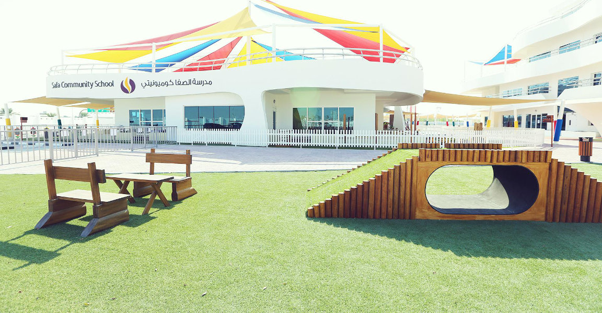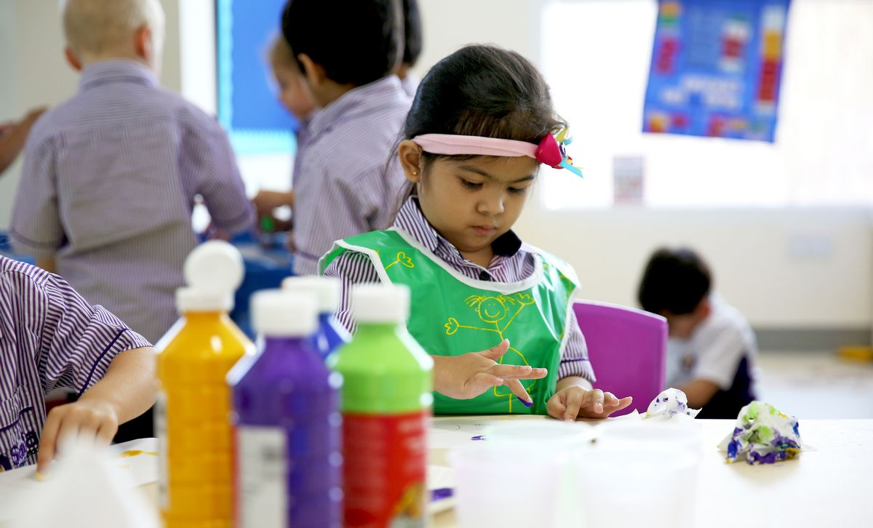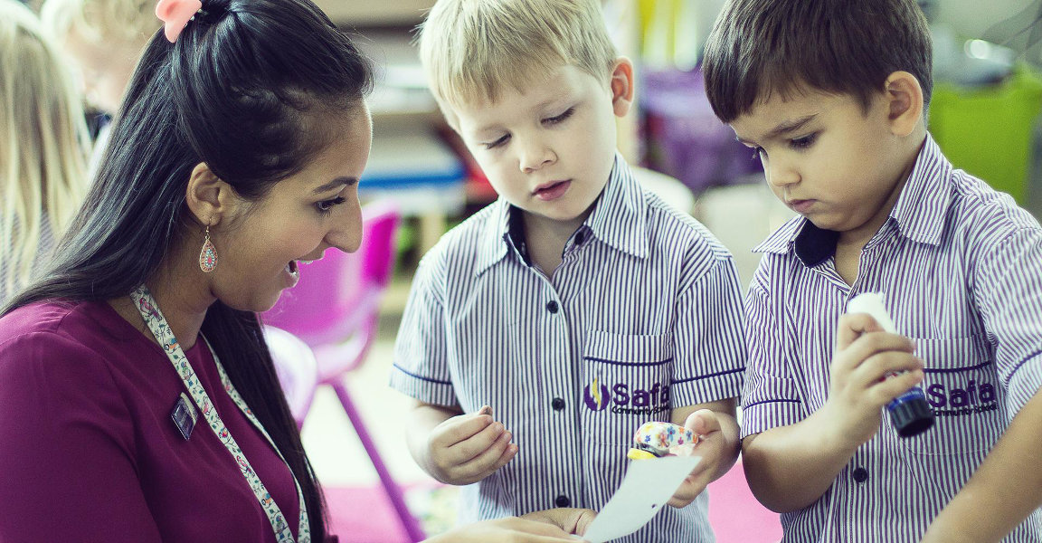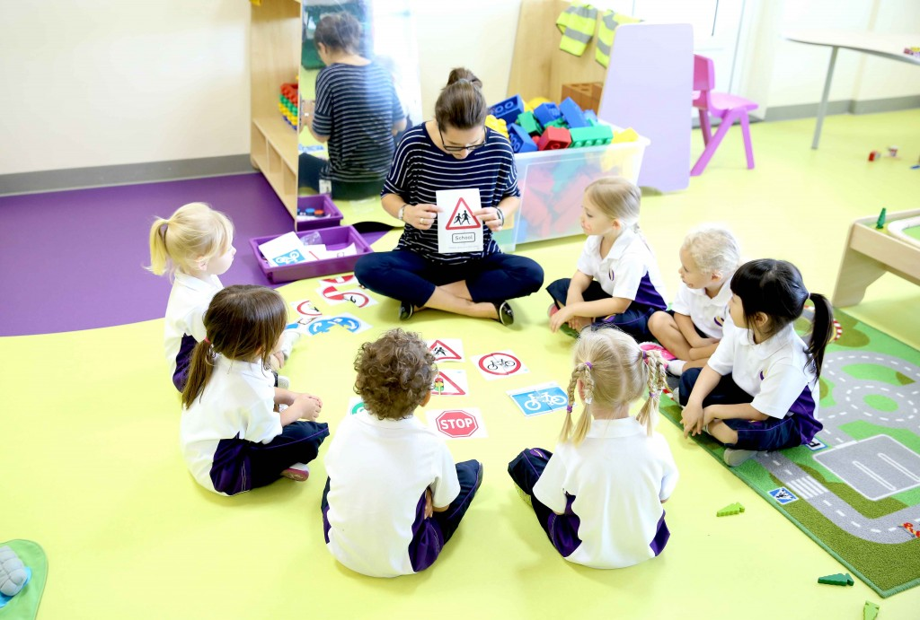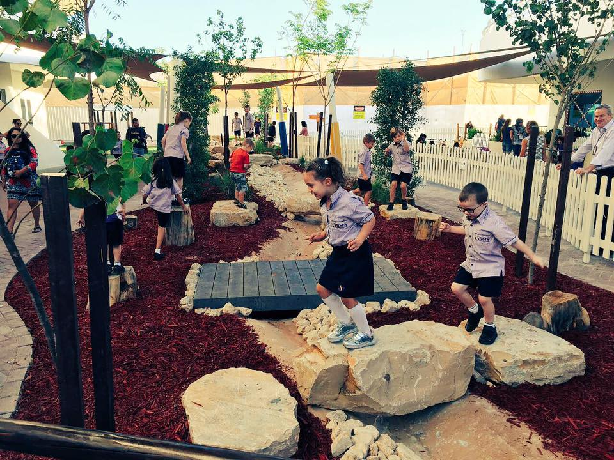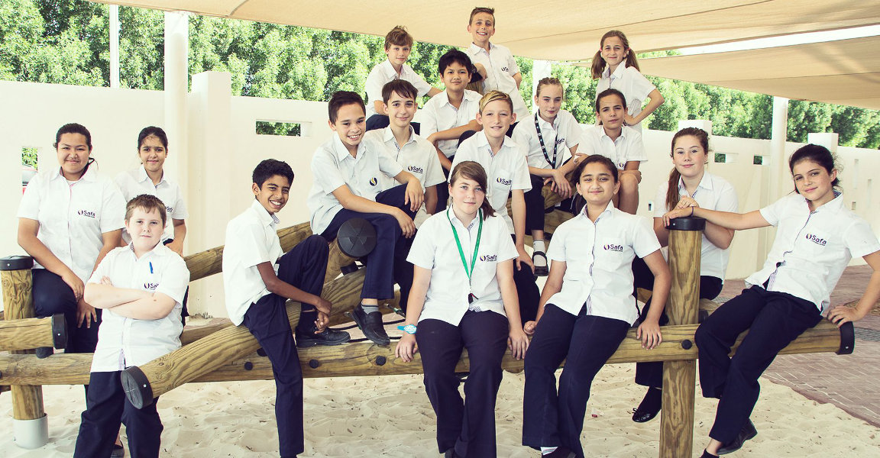

Safa Community School (SCS) is the sister school of Safa British School. Since its establishment, the school has developed rapidly and now has over 1900 students, with a significant increase in the number of students in the secondary department compared to previous years. Received a Good rating during the first KHDA examination in 2016-17 and has since been elevated to the second highest level of Very Good. This rating was also retained from 2018 to 2019.

**School Introduction**

Each grade has 6 to 9 classes, with an average of 16 to 24 children per class, up to a maximum of 24. The number of employees has also significantly increased with the development of the school, with 162 teachers mainly from the UK and receiving assistance from an additional 93 teaching assistants (including 22 from the inclusive department) and two counselors. All teachers must have a UK teacher qualification certificate and 90% have taught in the UK. The teacher-student ratio is 1:12

About 30% of students are UK passport holders, while there are also students from 87 other countries attending schools, 8% from South Africa, 10% from the Indian subcontinent, and 10% from North Africa. SCS has over 30 children from the United Arab Emirates.

SCS describes itself as a "fully inclusive, non selective school.".

SAFA is recognized for its inclusive policies towards children with special needs and gifted children. Its advantages have been reflected in the KHDA report. One of the advantages of Safa British School is that it provides support for children with learning difficulties, while its new sister schools continue to provide services in this field, with approximately 7% of students having special needs requiring additional support

School system

**Curriculum**

Like the original Safran UK school, Safran Community School offers the UK National Curriculum, using "Early Years Foundation Stage Curriculum" in the early foundational stages of FS, "National Curriculum" in grades 1-9, and iGCSE and GCSE in grades 10 and 11. The first batch of iGCSE/GCSE students completed their exams in June 2019. The school has recently established A Levels, A Levels, and BTEC national qualifications for grades 12 and 13.

The school also offers a wide range of extracurricular activities and up to five international trips per year, offering approximately 120 expansion classes, of which 80% are free.

FS1&Grade 2

Flexi-FS1

To provide greater flexibility and convenience for parents of young students, SCS has provided more options for the campus schedule of FS1 students in the 2019-20 academic year. The Flexi-FS1 project allows children to attend classes 5 days a week in the traditional way; Alternatively, they can choose a class cycle of "3 days a week" or "4 days a week" in the first two semesters. Parents can also choose a later end of school time to meet their busy work schedules.

In addition, in order to cultivate a love for language, SCS introduced more languages from the second year onwards. The foreign languages provided include French, Spanish, German, and Mandarin. Language is taught in a fun and child friendly way, including songs, dances, and other elements that children can easily access. These language courses, as part of the overall curriculum, are not charged extra. Other non-native English speaking students can take GCSE courses in their native language.

Grade12- Grade13

A Level

The school offers a wide range of A Level options, while recommending that most students study three subjects, it also encourages students who also perform exceptionally well to study the fourth subject. The A Level options include: art and design, business research, biology, chemistry, computer science, design and technology (product design), English literature, geography, history, mathematics, sports, physics, psychology, drama and drama research, French, economics, German, Mandarin, Spanish, advanced mathematics, music, and politics. Arabic is a mandatory subject that complies with KHDA and MOE regulations. The school also hopes to provide astronomy, government, politics, and sociology in the near future.

GCSE stage

The school also offers unique course options, including contemporary design for 7th grade students in the GCSE stage, REACH programs for 12th grade students, and internships/work experiences for 10th grade students. In the 2021 GCSE results, 42% of all subjects scored 9-7 (A \*), while 57% of all grades scored an astonishing 8/9 (A \* - A).

**School facilities**

The Safa Community School is located in two oval shaped buildings that have been carefully designed to meet the needs of children. The buildings include a central block, a global learning center, a multifunctional sports hall with retractable seats, an auditorium, a self-service restaurant, a theater and dance studio, as well as a theater, music practice room, and a high school library

The architect is Fielding Nair. The building is a very bright open classroom, providing specialized furniture for children of different ages and using special "soft" flooring. Classroom resources are abundant, and outdoor areas are also made of wood as much as possible as amusement equipment. The central resource area used by teachers is a glass area, allowing staff to pay extra attention to children using the central area. Each classroom can lead to the terrace area on the first floor or connect to the balcony area.

**tuition**

Application fee: 500 dirhams

PK tuition fee: 49700 dirhams

K tuition fee: 49700 dirhams

1st grade tuition fee: 51815 dirhams

Tuition fee for 2nd grade: 51815 dirhams

3rd grade tuition fee: 51815 dirhams

4th grade tuition fee: 53930 dirhams

5th grade tuition fee: 56045 dirhams

6th grade tuition fee: 58160 dirhams

7th grade tuition fee: 68734 dirhams

8th grade tuition fee: 68734 dirhams

9th grade tuition fee: 72964 dirhams

10th grade tuition fee: 73490 dirhams

Tuition fee for 11th grade: 75532 dirhams

Tuition fee for 12th grade: 77573 dirhams

Tuition fee for 13th grade: 81656 dirhams

Refundable deposit: 4000 dirhams

Other expenses: Medical expenses: 1500 dirhams

**School culture**

Safa Community School advocates fairness in competition, so every child has an equal right to speak. We uncover the hidden talents in children and encourage them to fully unleash and unleash themselves. We motivate every student to seize new opportunities, actively participate in activities, and experience different experiences. We never hesitate to praise students for their comprehensive achievements. At the same time, regardless of the age and needs of students, we provide them with unique care and care, and we are deeply proud of this. Our mission is clear, our expectations are practical, and our commitment is sincere. We are a school that is good at listening, and listening to your voice is our wish. Our school actively adheres to an open educational policy and strives to establish positive and sincere communication relationships with parents and students.

# Kings School Nad Al Sheba

Established in 2004, it consists of three Dubai King's Schools, one located in Dubai and the other in Al Barsha (1660 students) and Nad Al Sheba (340 students). Kings' School Dubai and Nad Al Sheba campuses are primary schools, while Al Barsha school is comprehensive. All three teach English courses, and the Al Barsha campus offers GCSE and A Level, as well as customized King's diplomas, to assist in applying to universities in the UK and the US.

Kings School Dubai was founded in 2004 and is adjacent to the Sailing Hotel. It is one of the highest ranked British schools in Dubai's Out Standing. According to data from the Dubai Board of Education, Kings School Dubai has been listed as one of the most successful schools in the UAE since 2008, with the highest rating from the Dubai Board of Education. From 2016 to 2017, we have been granted exemption from inspection by the Dubai Ministry of Education KHDA.

In September 2014, two new schools under the brand were established - Nad Al Sheba King School and Al Barsha King School, both of which were rated as good during the first inspection in 2016/17. King Albasha was rated excellent during the third inspection in 2018-19, while Nadal al Sheba School was rated very good.

King's School is one of the most prestigious schools in Nadesheba. It provides children with an environment where they can aspire and achieve good grades. This is another expensive Dubai school that follows the framework of British curriculum and provides learners with a rich learning experience.

King's School has a wide range of facilities, from a spacious library to fully equipped gyms, indoor and outdoor sports fields, music rooms, and more. The school also regularly holds holiday camps, where students can participate in scientific experiments, art and handicraft activities, as well as various team building challenges.

This expensive school located in Dubai has maintained a coveted KHDA outstanding rating for many years, earning the respect of the UAE education community.

Location: Nadsheba

Average tuition fee: AED 52000- AED 63700

Time: 07:30 am -03:30 pm

# Sunmarkee School

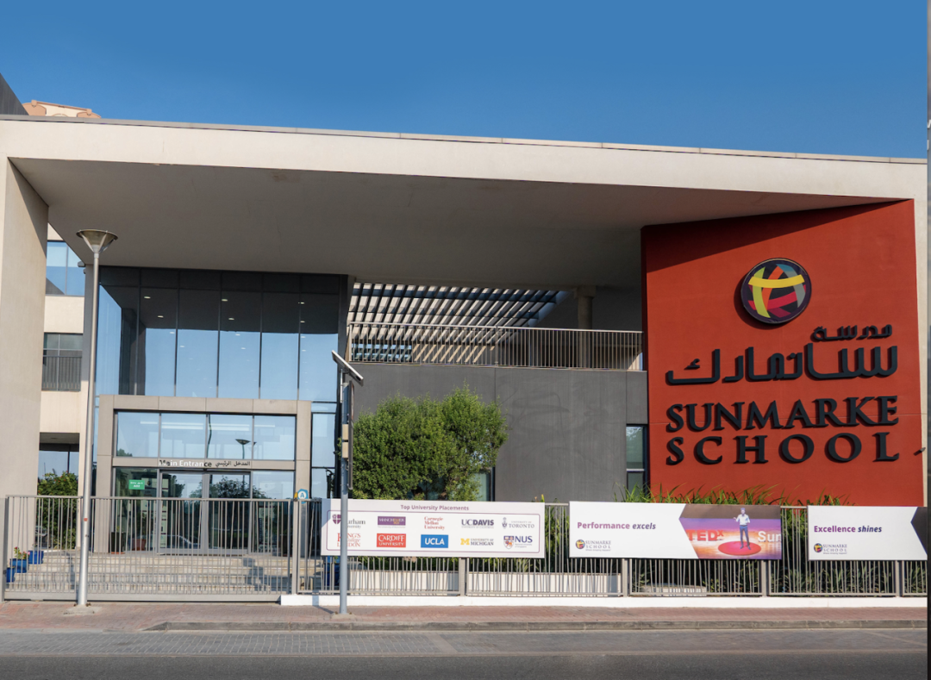

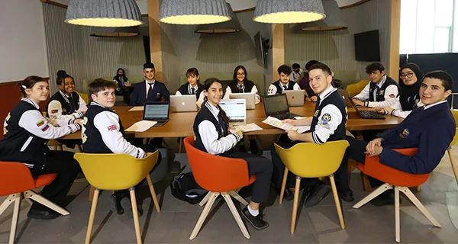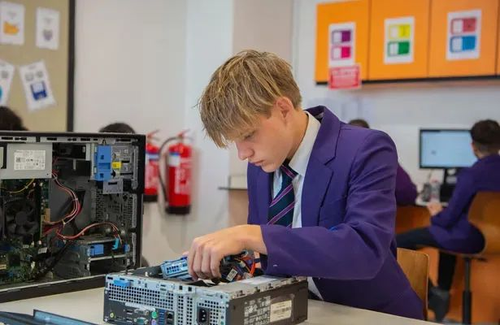

School system: English system

Current rating: Good

Enrollment grade: FS1-Year13

Recruitment age: 3-18 years old

Admission test: 600AED (non refundable)

Tuition fee: 44900-71900AED

School bus: providing school bus services

Address: Al Khail (approximately 30 minutes from International City)

**School Introduction**

Sunmarke School is a high-quality education school in Dubai, established in 2016, and admits primary and secondary school students aged 3-18. The school follows the UK national curriculum and offers GCSE and A Level courses. There are currently 727 students on campus. The school is part of Foetes Education, a leading education group that has been established for over 20 years. Sunmarke School has always advocated for positive education, which is also a paradigm shift in global education. The characteristic of positive education (PosEd) is the outstanding teaching supported by positive psychology, happiness, and the science of happiness.

Positive education defines Sunmarke's school culture, allowing children to accumulate academic and achievement learning skills in critical thinking, literacy, and computational abilities, as well as character development such as resilience, confidence, and self-esteem, as well as professional ethics such as happiness, kindness, gratitude, discipline, and resilience.

Although Sunmarke School is open to students of all nationalities, it has always been a highly selective and academic institution, establishing a high level of student literacy.

**Course Introduction**

Nursery

Sunmarke has an independent daycare center on campus, providing students with a seamless transition from kindergarten to early childhood basic stage (EYFS). The daycare is operated by Jumeirah International Nursery (JINS) and is also part of the Fortes family school. JINS has been established for over 30 years and is one of the oldest and most trusted daycare institutions in Dubai. JINS accepts children from 6 to 4 years old.

At JINS, children learn through games and practical activities. The course is based on the early foundational framework of the English national curriculum. The kindergarten is exquisitely designed with ample playgrounds, children's equipment, and vibrant colors to capture their imagination. Sunmarke provides a large educational and entertainment learning center for young children, allowing them to engage in experiential learning through role-playing as bakers, architects, shoppers, and more. And there is also an immersive second language course that familiarizes children with the sounds of a second language. In addition to early education and childcare, schools also provide aftercare and holiday care.

Early education

Early education (3 to 5 years old) is the most critical period for children's education, and good early education can lay an important foundation for children's future development. Fortes School has an "Outstanding" EYFS department evaluated by the KHDA Inspection Bureau DSIB. Following the principle of "positive education", Sunmarke adheres to this philosophy and cultivates teachers to provide a safe and happy environment for children, ensuring that each child's educational and developmental needs are addressed, monitored, and met.

The basic curriculum of the school is based on multiple senses and games. Playing, enjoying, and challenging are the core components of Sunmarke's teaching and learning plans and activities.

Sunmarke also has expert teachers in second languages such as sports, music, Arabic, and French. Other language courses such as Spanish, Russian, German, Chinese, Hindi, and Japanese can also be provided during or after class.

Primary school curriculum

Sunmarke's primary school curriculum has strong academic rigor and personal development. In primary school, hands-on experiential learning, research and field investigations are the core contents of daily learning.

Students have many opportunities to communicate their interests related to the topics they study each semester, and showcase their experiences and findings to their classmates. Students can participate in various extracurricular sports and rich after-school activities to cultivate their skills and interests, and shape their personalities. The main courses offered in primary school include Information and Computational Technology (ICT), Mathematics and Mathematical History, Geography, and Modern Foreign Languages: Arabic and French. Spanish, German, Russian, Mandarin, Japanese, and Hindi are provided as part of the course during or after class hours. Art and Design, Design Technology, Music, Sports, Personal and Social Development (PSD): Muslim Human Values and Islamic Studies, etc.

Secondary school curriculum

To ensure a smooth transition from primary school to secondary school, students need to have the necessary foundation in order to achieve success in the next stage of their learning journey. The school provides unique curriculum design for students every year to ensure that they can easily reach the next grade level.

Sunmarke School follows the national curriculum of the UK. Starting from the third year after its establishment, international courses will be offered to 11th grade students, and International Baccalaureate Programme (IBDP) will be offered to 12th and 13th grade students.

Secondary schools in grades 7 to 11 follow the UK national curriculum and are divided into three stages:

one

Key stage 3 Year 7-8

The focus of the KS3 course is to develop learning skills and abilities, master international curriculum knowledge, and how to use and apply knowledge in a wider range of life. Sunmarke provides students with opportunities to learn in interdisciplinary fields.

two

Key Stage 4 Year 9-11

At Sunmarke School, students complete grades 7 to 8 and can then choose GCSE courses in grade 9.

The General Certificate of Secondary Education (GCSE) requires a 3-year course of study, starting from 9th grade (Key Stage 3), 10th and 11th grades (Key Stage 4). Students usually choose their GCSE subjects in 9th grade.

Unlike some schools, Sunmarke does not categorize students into different learning levels and reduces or restricts course choices for students with lower abilities. The school firmly believes that all students should have equal educational opportunities and receive necessary challenges and support. However, the core is based on the school's STEAM (Science, Technology, Engineering, Art, and Mathematics) and creative learning programs, which are the foundation of Sunmarke school teaching.

three

Year 12&13

Starting from 2019, Sunmarke School will offer the International Baccalaureate Programme (IBDP) for 12 and 13 years.

Both courses provide a rigorous and creative structured framework, as well as internationalization, breadth, and flexibility in pursuing multiple career paths in university.

International courses and diplomas are the most sought after and globally accepted school curricula in the world. Both courses are based on strong research-oriented courses in mathematics and English, as well as all major courses in arts, sciences, and humanities, providing students with a strong educational foundation. And they encourage students to become active learners, openly challenge their ideas, and discuss with teachers and classmates. The course emphasizes the development of critical thinking, problem-solving, exploration, creativity, and "learning how to learn"

# Emirates International Private School(BR)

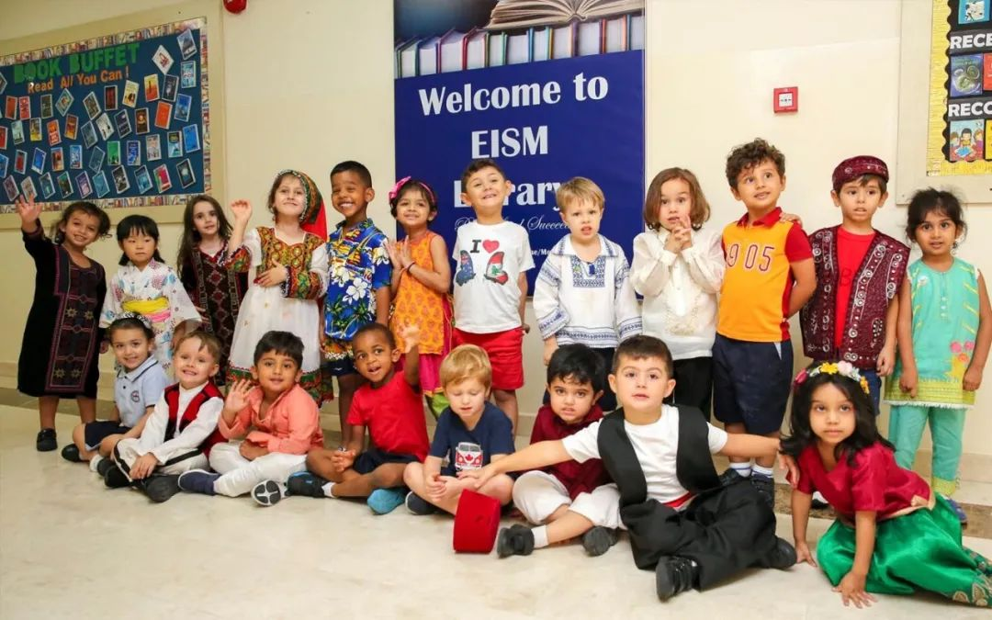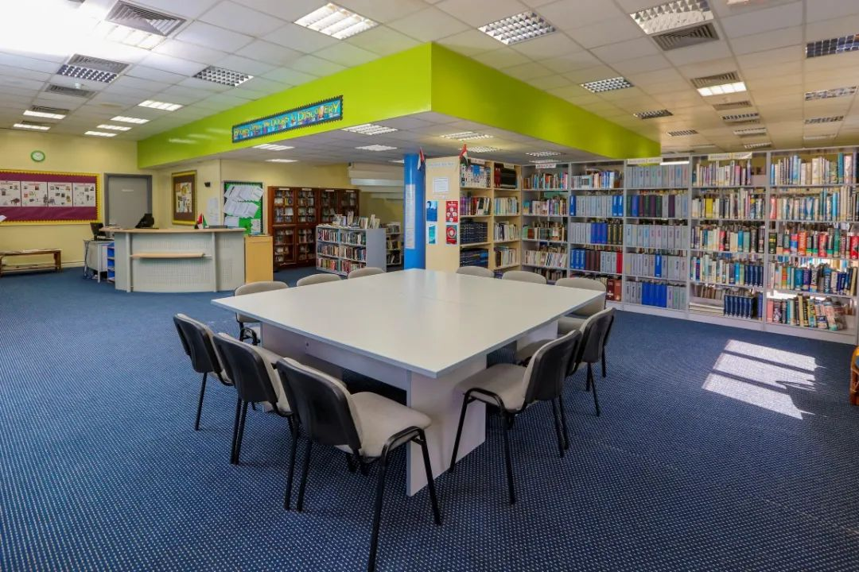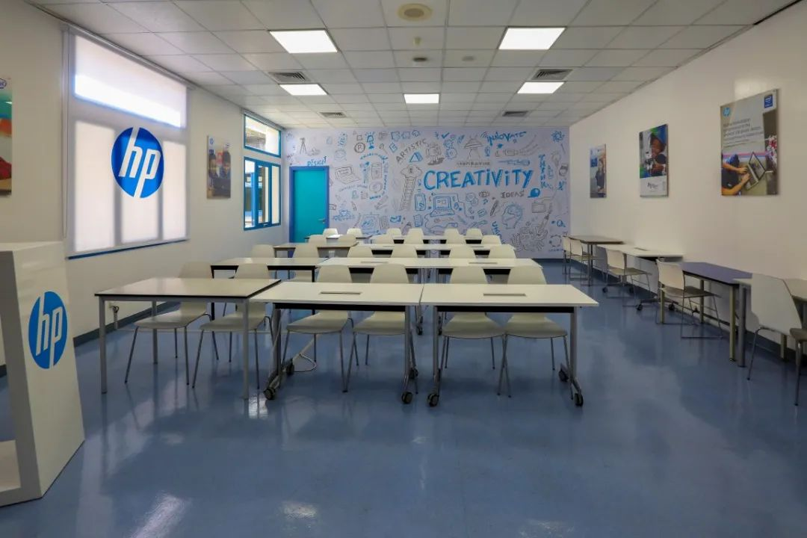

**School Introduction**

The UAE International School (Meadows Campus) was officially opened on September 10, 2005. The school now provides high-quality international education to over 1730 students in grades 1 to 13 (ages 3 to 18) from over 81 different countries around the world. As the first IB school established in Dubai, UAE International School has an authorized integrated IB system and was certified by The Council of International Schools in 2011. EIS offers IBDP (Diploma Curriculum 16-19 Years), MYP (Secondary Curriculum 11-16 Years), and PYP (Primary Curriculum 3-12 Years). The campus is divided into primary and junior high schools, as well as high schools, with 148 teachers and 29 teaching assistants. The ratio of teachers to students is 1:12.

Emirates International School (Jumeriah Campus) is one of the oldest international schools in Dubai, and celebrated its 30th anniversary in 2021. EISJ was the first school in Dubai to offer an IBDP program. The school is proud of its status as an "IB World School" and, like its sister schools, offers four IB courses simultaneously. From the first IB graduation class in 1994 to the 2020 IB graduation class, 1464 students have registered for the IB diploma program. 1262 (86%) students obtained an IB diploma. EISJ currently has over 2100 students from over 70 different countries, divided into two parts: early year and primary school, middle and high school. Each class has no more than 25 students and currently has 174 qualified teachers. Most teachers come from the UK. Teacher: The student ratio is 1:12.

**Why choose EIS?**

1. Effective team management and accurate self-assessment

Effective team management and accurate self-evaluation provide a more positive learning environment for continuous reflection in schools. The school has become a role model for other IB schools in Dubai. Due to the efforts and encouragement of the management, the average IBDP score of students is 33, making EIS Meadows one of the best performing schools among all IB schools.

2. High quality teaching and personalized teaching

High quality teaching quality and effective utilization of assessment in teaching students according to their aptitude have led to remarkable achievements, especially in English, mathematics, and science. The good environment provided by schools for children has promoted their rapid progress in various fields of learning. The school attaches great importance to science and the establishment of concepts. A carbon nanotube experimental project involving 11th grade students was selected and launched into space by NASA. This cannot be separated from the teachers of the Science Department, as they have cultivated and discovered the talents of students

**School curriculum**

EIS Meadows follows the International Baccalaureate (IB) curriculum to provide IB Primary Curriculum (IB PYP), Secondary Curriculum (IB MYP), and Diploma Curriculum (IBDP). IB courses have become increasingly popular in the United Arab Emirates in recent years. Especially IBDP is highly respected in British schools. At the same time, the school also provides IGCSE courses for students in grades ten and eleven.

**IBDP score**

The recent IBDP graduates of the school have consistently exceeded the global and local average levels, and over the past five years, the school has steadily achieved its academic goals. Graduates have been admitted to top international universities such as Oxford University and the University of Berkeley in the United States. Among the 21 subjects, 19 of them achieved scores higher than the IB world average.

# Safa British School

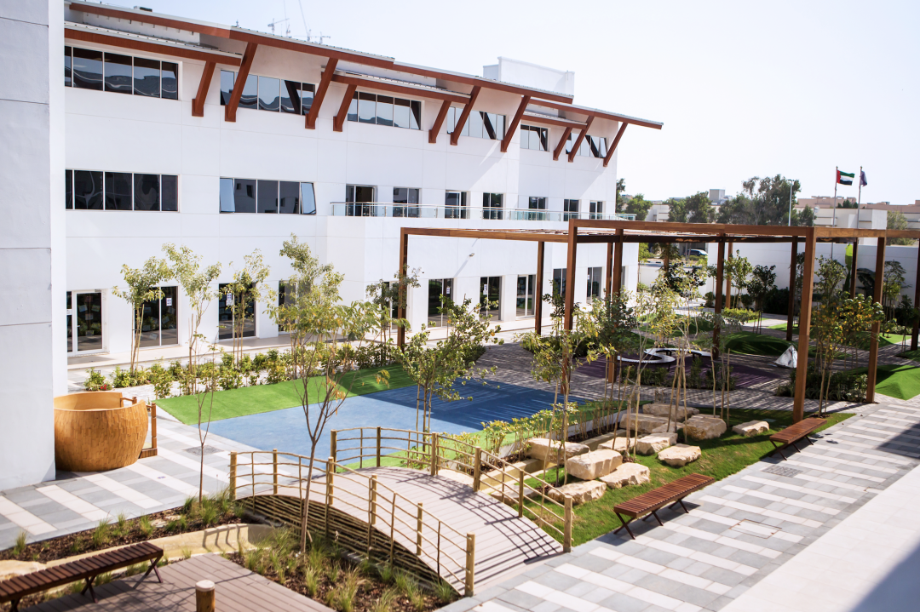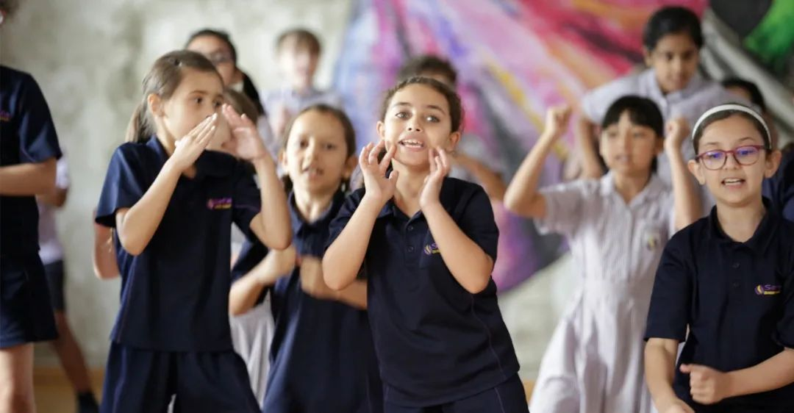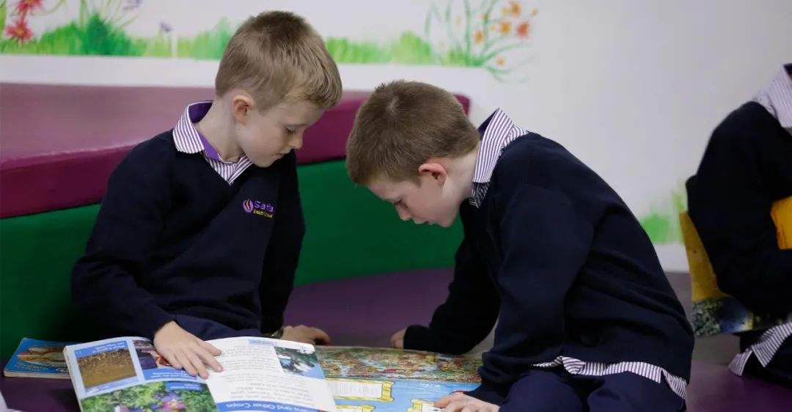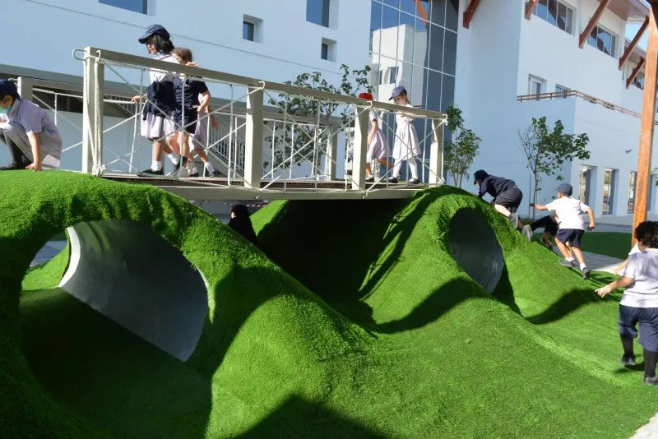

Safa British School was founded in 2004 and is a school with a long history. It is the sister school of Safa community school with a KHDA rating of 'very good'. In a new stage of development, Safa British School is opening a new campus in the Jumeirah area and is expected to open a secondary school department in the 2020-21 academic year. SBS (Safa British School) received a "Very Good" rating from KHDA during its 2019-20 review.

**Composition of School Students**

There are currently approximately 760 students aged 3 to 14 in the school. Students come from 41 different countries and regions, with the largest proportion of the population (24%) being Arabs. Students from India account for about 17%, followed by students from the UK (10%). The ratio of boys and girls is quite average at 51:49. About 40 students in the school are from the United Arab Emirates. SBS has 61 teachers and a large number of teaching assistants (30 in 2019-20) to provide support for children. Most teachers are recruited from the UK. The teacher-student ratio is 1:12, and the average class size is 24, which is also the largest class size in the school.

**School philosophy**

Like most schools, SBS aims to create a school that unleashes the potential of every child. To achieve its educational objectives, the school has the following educational philosophy components:

To become a diverse community composed of different nationalities, while also emphasizing the cultivation of local spirit and cultural development, in order to cultivate true multinational citizens and make them leaders in their respective fields.

The school is committed to creating a learning environment that eliminates all learning barriers and formulates appropriate policies to meet the needs of all learners.

By implementing the latest teaching methods, our primary goal is to ensure that every student in the school can achieve excellent grades in all core subjects. By implementing differentiated policies in school planning and teaching, each student can unleash their full potential.

Sports will become an integral part of our educational products and will be used to teach lifelong skills such as perseverance, perseverance, and self-discipline. Our challenging physical education curriculum cultivates the physical and mental health of our students.

We will provide excellent career development and customized career development opportunities for all employees, and establish a highly professional workforce that is always willing to face challenges and work with excellent standards.

We will provide parents with high-quality information, reports, and feedback on their child's progress, while encouraging them to actively participate through meeting plans, parent forums, and social activities.

**School system**

SBS offers a national curriculum in the UK, which also meets the teaching requirements of the Ministry of Education for Arabic and Islamic studies. To ensure that the curriculum truly reflects the national curriculum in the UK, SBS has obtained recognition for its overseas school qualifications, becoming the only school in 93 British schools overseas that fully meets the education standards of the UK. This qualification is recognized by BSO (British Schools Overseas) in accordance with the inspection standards of the UK government organization OFSTED.

The central goal of SBS courses is to provide learning and achievement opportunities for all students through the collaborative efforts of parents and local communities; Promote the moral, social, and cultural development of students, and prepare all students for opportunities, responsibilities, and experiences in their future lives.

By studying at SBS, students will gain:

lifelong learning competencies

Basic reading, writing, and arithmetic skills

Cultivate the attitude and understanding of successful independent learners

Cultivate their creativity

Cultivate lively and exploratory minds in students

Cultivate personal values, qualities, and attitudes, and teach students to respect others, their viewpoints, and opinions

Cultivate appreciation and attention to the environment

Collaboration ability

Unleash one's potential

FS1- FS2

Learn through play, observation, experimentation, adventure, questioning, repetition, and conversation. Conducted in seven areas of learning and development: communication and language, physical development, personal, social and emotional development, literacy development, mathematics, understanding the world, and expressive art and design.

KS1-KS2

KS1 is a school education between the ages of 5 and 7. KS2 is a school education for grades 3 to 6.

The subjects taught by KS1-KS2 include English, Mathematics, Science, Information and Communication Technology, Geography and History, Design and Technology, Music, Art, Arabic (as first and second languages), Islamic Studies (for Muslim students), Sports and Sports, Personal, Social, Health Education (PSHE), and Citizenship. Drama and sustainable development.

KS3

The KS3 course originates from the national curriculum and is improved to adapt to the local situation in the UAE, while also providing cross referencing between disciplines to ensure that students not only engage in tedious learning according to the theme, but also apply the knowledge they have learned to their daily lives.

GCSE/IGCSE

Students will choose GCSE or IGCSE for their courses. The courses will include English, mathematics, biology, physics, chemistry, history, geography, social research, moral education, French, Arabic, Islam, music, drama, art, design and technology, computer science, and physical education. The school also ensures that children are not solely focused on their studies, but provide opportunities to develop other skills, offering over 90 free extracurricular courses. Encourage middle school students to participate in sports, creativity, and community activities.

For students in need of special assistance

Safah UK School is an inclusive school that accepts students with varying levels of academic abilities. Approximately 100 students in this school have been identified as having some form of special education needs. These students are supported by an expert group consisting of 5 teachers and 22 learning assistants.. In primary school, schools offer ASDAN courses aimed at providing special learning programs for children with additional needs or disabilities.

# Greenfield International School

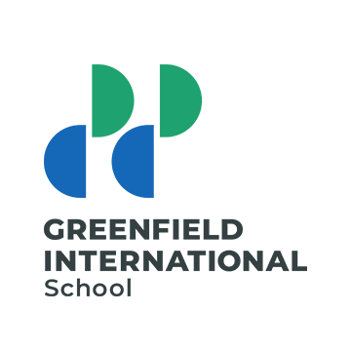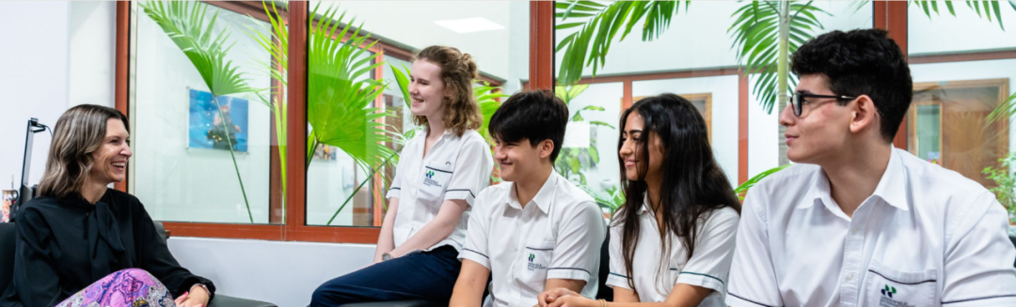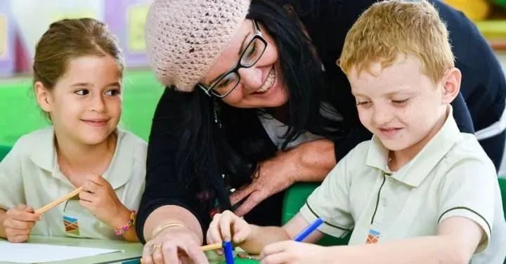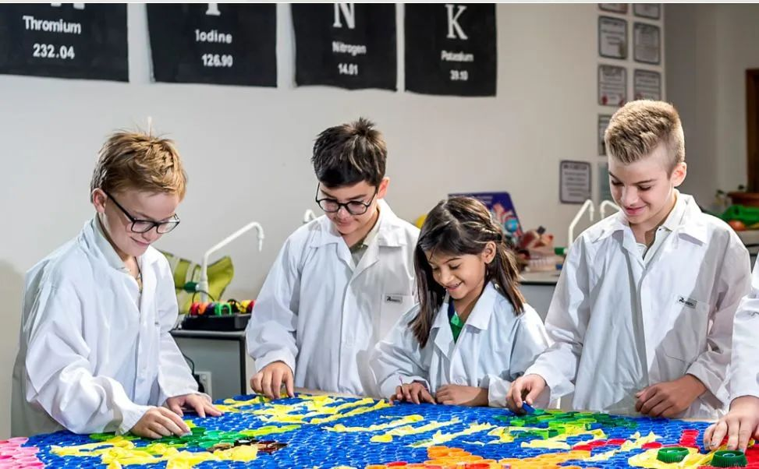

School system: IB system

Enrollment grade: Pre k to Grade 12

KHDA ranking: Very good

Tuition fee: 31750-78600

Address: Dubai Investment Park, Dubai United Arab Emirates

**Principal's message**/Ms Leigh Girven

Welcome to Greenfield International School

At Greenfield International School, we are proud to be more than just a school. We are a community composed of children, young people, educators, and families who play a unique role in making GIS an amazing place. We know that choosing a school can be one of the most difficult decisions faced by any parent, and we are happy to support and guide you through every step of this journey.

Greenfield International School is a highly respected member of the Taaleem group, which started in 2007. We are a fully authorized International Baccalaureate Continuing World School, offering IB courses from kindergarten to 12th grade. We are one of the few schools in Dubai that offers students two paths to high school, namely IB vocational related courses and IB diploma courses. IB is widely regarded as the most prestigious learning program, providing students with the educational background they need to enter the world's top universities.

As a new member of our community, you will immediately notice that we are a truly international school with rich cultural diversity. Our students come from over 80 different countries, and we are immensely proud of their respect for their traditions. Through IB's values, they also work together as true global citizens. In daily life, they show us their respect, openness, and tolerance, and attach great importance to their education.

Greenfield International School is a symbol of quality assurance and has obtained comprehensive certification from two of the world's most respected certification bodies; The International Council of Schools (CIS) headquartered in Europe and the New England Association of Schools and Colleges (NEASC) headquartered in the United States. In addition to IB authorization, CIS and NEASC certifications provide quality assurance for parents as you know your school meets or exceeds international standards.

As steadfast IB practitioners, our Greenfield International School staff are experienced international educators and the driving force behind the school's academic and pastoral success. Our classroom is a dynamic student-centered environment that balances exploratory methods with direct teaching. Our teachers actively encourage children's innate curiosity and love for learning both inside and outside the classroom. They pay great attention to supporting each child's social and emotional growth, and encourage them to apply their learning in a way that has a positive impact on the world.

Greenfield understands that we not only hope that every student can unleash their potential academically, but we also strive to provide opportunities for children to thrive in various fields. We offer a wide range of extracurricular activities (ECA), music, art, as well as social and competitive sports teams. With the support of our passionate and talented employees, many students have achieved regional or even national success, while others have the opportunity to explore their passion, learn new things, and enjoy a lot of fun!

Thank you again for your attention to our school. We look forward to you and your family becoming members of our international learner community.

**Course Introduction**

PYP (KG1 Grade5 3-11 Years)

The framework design of Primary School Curriculum (PYP) is specifically designed for international students. Composed of six interdisciplinary themed courses. Theme courses are all related to students' real lives, applying the knowledge learned to their daily lives and connecting it with other courses, not limited to textbook knowledge. This is called interdisciplinary theme courses.

Teachers work in collaborative groups, developing skills and conducting research through conceptual understanding, while also incorporating high-level student engagement. Students learn how to be thinking oriented and take responsibility for their own learning through exploratory guidance.

As an IB student, children need to learn how to show respect for themselves and others, develop international thinking through sharing with classmates, and actively respond to challenges.

Whether students return to their own country to study local courses or enter the middle school stage (MYP) of the IB system, or even the later IBDP and IBCP courses, PYP students are already prepared for this.

MYP (Grade6 Grade10 11-16 Years)

The MYP course is specifically designed for international students aged 11-16. The framework of holistic learning encourages students to have creative, critical, and reflective thinking.

The course emphasizes the challenge of intelligence and encourages students to establish connections between traditional subjects and the real world. This will cultivate students to develop their communication skills, cross-cultural understanding, and global engagement, which are essential qualities for becoming young leaders in the modern global environment. Whether it's IBD or IBCP, MYP students are always ready to tackle the learning tasks of higher grades.

DP (Grade11-Grade12 16-18 Years)

IBDP was the first research and development teaching project of IB, established in 1986. Combining academic rigor and broad knowledge, students are required to possess skills and expertise, as well as essential experience to become global citizens.

IBDP is a curriculum project that presents academic challenges and balanced education, with the final exam as the final stage, preparing students between the ages of 16 and 18 for success in university and beyond.

IBDP students mainly study six courses. At the same time, they also require the completion of additional university like papers and the study of epistemology. Students contribute to more communities by utilizing their creativity, participating in specific activities, and providing services.

CP (Grade11-Grade12 16-18 Years)

The IBCP course is specifically designed for students interested in vocational education in the last two years of high school.

IBCP combines the academic rigor of IBDP and applies it to the relevant career learning of CP. In IBCP, students can develop personal qualities and professional skills, while intellectual thinking habits are essential for lifelong learning.

IDCP students at GCS (Greenfield Community School) must study three DP courses and three BTEC courses related to their careers. The three DP courses chosen by students can help improve the theoretical foundation and academic rigor of their CP courses. These three courses should be relevant to the vocational courses they are studying and have a supportive effect. GCS (Greenfield Community School) emphasizes providing students with career related learning that aligns with their needs, preparing them for longer-term learning and career development in the future.

At the beginning, CP students will choose three courses from DP's curriculum: language, culture, language acquisition, personal and social, science, mathematics, and art.

We are familiar that GCS (Greenfield Community School) is an authorized IB international school, and students can also choose to join the school's online DP courses. In this course, students also need to complete the main courses of CP, as well as their personal qualities and professional skills, service learning, and language development.

In addition, students need to complete a project with reverse thinking, which can help them focus on their areas of interest. The combination of academic rigor and related vocational learning and development skills in CP courses can enable students to receive comprehensive education and gain global recognition and respect.

The most important thing is that whether choosing college life, internship, apprenticeship, or directly entering a career, students are already prepared for it. The research on career related learning provided by Greenfield Community School (GCS) will be continuously reviewed and developed to ensure that we meet the standards, certifications, and quality assurance of the IB system.

**extracurricular activities**

Greenfield International School provides students with optional and exciting extracurricular activities that complement the curriculum. These extracurricular activities can help students explore and develop their interests.

The extracurricular activities at school include: football, basketball, swimming, cricket, modern dance, chess, drama, rock bands, choirs, orchestras, Arabic calligraphy and art, creative arts, photography, science, robotics, ecological clubs, news, investment clubs, film clubs, debate clubs, Model United Nations (MUN), DELF French clubs, dynamic mathematics, and more.

Some ace clubs are provided by external suppliers and require additional fees.

# GEMS Wellington Academy Al Khail

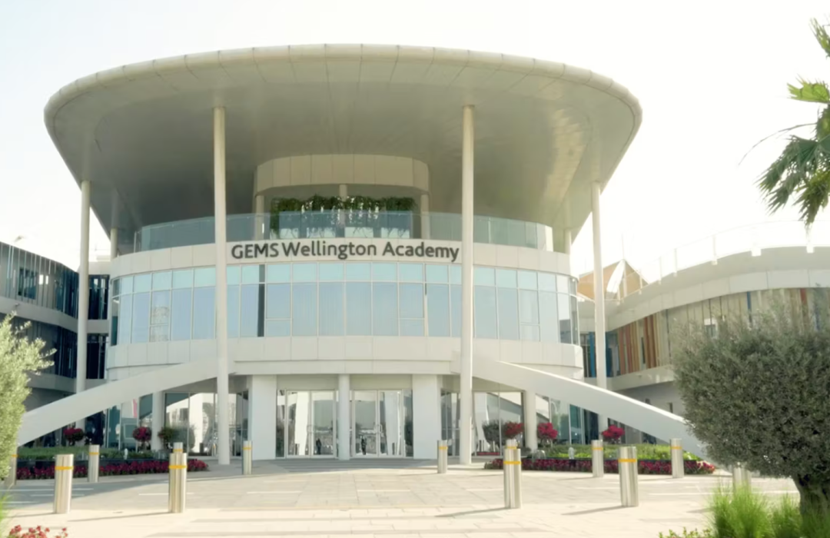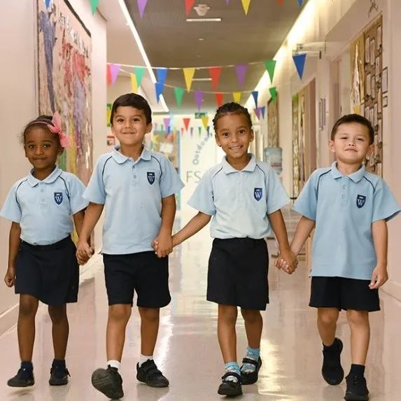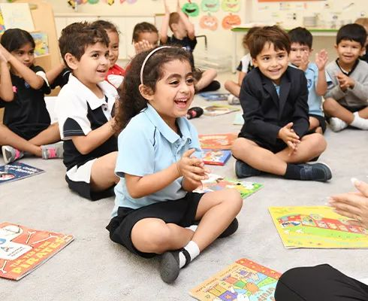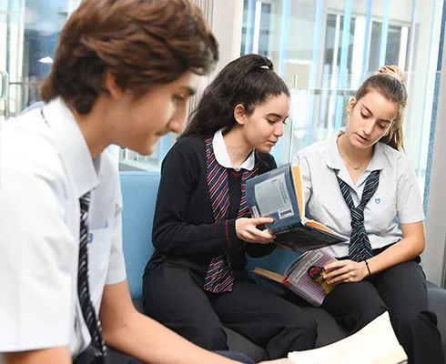

**School Introduction**

GEMS Wellington Academy - Al Khail was founded in September 2013 and is a world-class school with an international perspective, committed to cultivating students' outstanding learning abilities and love for life. The school is based on the mature GEMS Wellington academic learning model, creating an inclusive and creative learning environment for children, providing rich learning activities and international cross-cultural learning opportunities, encouraging children to maintain curiosity, independent thinking, and proactive exploration, and cultivating their enthusiasm for learning.

The curriculum system of the school is rooted in the National Curriculum of England (NCFE), combining theory with practice, guided by values, and integrating the diversity of cultures, backgrounds, abilities, and skills of students from over 80 different countries and regions. Through rich extracurricular activities and professional teaching plans, students can bring a broad perspective, achieve the best academic results, develop good study habits, have excellent learning abilities, and become lifelong learners. Can make independent decisions and effectively solve problems, actively communicate and integrate into the overall environment.

It is worth mentioning that GEMS Wellington Academy - Al Khail is a school rated as "very good" by the KHDA (Knowledge and Human Development Agency), which demonstrates the school's commitment to providing high-quality education and continuously improving its standards. This rating reflects the school's outstanding performance in teaching and learning, student achievement, and overall course quality.

**Principal's message**

GEMS Wellington Academy - Al Khail was founded in September 2013 and is a world-class school with an international perspective, committed to cultivating students' outstanding learning abilities and love for life. The school is based on the mature GEMS Wellington academic learning model, creating an inclusive and creative learning environment for children, providing rich learning activities and international cross-cultural learning opportunities, encouraging children to maintain curiosity, independent thinking, and proactive exploration, and cultivating their enthusiasm for learning.

The curriculum system of the school is rooted in the National Curriculum of England (NCFE), combining theory with practice, guided by values, and integrating the diversity of cultures, backgrounds, abilities, and skills of students from over 80 different countries and regions. Through rich extracurricular activities and professional teaching plans, students can bring a broad perspective, achieve the best academic results, develop good study habits, have excellent learning abilities, and become lifelong learners. Can make independent decisions and effectively solve problems, actively communicate and integrate into the overall environment.

**Curriculum system**

Enlightenment stage

Children are the center of everything, and experienced teachers provide children with rich gaming experiences. Children can explore, create, solve problems, and express themselves in different ways. Adults are co learners of children's games and interactions with the world. Teachers adjust the environment and curriculum to meet the needs, strengths, next steps, and interests of each child, encouraging them to discover and follow their own interests and exploratory thinking.

The Reggio Emilia heuristic education environment in the school provides a child centered and comprehensive approach to early education. Schools use natural resources, natural light, and materials to create a place to cultivate a shared environment, making children feel confident and happy. The game area specially built by the school aims to provide a warm and comfortable "home outside of home" for your young children. The school environment is rich in language characteristics, and teachers receive training to promote early language development. Children are encouraged to express themselves in various ways throughout the day, including sports, drama, dance, painting, construction, and sculpture.

Schools attach great importance to cultivating children's sense of responsibility and respect, encouraging them to develop independence and confidence in interacting with others, and developing their unique personalities. The school has carefully designed indoor and outdoor learning spaces for children, allowing them to learn and play together, learn to interact, communicate, and cooperate with others.

In the early stages of education, schools strive to create a strong sense of community and value the interaction and connection between children, adults, and the environment. The school also pays attention to the continuity between different stages within the curriculum system, laying a foundation for children to enter higher grades and the English system in the future, and making good connections.

Fundamentals of Early Education

The courses in the basic stage of early education provide excellent early learning for children. When children are in FS1 and FS2, schools practice the early basic stage curriculum of English, targeting children under 5 years old, including those with special education needs and disabilities. There are a total of seven areas of learning and development, all of which are important and closely related, ensuring development and progress through planned and purposeful games as well as adult led and child initiated activities. Through games, children can learn to explore, think about problems, and build confidence when interacting with others.

There are four guiding principles for early childhood education centers:

Every child is unique, and through continuous learning, they can become resilient, capable, and confident; Through active interaction, children learn to be strong and independent; Under the guidance and support of teachers, children gradually establish a learning model, and their interests and needs are maximized in response. Home school cooperation is carried out to witness the growth of children together; Children develop and learn at different speeds.

The school adopts a small class teaching model, with the most advanced facilities and excellent teaching team, allowing every child to pursue, create, and surpass, providing a safe, valuable, healthy, and happy environment for children.

Primary school stage

In primary school, the school sets annual curriculum standards, and teachers inspire and inspire children to learn through planning and engaging activities, providing personalized learning for each child, supporting and developing their unique abilities. Children integrate the connection between disciplines, theory and practice, complete open-ended tasks, continuously explore, exercise thinking abilities, and acquire problem-solving abilities.

The primary school curriculum is divided into core subjects, Projects 4 Change courses, and additional professional courses. Children will work hard according to the annual curriculum standards to prepare for a smooth transition to the next grade and the secondary school department. The core courses include English, Mathematics, Science, Arabic A, Arabic B, Islam, Social Ethics, and Cultural Studies. And the basic subjects are conducted through our Projects 4 Change course, each of which provides opportunities to deepen students' understanding of the subject area, ensuring a balance between thematic and discrete teaching, while emphasizing knowledge and skills, mainly including geography, history, design and technology, art and design, computing and robotics, and Grovell Happiness class. In addition, students also have a large number of additional professional courses, including Arabic, Islamic culture, sports, music, French, and Spanish, all taught by expert teachers. In addition, the school also offers a variety of extracurricular activities, tours, theme exploration activities, campus activities, performance competitions, speeches and dramas, student unions, private vocal and instrumental courses, ESM after-school clubs, and more. To enhance the classroom learning experience of students, as a supplement to teacher teaching, students in third grade and above in schools carry iPads and use many educational applications, such as CENTURY, Seesaw, Purple Mash, Times Tables Rock Stars, NumBot, etc., allowing children to access a wide range of cutting-edge digital resources and personalize their learning experience.

Middle school stage

In secondary school, students need to prepare for the GCSE or ASDAN exams at the end of 11th grade, and also prepare for and connect with continuing A Level or BTEC education beyond the age of 16. The expert team attaches great importance to the important connection between ideals, motivation, and independent learning, and has developed a consistent teaching method that can cultivate thinking ability and collaborative learning, and encourages students to participate in various formal and informal courses. At this stage, students focus on cultivating their leadership, sense of responsibility, and positive behavior management abilities. The school also strives to cooperate with parents and encourages them to meet with teachers regularly to discuss learning progress and the next steps, without letting any children fall behind.

Grades 7-9 attach great importance to curriculum balance and cultivating children's interest in learning, cultivating an academic culture, encouraging students to become independent explorers and thinkers, and learners who engage in extensive reading, challenge, and questioning. The subjects in this stage mainly include English, mathematics, biology, chemistry, physics, Arabic, Islamic studies, morality, social and cultural studies, society and enterprise, geography, history, French, Spanish, drama, music, sports, art, design technology, and computation. After 9th grade, students are required to take compulsory courses and choose four elective subjects to study GCSE, IGCSE, and BTEC level courses. The compulsory courses include English language, British literature, mathematics, biology, chemistry, physics, morality, social and cultural studies, physical education (non examination), Islamic studies (only for Muslim students), Arabic as the first language (only for Arab passport holders), Arabic as the second language (non Arabic students up to 10th grade). The elective courses include geography, business research, enterprise, psychology, history, French, Spanish, media research, computer science, sports, art, 3D design, dance, drama, music, design technology - product design, design technology - textiles, design technology - Technology - Food Preparation and Nutrition, Economics, Photography, ASDAN International Awards, BTEC Level 2 Sport, BTEC Secondary Creative Media. In addition, there are also rich on campus and off campus activities to promote the comprehensive development of students' physical and mental health.

After the age of 16

The curriculum of the college is different from that of other schools in the United Arab Emirates. Starting from the 12th grade, students learn a wider range of A-Level and BTEC courses. The school establishes a personalized personal support system centered on the comprehensive development of children, providing them with the best learning platform. In 12th grade, students begin college education and life skills programs to cultivate life skills and abilities, face special situations with more confidence, improve academic performance, and promote social, moral, cultural, and spiritual development for all of us students, preparing for college life.

# Dubai British School Jumeirah Park

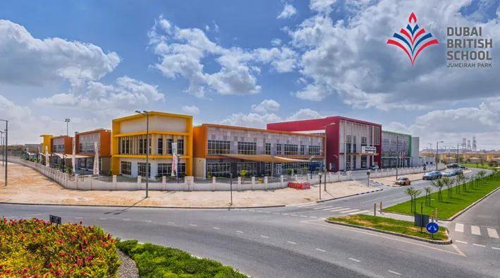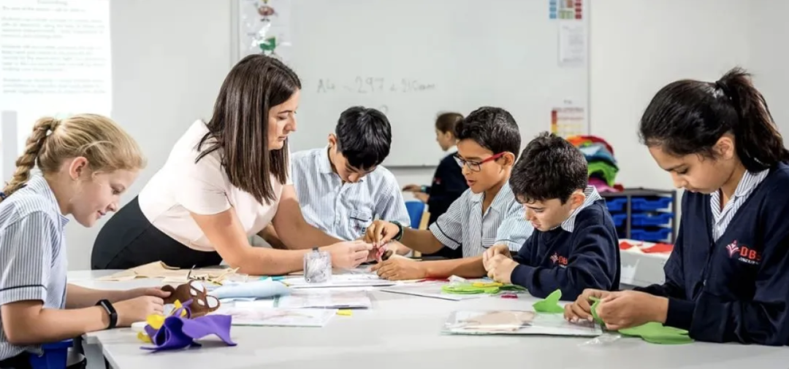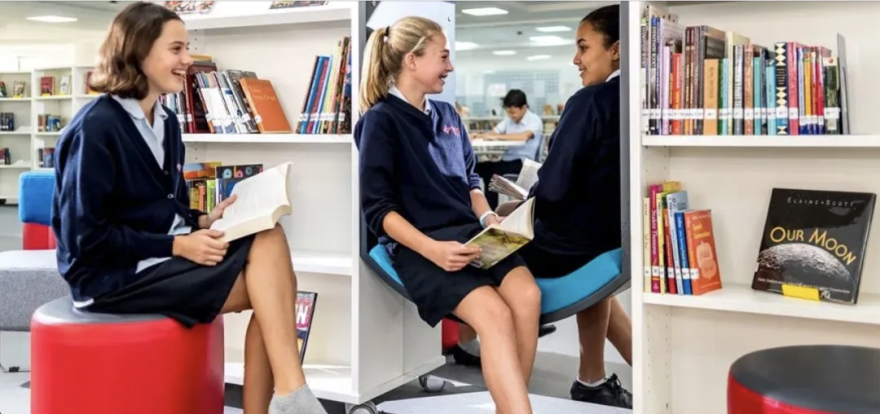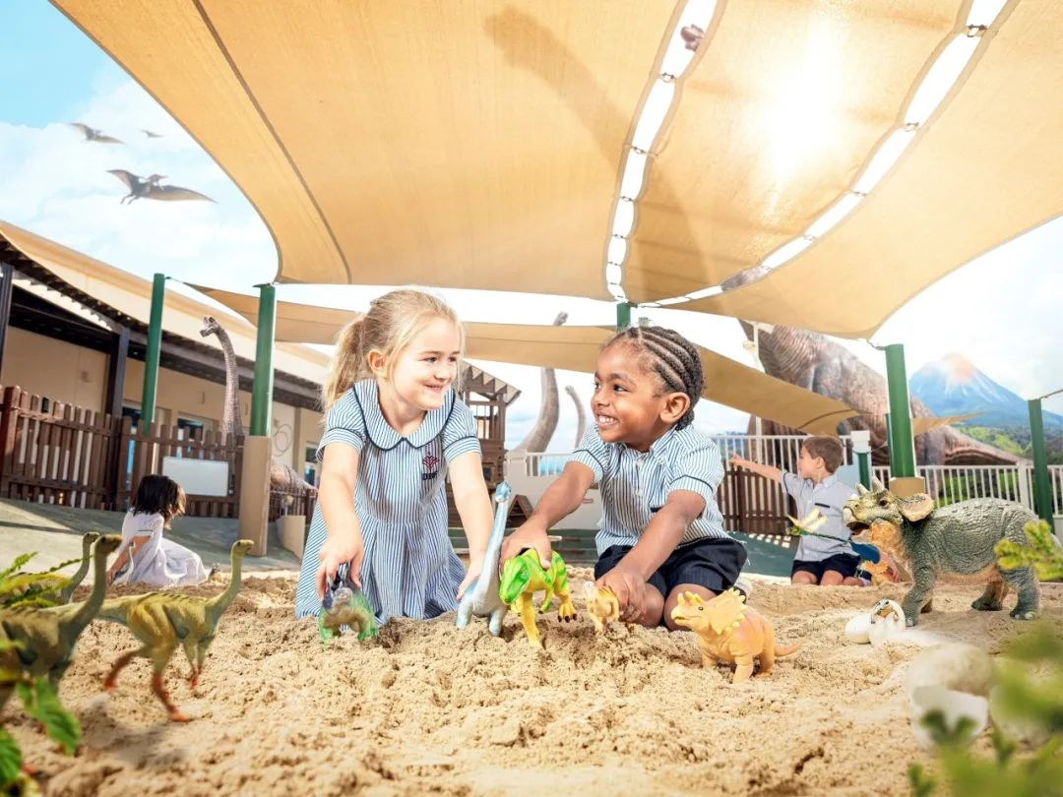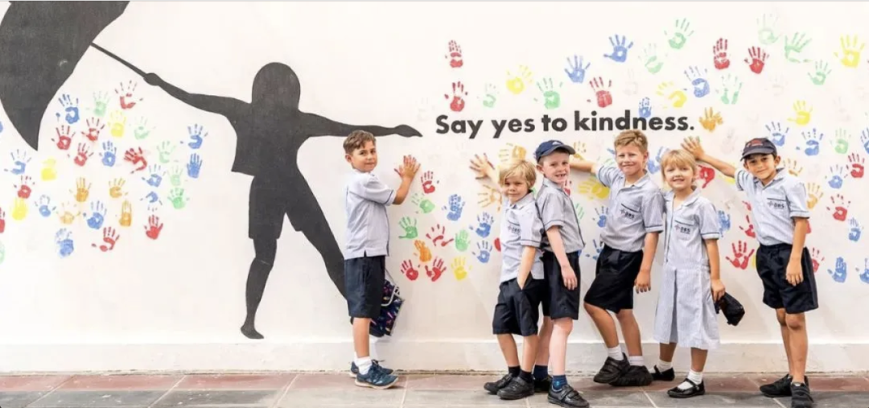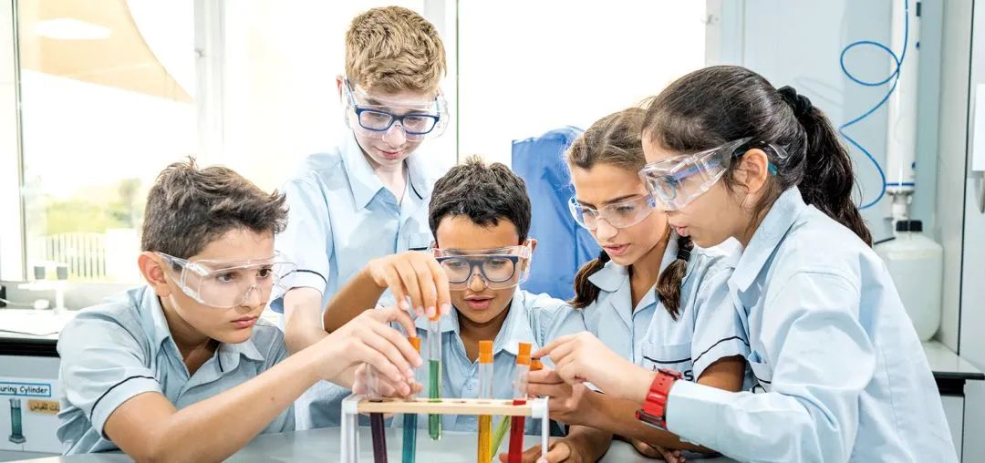

School English Name: Dubai British School Jumeirah Park

School system: English system

Current rating: Very good

Enrollment grade: FS1-Year13

Tuition fee: AED -59700-77250

Address: Al Ward St 1, Jumeirah Park Dubai, United Arab Emirates

**School Introduction**

DBSJP, also known as Dubai British School, is one of the schools under the Dubai Taaleem Group and was opened in 2015. DBSJP is a branch of Dubai British School and has been rated as outstanding for many years. DBSJP is located adjacent to the Jumeriah Park, Springs, Meadows, JLT, Emirates Hills communities and has rapidly developed into one of the best British schools in the community. The school accepts students aged 5-18 from around the world. DBSJP puts students first and drives the interests of the entire community near the school. "Enjoyment", "Desire", and "Achievement" are the common vision of Dubai UK schools. Schools provide perfect facilities, teacher resources, and inspiration, allowing students to fully enjoy their campus life, learn to set their own expectations, and ultimately achieve their goals through hard work.

In addition, it specifically provides students with all the facilities necessary for a thriving educational experience. This includes science laboratories, art studios, drama and dance studios, music and practice rooms, ICT kits, gymnasiums, learning and language support rooms, libraries, activity rooms, and innovation centers that support STEM learning and design technology kits.

In addition, DBSJP School also has a food laboratory, broadcasting studio, and radio station, an auditorium that can accommodate 550 people, a multi-functional sports arena, a multi-functional stadium, an indoor 8-lane champion sized swimming pool, and a training pool. The school also has a football field, tennis court, indoor and outdoor playgrounds, as well as a restaurant and two health centers.

**Course settings**

The curriculum of Dubai UK schools is divided into four categories, and schools follow the curriculum of English speaking countries at all levels. This includes Foundation Stage, Primary Curriculum, Secondary Curriculum, and Six Form.

Foundation Stage

Kindergarten Stage 1 and 2 (EYFS) provide basic learning, early childhood development, and care for children from birth to the age of 5. FS 1 and FS 2 are managed by the Dubai British School Jumeirah Park Foundation and are only a 5-minute drive from DBSJP School.

Primary Curriculum

In primary school (Key Stage 1&Key Stage 2), Key Stage 1 is in grades 1-2 and Key Stage 2 is in grades 3-6. Students will learn the best country calculations and national literacy strategies based on the UK curriculum. The courses offered at this stage include English, Language and Literature, Mathematics, Science, Design and Technology, Computer Science, History, Geography, Music/Dance/Drama, Physical Education (PE), and Arabic.

3rd and 6th grade students can choose optional languages, such as French and Spanish. Similarly, sixth grade students are required to take Standard Achievement Tests (SATs). These tests and courses enable students to develop the skills, knowledge, and understanding required for high school proficiency.

Secondary Curriculum

The middle school stage includes key stages 3 and 4. The school follows the General Certificate of Secondary Education (GCSE or IGCSE). Students will take the International General Certificate of Secondary Education (IGCSE) exam in 11th grade.

Key Stage 3 is for grades 7-9 and matches the curriculum of leading independent schools in the UK to promote seamless learning for students in university. DBSJP has adapted the national curriculum for England and Wales and enriched it to align with the governance of our country. According to the regulations of the UAE Ministry of Education, Jumeirah UK School in Dubai provides Arabic language, Arab social studies, and Islamic studies for Muslim students.

Key Stage 4 is for grades 10-11, and the course prepares students for a series of (I) GCSE exams for national courses in England and Wales. These exam courses will provide comprehensive guidance and coaching systems to support students based on their individual learning needs. Through our personal, social, and health education programs, as well as outdoor education opportunities, we will encourage our students to participate in decision-making. We will cultivate and encourage each student to grow into responsible small leaders.

Six Form

Six Form, also known as Key Stage 5 in the British system, is for grades 12-13. The purpose of Dubai Jumeirah UK School is to provide challenging, purposeful, and balanced courses for our students under the age of 16, enabling them to gain international recognition and be accepted as qualified students for higher education admission requirements.

DBSJP provides three academic learning methods for Six Form stage students: A-level, BTEC, and a hybrid system of A-level and BTEC.

**extracurricular activities**

Providing students with activities they are passionate about can enhance their brain function, help them better concentrate and manage time, all of which can help improve grades. DBSJP provides various free additional extracurricular activities to ensure the improvement of students' social skills and self-development. In addition, DBSJP also offers some paid extracurricular activities.

# Hartland International School

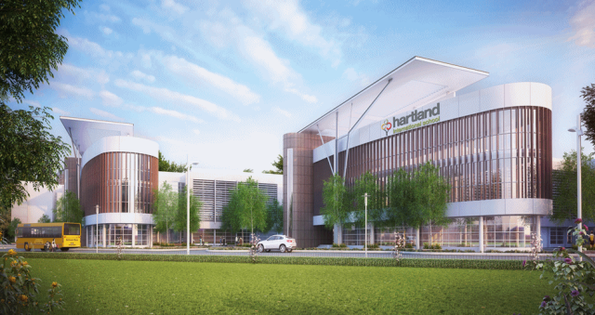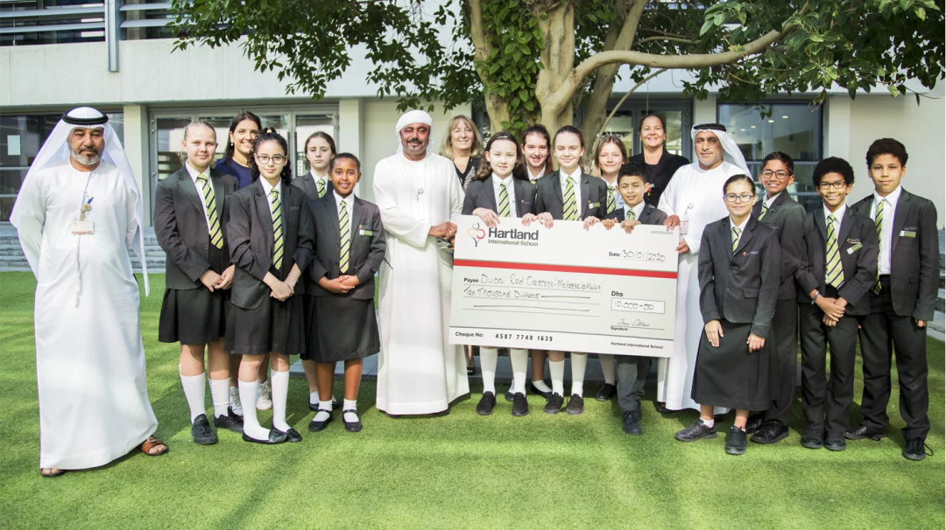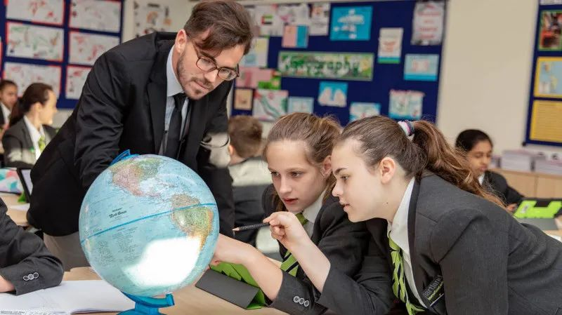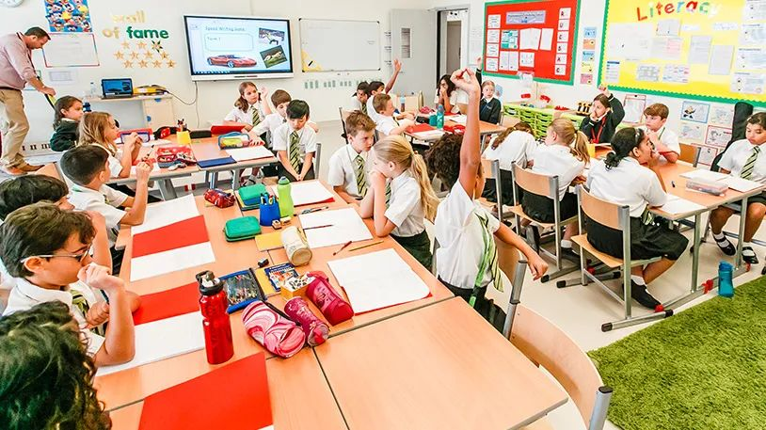

**Why choose Hartland?**

The constantly advancing ideology and a strong and experienced teaching team have converged into a unique and vibrant Hartland. We are well aware that successful education is not just about pursuing the highest scores, so Hartland provides high-quality academic education for children while also creating a safe and warm environment, equally emphasizing the development of children's minds.

Experienced academic team

Experienced

01

Each member of Hartland's senior teaching and research team, whether at the Dubai or UK campuses, has taught courses under the British and other national systems for an average of 20 years and has also participated in them

Teaching and research work at Outstanding School. Hartland's teachers value the academic, social, and psychological development of every child.

2019-2020 KHDA Report

"Principal Hartland and all senior academic advisors form a very strong and professional leadership team. They work closely together, have consistent goals, and rely on their rich experience in the education industry and innovative spirit to provide high-quality and inclusive top-notch education for children, while perfectly aligning with the local culture of the United Arab Emirates."

Excellent academic abilities

Excellence

02

The academic ability of Hartland International School is not only reflected in "beautiful transcripts", but also in the environment that the school wholeheartedly creates for children to think and seek knowledge. Through a practice based learning approach, children can acquire necessary basic skills from the enlightenment period and lay a solid foundation for future learning.

2019-2020 KHDA Report

"Students at various stages have made great progress in English, mathematics, and science, and have also reached a high level."

Wide range of interest courses

Enrichment

03

Interest courses are an important component of a child's comprehensive development. Students can choose their favorite extracurricular activities from over 100 clubs and a variety of interest courses. Hartland International School is never limited to limited classroom learning. Children will have 4 hours a week for a series of extracurricular activities to develop their existing or explore new interests and hobbies. In order to have more diversity and professionalism in activity types, after-school activities are not limited to teacher led activities, and schools will also cooperate with third parties to provide various courses and activities for children. Moreover, the cost of extracurricular interest courses and activities is almost always included in tuition fees.

2019-2020 KHDA Report

"The interdisciplinary connection between mainstream courses and extracurricular interest courses greatly stimulates children's interests and talents."

The happiness and tolerance of students

Well Bei

04

Hartland International School has always been committed to becoming a "inclusive" school, striving to meet the diverse needs of all students. Hartland's teachers are not only dedicated to helping students during class hours, but the entire teaching team puts students at the center of the entire school at all times. The Hartland gifted program not only provides space for students who have spare energy to expand their abilities, but also provides opportunities for development for all students.

2019-2020 KHDA Report

"Hartland is a school that respects the local policies of the United Arab Emirates and is highly inclusive. The entire teaching and research team, led by the teaching and research team, strictly follows the school's relevant rules, and the school has been practicing the Hartland spirit through actions."

Community schools

Community

05

It is crucial for schools to establish strong connections with parents and students, and Hartland maintains close communication with every student and parent. In every parent teacher meeting, the school has planned for each child's future and carefully listened to each parent's vision and ideas, connecting home and school, and working together. Parents are indispensable for both Hartland management and parental roles, so we affectionately refer to them as "Hartland Friends.". Our shared vision that spans all aspects of school life has long gone far beyond the realm of education, which is why parents and students from 65 different countries are willing to believe in Hartland International School.

**From Mr. Fiona Cottam**

Welcome to Hartland International School!

We attach great importance to the quality of teaching, school life, and education itself, but the source of our emphasis and concern is our students. Children will have various needs, academic and emotional, but they also have many creative ideas, different hopes, dreams, and visions. All staff at Hartland have always adhered to Hartland's teaching philosophy and spirit of putting children at the center, which is also the source of my confidence in our team.

We always strive to shape Hartland into an orderly, supportive, and loving small community that includes 91 students from different countries, and help encourage every child to embark on the path of success. We firmly believe that children can only better develop their potential and personality in happiness. If you stroll through the school corridor and pass by the classroom, you can definitely see the joy and satisfaction on the faces of the children, as well as feel their inner thirst for knowledge and curiosity. Our students enjoy the classroom, are positive and always show confidence, friendliness, happiness, and liveliness. Moreover, Hartland's students have a strong sense of pride and honor towards their school.

We adhere to education as providing children with correct guidance and fully unleashing their potential. This also depends on the support of the child's family, so we attach great importance to communication and cooperation with parents.

**Course settings**

Basic Stage FS1 and FS2

(3-4 years old)

Schools provide a good starting point for children's education, igniting their enthusiasm for learning during their early stages of development.

Hartland provides an environment where academic and fun coexist, ensuring the safety of children and cultivating the confidence they need to face new challenges. In the preparatory stage, the school encourages and promotes learning in all areas of the Early Childhood Basic Stage Curriculum (EYFS), celebrates the achievements of each child, and prepares them for a smooth and happy transition to primary school. The goals that most children should achieve at the end of their basic stage consist of seven learning areas: personal, social, and emotional development, physical development, communication and language, reading and writing abilities, mathematics, understanding and comprehension of the world, and expressive arts and design.

Experienced teachers encourage and expand each child's innate curiosity and enthusiasm when developing various skills, and will group children into pairs and study various different activities separately based on their learning styles and preferences. The seamless integration of digital technology and curriculum ensures that all children are confident in using technology as a learning tool.

Primary school grades 1 to 4

(5-8 years old)

When children transition from the basic stage to primary school, schools will expand their thinking, cultivate their ability to observe in all subject areas, enhance their questioning and participation in survey work. Teach children to make decisions and seek greater independence in learning, and continue to expand the various challenges they face. Encourage them to explore key issues in the thematic area and deepen their understanding of things. The teaching style of the school will enable students to connect their learning with the real world, make learning more active, and ensure that the skills they acquire will not be forgotten in the coming months and years.

Language ability is Hartland's top priority. As a part of the international community, schools regard language learning as a core deliverable. Whether it's a commitment to learning Arabic or providing Mandarin, French, Spanish, and German starting from 2nd grade, we will ensure that every child can maintain fluency and be undisturbed in any primary school environment around the world.

Through powerful performing arts courses, children will continue to unleash their imagination and be able to confidently and creatively express themselves. The school encourages all students to participate in school performances, providing them with the opportunity to build social skills while learning collaborative work to achieve success.

5th and 6th grade

9-10 years old

In the upper grades of primary school, children will continue to be encouraged and challenged within a more rigorous academic framework. In addition to the professional courses already provided, the school will introduce drama as an independent and professional theme, as well as humanities to enrich the international primary school curriculum. The goal of schools is to connect thoughts and learning with the real world of children's lives.

Through this personalized learning method, the school hopes to cultivate students who have confidence, determination, and enthusiasm to face future challenges.

Middle school grades 7 to 13

11-18 years old

When students enter Hartland's secondary school stage, they will possess excellent learning skills and have confidence in mastering their learning outcomes. The school curriculum provides comprehensive education, combining academic excellence with abundant learning opportunities. Intended to cultivate independent learning ability, adaptability, and confidence. The school's belief is to provide students with a direct advantage in obtaining degrees at top universities and later in the workplace.

In addition to academic courses, the school will continue to provide a complete curriculum that encourages students to participate in sports, creativity, and community activities. In 12th and 13th grade, the school plans to offer a wide range of international diploma courses or more specialized A Level courses. The school's mentors, advisors, and counselor team will provide guidance to students and parents to help you make these choices.

School sports

Hartland International School offers a variety of competitive and recreational sports activities in its spare time. The school not only wants to improve the physical fitness of students, but also aims to cultivate their teamwork awareness and self-discipline through rich sports activities.

Competitive sports

Competitive

Dubai is divided into three semesters a year, and each semester the school divides students into different alliances and holds different sports activities. Students have been participating in competitive sports activities since Year 3 (u8 level), and it has been a long journey of sports competition until Year 13 (u19 level). The sports season usually starts in mid October when the weather gradually cools down, and the training time is usually before the first class or after the last class.

At present, the types of sports in Hartland include:

Sports teams: football, basketball, rugby, cricket

Individual sports: cross-country skiing shooting, athletics, swimming, golf

Entertainment non competitive sports and activities: dance, yoga, sailing, skiing, martial arts, gymnastics, cycle training

# North London Collegiate School Middle East

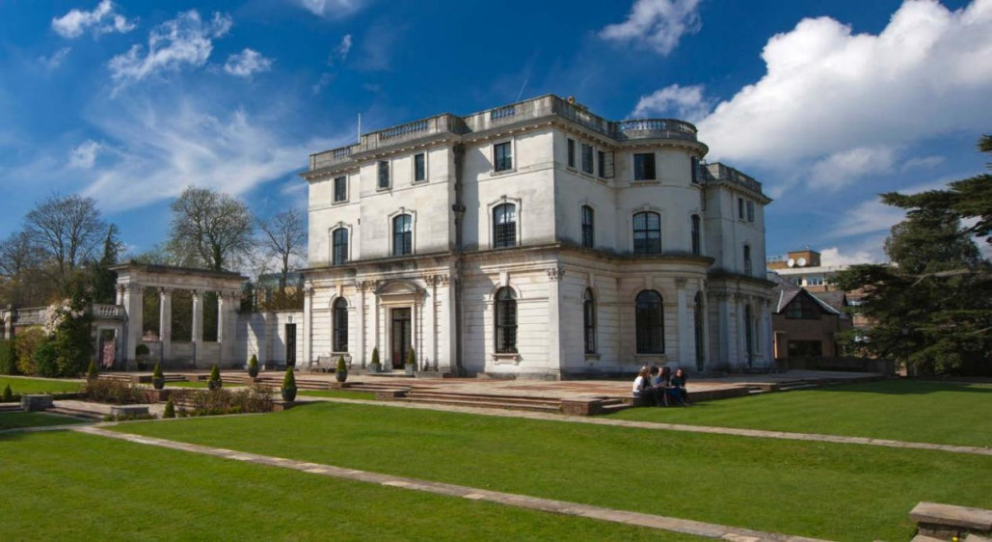IMG_256IMG_256IMG_256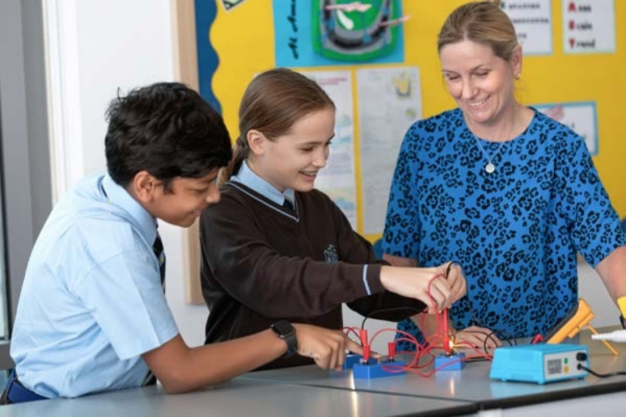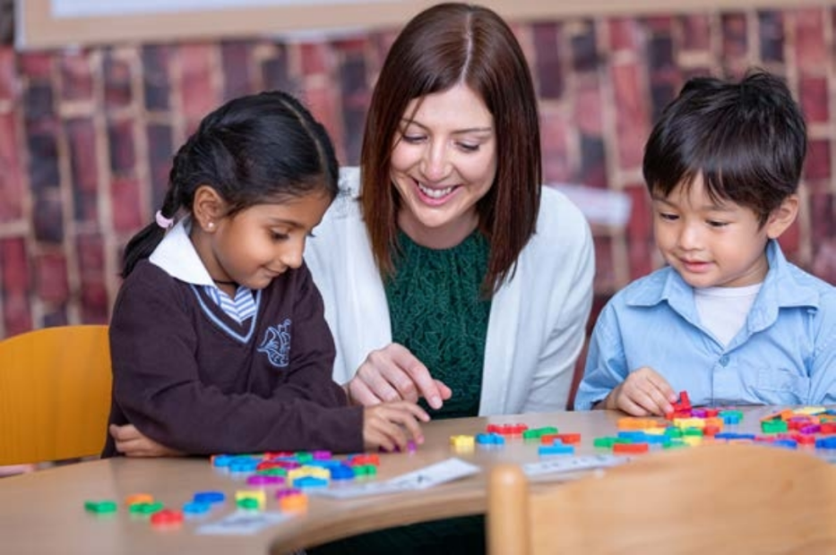

Current rating: Very Good

Enrollment grade: Pre primary - GRADE 12

Tuition fee: AED 87358-136825

Address: Nad Al Sheba - Nad Al Sheba 1- Dubai - United Arab Emirates

**Principal's message**

NLCS Dubai provides unique educational services for families in the region, combining rich traditions with academic excellence and inspiring subject teaching.

The school was founded in 2017 and has grown rapidly, becoming an exciting and vibrant learning venue. Every day is filled with the sound and energy of activities, and students can pursue their interests and enthusiasm under the guidance of our inspiring teaching team. The various sounds echoing within the school, from music playing to students chatting and laughing, parents chatting, and teachers warmly guiding students in the classroom, are all enjoyable. The warm and open relationship between employees, students, and parents provides a genuine sense of community and care. You only need to spend a few hours at school to feel the safe and happy atmosphere of North London schools.

The school has established a strong and inspiring educational reputation for students in Dubai in a relatively short period of time. The International Baccalaureate (IB) curriculum and the philosophy of North London schools have been cleverly integrated to ensure that the academic experience we provide provides students with a very rich and engaging environment. We have high expectations and aspirations for all students, whether in the classroom, on the sports field, or at the school's performing arts center. In the past few years, they have indeed addressed this challenge and achieved record success in MYP and diploma exams. In 2023, NLCS Dubai was the best performing IB school in the region, with an average diploma score of 37.2 and an average MYP score of 49. Many of our students have graduated and entered top universities around the world, continuing to achieve success shared by our school family.

We are very fortunate to have a venue with excellent facilities. Nevertheless, the most important feature of the school is our teachers. We have recruited high-quality and passionate teachers who can inspire and inspire the students they care about. They love their subjects, making learning irresistible. This is combined with excellent psychological care and attention to extracurricular life in school, continuing to ensure that students are happy to attend school every day and have the opportunity to fully unleash their potential, while making multiculturalism and inclusivity a part of the school. I look forward to meeting many of you who will soon come to visit us and join our beautiful community.

Jonathan Locke

principal

**Course settings**

Junior School

The junior high school section of NLCS Dubai is designed for students from preschool to fifth grade (kindergarten to sixth grade in the UK system). It includes the first school (preschool to first grade) and the junior high school (second to fifth grade).

In the 2023-2024 academic year, there are still vacancies available for all grades in the junior high school department. The life in the junior high school department is full of vitality, happiness, and excitement, with rich courses and a warm community atmosphere, providing the best educational starting point for your child. Starting from the age of three, students will follow an academically ambitious learning plan, and their teachers create a good learning environment that enables them to actively discover new knowledge, skills, and understanding.

Senior School

The high school section of NLCS Dubai is open to students from grades 6 to 12 (grades 7 to 13 in the UK system). The high school section consists of middle school (grades 6-8), high school (grades 9-10), and sixth grade (grades 11-12).

The school provides exceptional education, ultimately leading to the International Baccalaureate Preparatory Program. This is a course with an international qualification of "gold standard", which helps to enter world leading universities. The goal of the school is to make every student aware of outstanding academic achievements and realize that they can be achieved. The school believes that students should have every opportunity to try new things, explore interests and talents, in order to promote the development of their overall personality. Through inspiring teaching, NLCS students will cultivate a passion for the subject and truly become independent learners by exploring this passion for the subject.

All students from grades 6 to 10 will belong to a "vertical" mentor group composed of students from different grades and will receive psychological care from the mentor, who will accompany them as they advance to school. These mentor groups are part of a psychological care "family" system, enabling students of different grades to socialize and grow together, thereby creating a strong sense of community and cultivating a healthy competitive spirit!

**School culture**

Our lives are influenced by our experiences during our school years. We provide ambitious academic education that encourages students to discover their passions, helps them see higher and farther, becomes leaders, and prepares them for success and a fulfilling future. At NLCS Dubai, we support every child in developing their unique talents and becoming a grounded and confident individual, allowing their potential to develop without any constraints.

**tuition**

Application fee: 525 dirhams

PK tuition fee: 69600 dirhams

K tuition fee: 80750 dirhams

First grade tuition fee: 80750 dirhams

Tuition fee for 2nd grade: 80750 dirhams

3rd grade tuition fee: 80750 dirhams

4th grade tuition fee: 83300 dirhams

5th grade tuition fee: 83300 dirhams

6th grade tuition fee: 92000 dirhams

7th grade tuition fee: 92000 dirhams

8th grade tuition fee: 92000 dirhams

9th grade tuition fee: 96000 dirhams

10th grade tuition fee: 96000 dirhams

Tuition fee for 11th grade: 104000 dirhams

Tuition fee for 12th grade: 104000 dirhams

The English College Dubai

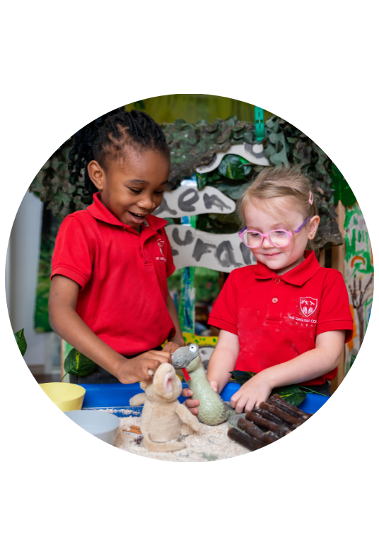

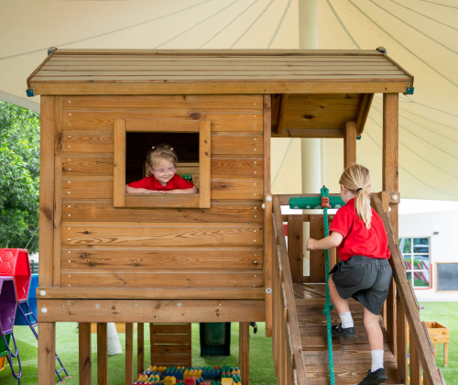

Welcome and Marhaba to The English College (EC), a British curriculum school in Dubai. We have been providing a world class education since 1992, for children from Foundation Stage 1 through to Year 13.

As a school, we have a particular and very special ethos. Put simply, our core purpose is to inspire confident and passionate learners who will thrive and make a difference during their time with us – a difference to their own lives and the lives of others.

With our BSO (British Schools Overseas) “Outstanding” rating and DSIB (Dubai Schools Inspection Bureau) “Very Good” rating, we are proud to provide an exceptional educational experience. Our outstanding pastoral care, personal and social development ensure that your children are valued as individuals who bring their uniqueness to our family-orientated community school.

We are very proud of our strong heritage, traditions, and values and are constantly looking forward, seeking to innovate and improve at every age and stage for each and every one of our pupils. High-quality teaching and learning and the very best pastoral care and extra-curricular provision lie at the very heart of our school.

We are not just another British curriculum school in Dubai – we are more than a school, we are a community, an experience and a way of life that nurtures excellence in every aspect. Our community is culturally rich and diverse and as a school, we recognise and celebrate this, helping each individual to ‘be the me I choose to be’. Our students are many things but most of all they are themselves. It is this which prepares them for the unknown and exciting life in the world beyond school.

Most importantly, we are a happy school with a great spirit and a sense that anything and everything is possible. It is only by coming to visit us that you will truly be able to get a sense of our positive and thriving learning community. On behalf of the EC community, we look forward to welcoming you and showing you our school in action.

**Course settings**

Child-Led Inquiry-Based Learning

We provide an outstanding child-led, inquiry-based curriculum that sparks curiosity and fosters a love for learning.

Highly Qualified and Engaged Staff

Our staff continuously enhance their understanding of pedagogy and the EYFS curriculum to ensure effective teaching practices. We prioritise increasing children’s Characteristics of Effective Learning (COEL), promoting resilience, confidence, and self-assurance.

High-Quality Enabling Environments

We create high-quality, stimulating, safe indoor and outdoor environments supporting children’s learning and development. Our environments are responsive to children’s interests, allowing them to explore, discover, and learn at their own pace.

Personalised Learning

We recognise that each child is unique and arrives with differing attributes and needs. Personalised learning is at the heart of our practice, ensuring that every child receives individualised attention and support.

Play-Based Curriculum with Sustained Shared Thinking

Our curriculum is delivered through play-based learning, fostering active engagement and independent thinking. Children participate in Choose Our Own Learning (CooL) activities throughout the day, led by their interests, while our skilled staff extend and challenge their skills.

Holistic Development

Our approach focuses on developing key skills, such as motivation, creative and critical thinking, and engagement, through a variety of learning experiences. We support children in becoming creative, happy, confident, and independent lifelong learners.

Enriching Classroom Environments

Our classrooms are designed as “enabling environments” that offer a rich and varied space for investigation, enquiry, and discovery. Each classroom features clearly defined learning, play, and relaxation areas, including book corners, writing opportunities, imaginative play areas, and abundant mathematical, construction, and creative resources. Children also have access to enclosed and large outdoor spaces, fostering exploration and learning in nature.

We invite you to experience Curious Cubs’ nurturing and supportive environment, where your child will thrive as they develop essential skills, embrace challenges, and become lifelong learners

Fee

<https://englishcollegedubai.com/admissions/school-fees/>

# Repton Al Barsha

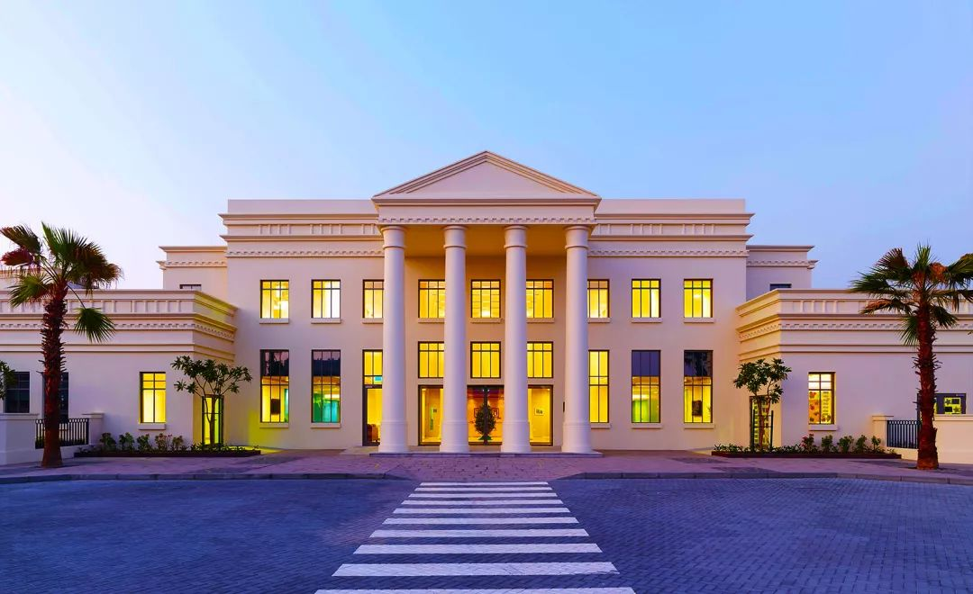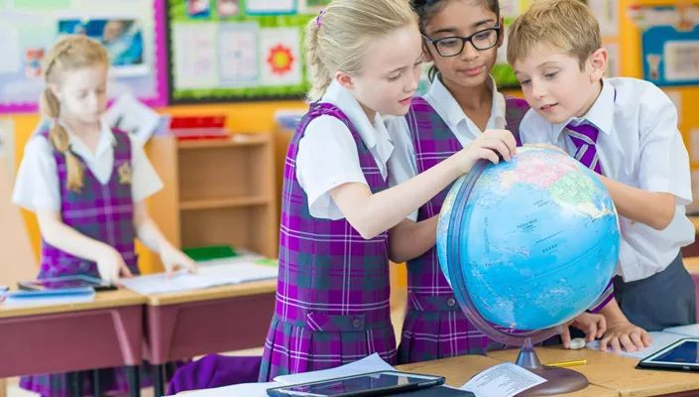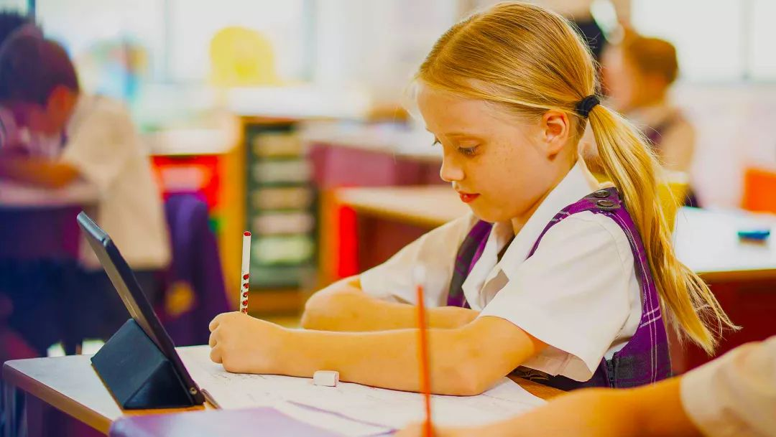

National curriculum adapted for England/regular enrollment; 3-13 years old; Coeducational education; Independent; Private ownership; 520 students

Originally known as Foremark School, but now renamed as Repton School (UK) and a partnership established between Dubai based company Evolving Knowledge Investments. With the start of 9th grade in September 2020, the group's daycare center "Dovecote" joined the campus at the beginning of the same year, thus expanding organically. Two thirds of the students are UK passport holders, while the rest come from over 40 other countries. Certified as the International Association of Independent Preparatory Schools (IAPS) World Center School, it is the second school in the world to receive this honor.

School system: English system

Current rating: Very Good

Enrollment grade: PK-8 grade

Tuition fee: 58500-83000AED

Address: Al Barsha South

**School Introduction**

The alma mater of Dubai's Foremark School is Foremark Hall in the UK. Vermark Hall School is a preparatory school established in 1557 for Repton School, while Dubai Vermark School is a preparatory school for Repton School Dubai, established in 2013. Dubai Vermark School is based on two pillars: academic excellence and attentive teacher care, integrating the traditional values of British private schools with the vibrant international life of the UAE. This enables our students to prepare for their next stage of education after leaving school, whether they go to schools in the UK, Dubai, or other international schools. We have always been committed to creating an inclusive and almost family like learning atmosphere, and maintaining and enhancing the rigor of the UK national curriculum within this vision. Fomack is located in the Dubai Science Park, with advanced facilities, science laboratories, art and design studios, and a variety of sports facilities. In addition, Fomack combines the traditional values of the British curriculum style with the international characteristics of the UAE, enabling students to fully unleash their potential and abilities in school, and achieve the goal of cultivating happy, comprehensive, and well-rounded young people.

**Course settings**

Encouraging students to actively learn and personalized teaching is the cornerstone of Fomack's curriculum. Fomack's learning objectives for students are not only to pass exams, but also to provide them with a rich and colorful life. The Fomack curriculum is extensive and balanced, with a focus on reading, English, mathematics, and science. The teaching emphasis is prominent, and teachers use modern methods and teaching concepts to create a dynamic learning environment during teaching. The course follows the UK national curriculum and enhances the elements of the ISEB curriculum, aiming to meet the strict standards of 11+and the general entrance examination. When necessary, additional support will be provided for students to prepare for exams, and the school also has a Fomack Achievement Base (FAB) to promote inclusivity among SEND and MAG&T students.

Early childhood stage

The courses provided by schools during the early childhood stage aim to cultivate children's love for learning through the opportunity to participate in learning games. At this stage, children grow rapidly, and through natural curiosity and imagination, they can stimulate their thinking and encourage intellectual, physical, and emotional development.

1、 Second grade

In this stage, we will continue to cultivate children's curiosity, and the school will carefully plan the transition process to ensure that students complete a good learning transition during this stage. In the early stages of learning, the school curriculum also includes physical education, music, and art, aiming to give children the opportunity to further develop their abilities and even explore new areas of interest.

Grade 3-5

The curriculum design for this stage of learning largely depends on the needs of 21st century learners, with the main goal of enabling students to comprehensively understand and master basic knowledge. Mastery of communication, reading, and calculation is the foundation of this stage of curriculum design.

Grade 6-8

At this stage of learning, Formark combines traditional and modern educational methods, with an orderly and organized curriculum that extends and challenges the potential of each child. Although the curriculum is based on the new national curriculum, many aspects go beyond the scope of the basic curriculum to ensure that children are prepared for the 11+, 13+, and other entrance exams.

**extracurricular activities**

Fomark not only hopes that students can experience high-quality learning experiences, but also strives to cultivate their self-confidence, leadership skills, teamwork spirit, perseverance, empathy, and other skills. The lessons and experiences gained through after-school projects, dance rehearsals, or specialized sports practice collaborations are very valuable. Students can also win awards by participating in competitions.

## Raffles International School

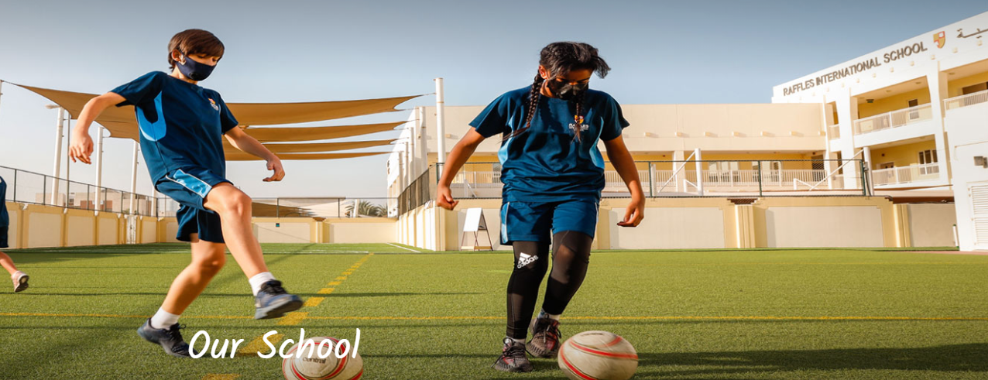

It welcomes families from almost 100 different countries to their Nursery through to Year 13 programme. The youngest pre-school learners are accommodated in the nursery and follow individualized learning pathways based upon ‘Development Matters’ - the earliest stage of EYFS, depending on their language background and personal development.

**Curriculum :** they use the National Curriculum for England and Wales, right through to IGCSE, A Level and BTEC options for the pre-university 6th Form.

**Languages :** English is the school's medium of instruction and Arabic is mandatory for all students attending school in the UAE up to Year 12. Starting in Year 3, all students choose between French or Mandarin as an additional language.

**Location:** Al Baghla Street (formerly Street 20) Umm Suqeim 3, Dubai, U.A.E.

**Address :** P.O. Box 122900 Makani No. : 1794281323

Main Office Telephone: +971 4 4271200/1202/1203

Front Office: +971 4 427 1202 / 1203

Admissions: +971 4 427 1205

**Timings :** they are open from Monday to Friday - 7 :30 am to 3 :30 pm   
they are closed on Saturday and Sunday.

**Fees:** <https://www.rafflesis.com/admissions/fee-structure/fee-2023-2024>

## Ranches Primary School

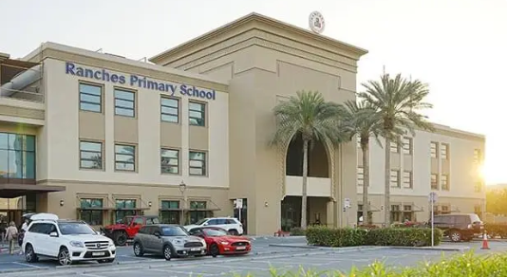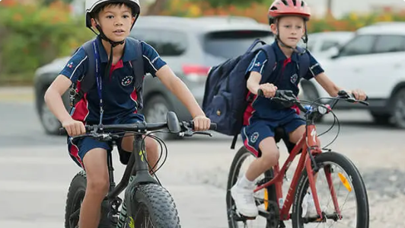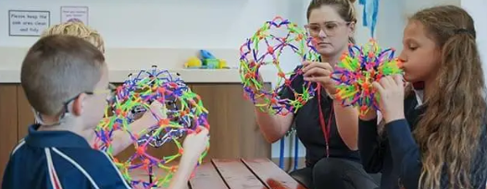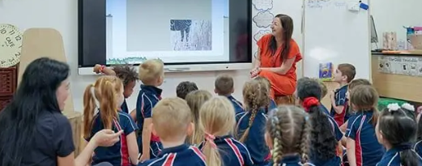

A primary school and nursery, has boys and girls from the ages of 18 months to 11 years (Year 6).  
they provide children with exclusive access to age-appropriate facilities, rather than having to compete for access with older year groups, which affords a learning journey tailored to the distinct developmental needs of younger students.

**Curriculum:** Continuous Provision (learning through playing).

**Location:** Arabian Ranches 2 - Dubai

**Admissions:** All of our departments may be reached by calling: +971 (0)4 442 9765

**Timings :** they are open from Monday to Friday different timing for different ages groups they are closed on Saturday and Sunday.

**Fees:** <https://www.rpsdubai.com/fees/>

## M S B Private School

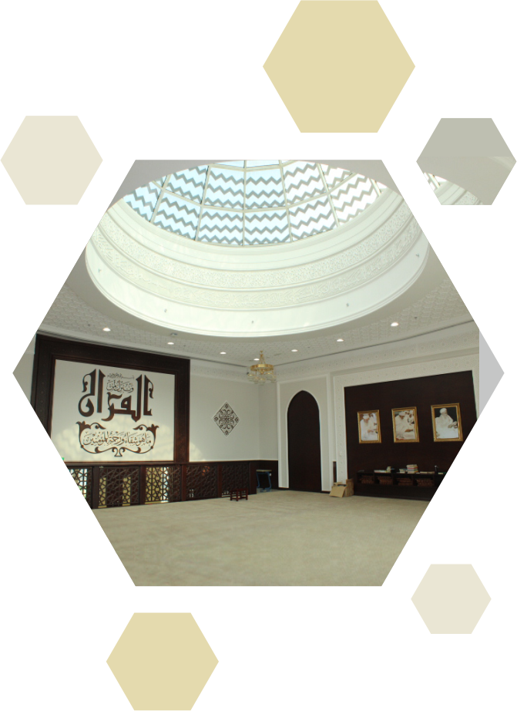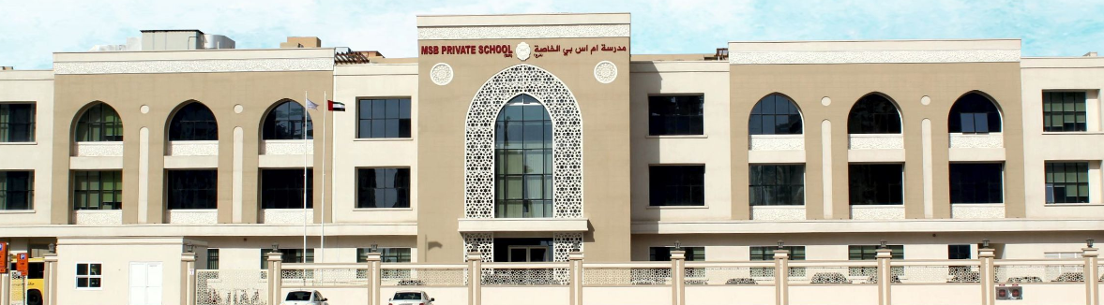

MSB Private School (Dubai) is an inclusive school which seeks to make the most appropriate grade placement and offers specific support for each student based on his/her age, academic, social and emotional development needs.

**Curriculum:** the Cambridge Curriculum and are affiliated to Cambridge University in offering the IGCSE and A Level syllabi (www.cie.org.uk).

**Location:** P.O. Box: 94550 - Al Nahda 2- Dubai - United Arab Emirates

**Admissions**: General Enquiries

Tel.: +971 4 2677100

Fax: +971 4 267730

Email: msbdubai@eim.ae

www.msbdubai.com

**Address:** P. O. Box 94550 Dubai, UAE *+971 4 2677100*

**Timings :** they are open from Monday 7 AM–4 PM to Friday, 7:15–11:30 AM they are closed on Saturday and Sunday.

**Fees:** <https://msbdubai.com/fees/>

GEMS New Millennium School

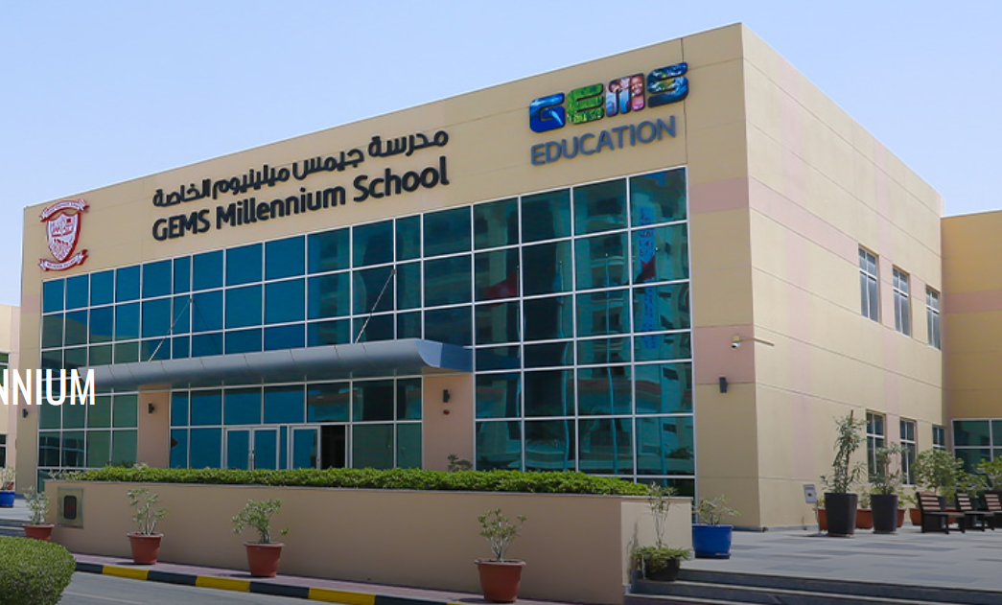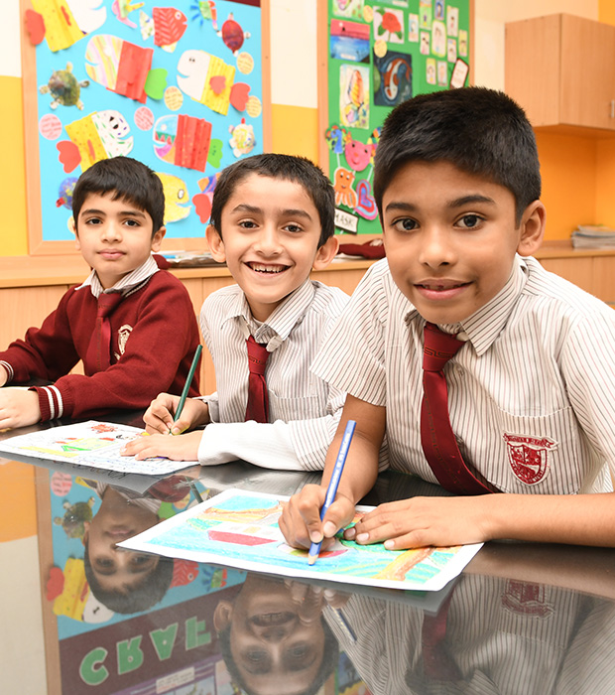

Video introduction: https://www.gemsmillenniumschool-sharjah.com/About-Us/Campus-Facilities-and-Location/Our-Facilities

Address: Al Khail Road South (Dubai to Jebel Ali)

Tuition fee: 18188AED-31025AED

Education System: English

Grade: Pre KG - Grade 12

**Why GMS?**

We achieve consistently high standards and external examination results that are substantially above national averages for Sharjah schools.

For us, it’s not just about academic success, it’s about developing exploration, innovation, and problem solving skills, alongside independent expression and decision making. It’s about providing a wealth of extra-curricular activities, community involvement programmes, and school events to support our rich, education programmes.

To help our senior students realise their potential as leaders and give them confidence when it comes to taking on roles of responsibility, GEMS Millennium School - Sharjah operates a flourishing House System which challenges our pupils to become well informed, confident, and active learners who are more than capable of becoming contributing members of the workforce and society as a whole.

**Curriculum Overview**

GEMS Millennium School (GMS), Sharjah follows the curriculum of the Central Board of Secondary Education (CBSE), a board of school education in India. The syllabus is the same as that followed by all schools affiliated to the CBSE board in India and abroad. The medium of instruction is English.

The curriculum which is up-to-date with latest educational trends and techniques offers a wide variety of hands-on application avenues that make learning both rewarding and meaningful. Continuous and comprehensive education is paced in a way that deepens learning and most importantly motivates children to learn. Understanding is given more value than memory and all learning experiences in the classroom are linked with experiences in life outside. A vast range of teaching methods prevents boredom and children are encouraged to learn at their own pace. There is a perfect balance between teacher-led and child-engineered activity both in the classroom and out.

**Evaluation**

In keeping with the recent directives of the CBSE, driven by a reformatory zeal, evaluation is done in a way that boosts the morale of a child and pushes him/her to further achievement. The focus is not on examinations and report cards but on real learning. Although examinations are an indispensible part of the education system care is taken to see that the teaching learning process is effective and learning is internalized. Continuous and comprehensive evaluation does not exclude traditional examinations but merely de-emphasises them.

Our endeavour to provide ‘high quality’ education is not at the cost of the child. In a stress-free and progressive environment we meet the expectations of all stakeholders in education. Formal assessment takes the form of not only pen and paper examination but self assessment, peer assessment, parental assessment and informal daily anecdotal reporting by the teachers. In all assessments and reports constructive feedback will be provided in a clear and simple language that will lead a child to improved performance. All assessment is objective and aimed at enhancing student achievement. At GMS Sharjah we believe that ‘report cards’ should be demystified for the child for its relevance is most to him/her.

A wide variety of evaluation methods is used in GMS Sharjah. Besides the mandatory CBSE prescribed formative and summative tests we also use diagnostic and prognostic tests to determine a child’s aptitude and attitude. Criterion Reference Tests (CRTs) are used to measure performance by comparing it with a pre-specified level of accomplishment – especially useful for assessing SEP benefits.

GMS Sharjah conducts holistic assessment of the scholastic and co-scholastic progress of all students. Personality development and social behavior are also scrutinized daily.

Obviously at GMS Sharjah High Order Thinking Skills such as knowledge, understanding, applying, analyzing, evaluating and creating assume greater importance than the traditional testing of memory.

JSS International School LLC

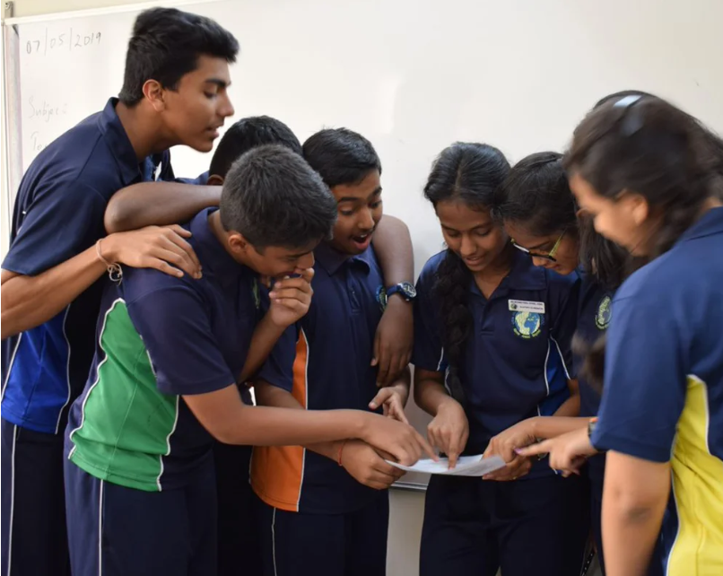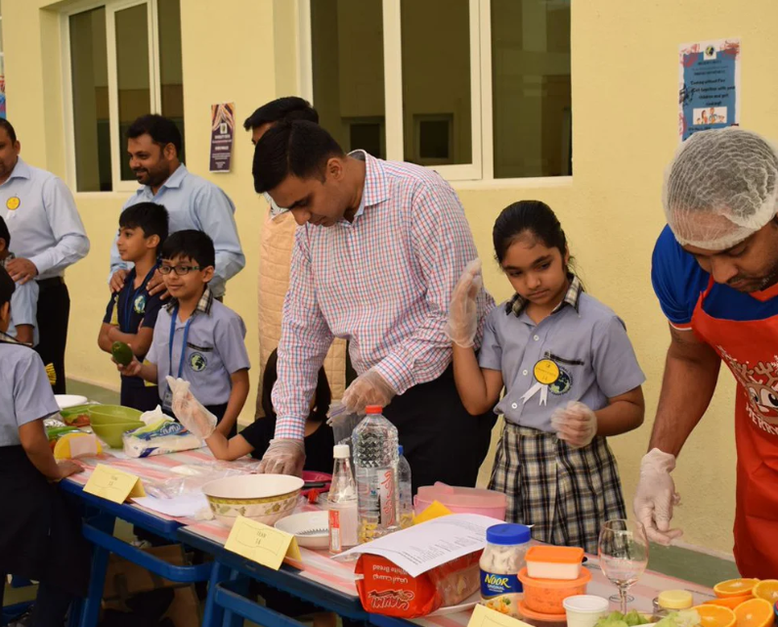

Address: Al Khail Road

Education system: India

**PRINCIPAL’S MESSAGE**

I believe that after the information revolution our responsibility towards our children’s education has become even more challenging.The need of the day is to equip our children with critical thinking and practical skills so that they can be useful contributors to a global society in the 21st century.

For this, educators have to be innovative and exploit all tools that Information Technology provides. Even social networking has to be adapted and linked to classroom learning.The many studies on the academic success story of Asian immigrants makes one pause and take a hard look at the Eastern Education system that does not rely much on technology.

Parental expectation and involvement, strong family values and the desire to succeed in life in a competitive environment is the Eastern contribution to successful education .If we can link the Western pedagogy and their best practices to the Eastern belief and value system, we would be on track to make our pupils global citizens in a continuously evolving world.

AND THIS IS AN INTERESTING CHALLENGE THAT JSSIS EDUCATORS HAVE TAKEN ON !!!

**Our Curriculum**

The JSS International School follows the curriculum laid down by Indian Certificate of Secondary Education (ICSE). Our mission is to provide for the varying educational needs of a culturally diverse and geographically dispersed student body with a goal of preparing students academically, personally and professionally for successful careers. The school has designed an international curriculum that is built around a strong ethical component and sets considerable store of knowledge and respect for the cultures and values of different regions of the world.

**Academic Environment**

The programme stresses on Experiential and Collaborative Learning through workshops, interactive sessions, role plays, project work, group discussions and games. The integrated curriculum enables students to think and solve problems, and comprehend concepts with manifold perspective. The activity based learning enables students to enjoy the subjects and learn without any fear. We seek to redefine achievements based on the capability for life long learning and acquisition of life skills rather-than mere academic excellence. Focus is oriented on students and an activity based curriculum for the holistic growth of the child in enriching and challenging atmosphere.

Technology is an integral part of the curriculum from the primary classes onwards and is used as a vital tool to enhance and accelerate the learning process. Arabic is a compulsory language for all grades.

AIMS

The curriculum aims to enable children to:

become successful learners who enjoy learning;

understand texts of different subjects so as to communicate knowledge and ideas in ways specific to the subject;

articulate thoughts and ideas effectively using oral, written and nonverbal communication skills in a variety of forms and contexts;

use technology to access and provide information and to communicate with others;

understand cross-curricular linkages- connect learning across subject areas;

become confident individuals who are able to live safe, healthy and fulfilling lives.

become responsible citizens who make a positive contribution to society;

understand and apply knowledge to real life experiences;

exhibit sensitivity towards environmental issues;

manage and utilize resources judiciously

**Salient features of the curriculum**

The Curriculum is Child Centered

Focus on using a wide range of learning experiences

Sequential arrangement of learning experiences

The Curriculum encourages an Integrated approach

The Curriculum provides scope for Contextualization

The Curriculum follows a Social Constructivist approach

The Curriculum encourages development of Life Skills

**fee**: <https://jssisdubai.com/school-fee-structure/>

# JSS Private School LLC

Education system: India

Tuition fee: 11230AED-24384AED

Address: Al Safa

Schools provide students with a learning world and strive to cultivate global citizens, who will strive to make this world a better place to live. By providing a suitable atmosphere, the school enables students to face the future with their heads up and confidence in themselves. The school sees that students can move forward with positive determination, and everyone will leave solid footprints on the path of progress

The construction of the curriculum aims to enable children to understand life and develop their potential, define and pursue goals and sensitivities for the well-being and feelings of others, as well as knowledge and understanding of the world. The school's vision and mission define the broader objectives of the curriculum

## GEMS Our Own Indian School GEMS 传统印度学校

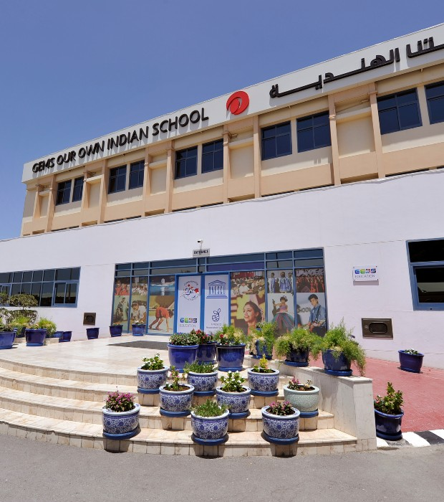

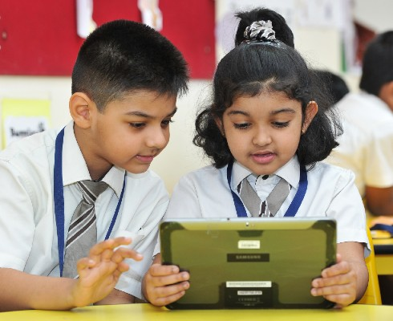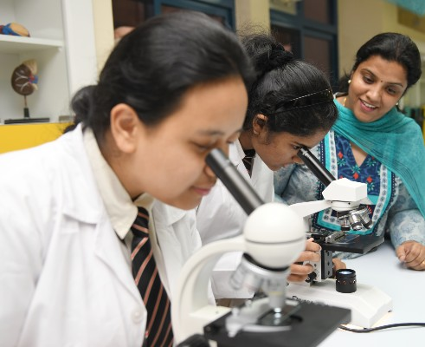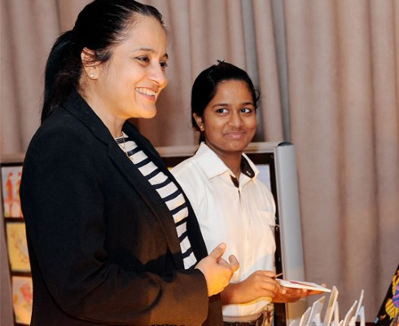

**Our School**

GEMS Our Own Indian School has earned an enviable reputation for high academic standards and the strong sense of community that has developed within the school. The standards of excellence also extend to the extra-curricular programmes that the school offers, ranging from sports, arts and crafts, dance and music. Winners of several competitions and awards, achievements in these areas have been formally recognized. The school has been appreciated widely for enriching its curriculum by integrating environmental activities through vegetable and fruit gardens in the school and participating in recycling and saving the planet projects.

Significant emphasis is placed on the development of strong relationships between teachers and their students and individualized attention has become a hallmark of GEMS Our Own Indian School.

At GEMS Our Own Indian School, students are provided with a high educational standards per the CBSE syllabus.

**Vision and Mission**

Our new vision statement is "Nurturing dynamic learners in an inclusive environment", which was framed in collaboration with students, parents and teachers.

**Curriculum Overview**

Ensuring the all-round development of each and every student

Learning at GEMS Our Own Indian School takes place in a friendly and supportive environment that encourages individual achievement and fosters a sense of team spirit.

The School offers the CBSE curriculum. GEMS Our Own Indian School is recognized by the Ministry of Education, Dubai, UAE, and affiliated to the CBSE Board, New Delhi. The School enjoys a distinguished reputation for high academic performance in the two streams of Science and Commerce in the Higher Secondary Examinations.

The CBSE curriculum is internationally recognized, preparing students for entry into universities and collleges anywhere in the world. It offers high and challenging standards of education that provides a unique educational platform to students with a wide spectrum of ability.

The medium of instruction at the school is English and special emphasis is placed on the development of communication skills in English at all levels. Learners acquire confidence through specialized teaching which is both enjoyable and efficient.

**Fee**

<https://www.gemsoo-alquoz.com/Admissions/Fees-and-Payments>